IT project part 2 ( AFTER MIDTERM)
Important questions and topics chapter 7-11

Chapter 7

Project cost management

Q: what is the processes of cost management , what is the output?

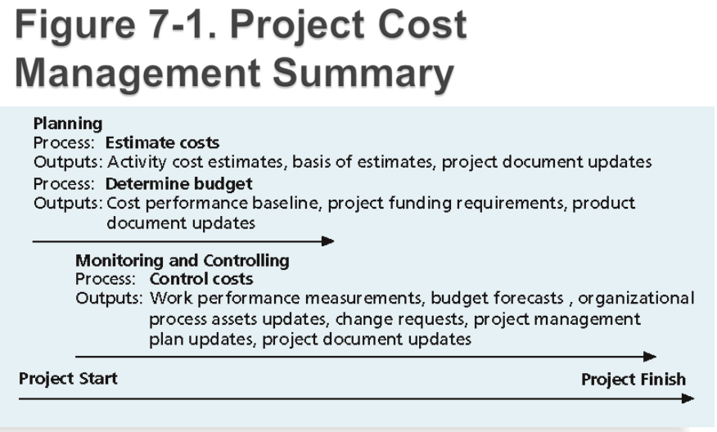

Q what is cost? What is project cost management ?
- Cost is a resource sacrificed or foregone to achieve a specific objective or something given up in exchange
- Costs are usually measured in monetary units like dollars
- Project cost management includes the processes required to ensure that the project is completed within an approved budget

Important terminology in cost management ( basic principle of cost management)

◦ Profits are revenues minus expenditures
- Profit margin is the ratio of revenues to profits
- Life cycle costing considers the total cost of ownership, or development plus support costs, for a project
- Cash flow analysis determines the estimated annual costs and benefits for a project and the resulting annual cash flow
- Tangible costs or benefits are those costs or benefits that an organization can easily measure in dollars
- Intangible costs or benefits are costs or benefits that are difficult to measure in monetary terms Direct costs are costs that can be directly related to producing the products and services of the project
- Indirect costs are costs that are not directly related to the products or services of the project, but are indirectly related to performing the project
- Sunk cost is money that has been spent in the past; when deciding what projects to invest in or continue, you should not include sunk costs
- Learning curve theory states that when many items are produced repetitively, the unit cost of those items decreases in a regular pattern as more units are produced
- Reserves are dollars included in a cost estimate to mitigate cost risk by allowing for future situations that are difficult to predict
◦ Contingency reserves allow for future situations that may be partially planned for (sometimes called known unknowns) and are included in the project cost baseline
◦ Management reserves allow for future situations that are unpredictable (sometimes called unknown unknowns)

Q: cost management plan
- A cost management plan is a document that describes how the organization will manage cost variances on the project
- A large percentage of total project costs are often labor costs, so project managers must develop and track estimates for labor

Q: what are variance cost estimation tools and techniques?
Basic tools and techniques for cost estimates:

◦ Analogous or top-down estimates: use the actual cost of a previous, similar project as the basis for estimating the cost of the current project
◦ Bottom-up estimates: involve estimating individual work items or activities and summing them to get a project total
◦ Parametric modeling uses project characteristics (parameters) in a mathematical model to estimate project costs

Q: what are cost estimation problems?
- Estimates are done too quickly
- Lack of estimating experience
- Human beings are biased toward underestimation
- Management desires accuracy

Q: what are different methods in controlling costs?
Project cost control includes:
◦ Monitoring cost performance
◦ Ensuring that only appropriate project changes are included in a revised cost baseline
◦ Informing project stakeholders of authorized changes to the project that will affect costs

Many organizations around the globe have problems with cost control

Known as terminologies

earned value management ( EVM) is a project performance measurement technique that integrates scope, time, and cost data
The planned value (PV), formerly called the budgeted cost of work scheduled (BCWS), also called the budget, is that portion of the approved total cost estimate planned to be spent on an activity during a given period
Actual cost (AC), formerly called actual cost of work performed (ACWP), is the total of direct and indirect costs incurred in accomplishing work on an activity during a given period
The earned value (EV), formerly called the budgeted cost of work performed (BCWP), is an estimate of the value of the physical work actually completed
EV is based on the original planned costs for the project or activity and the rate at which the team is completing work on the project or activity to date
Rate of performance (RP) is the ratio of actual work completed to the percentage of work planned to have been completed at any given time during the life of the project or activity

For example, suppose the server installation was halfway completed by the end of week 1: the rate of performance would be 50% because by the end of week 1, the planned schedule reflects that the task should be 100 percent complete and only 50 percent of that work has been completed

EARNED VALUE FORMULAs
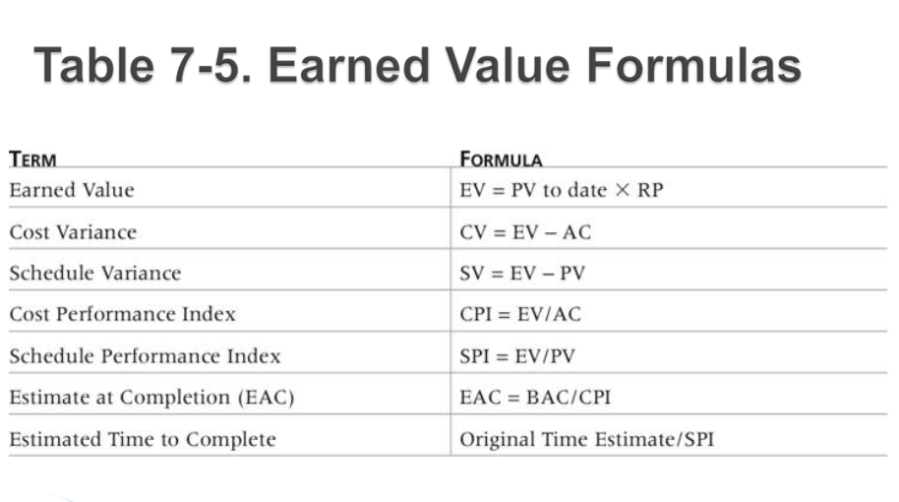

Rules of thumbs for earned value ( rules must be remembered in calculating Earned Value)

- Negative numbers for (CV)&(SV) cost and schedule variance indicate problems in those areas

- CPI and SPI less than 100% indicate problems

- Problems mean the project is costing more than planned (over budget) or taking longer than planned (behind schedule)

- The CPI can be used to calculate the estimate at completion (EAC), an estimate of what it will cost to complete the project based on performance to date; the budget at completion (BAC) is the original total budget for the project

Q; what is portfolio management, what are its benefits:
Many organizations collect and control an entire suite of projects or investments as one set of interrelated activities in a portfolio
Five levels for project portfolio management
1. Put all your projects in one database
2. Prioritize the projects in your database
3. Divide your projects into two or three budgets based on type of investment
4. Automate the repository
5. Apply modern portfolio theory, including risk-return tools that map project risk on a curve

Portfolio management benefits:
- \Schlumberger saved $3 million in one year by organizing 120 information technology projects into a portfolio
- ROI of implementing portfolio management software by IT departments:
◦ Savings of 6.5 percent of the average annual IT budget by the end of year one
◦ Improved annual average project timeliness by 45.2 percent
◦ Reduced IT management time spent on project status reporting by 43 percent and IT labor capitalization reporting by 55 percent
◦ Decreased the time to achieve financial sign-off for new IT projects by 20.4 percent, or 8.4 days
___________________________________________________________

CHAPTER 8
Project Quality Management

Q: what is project quality management process and what is the output?
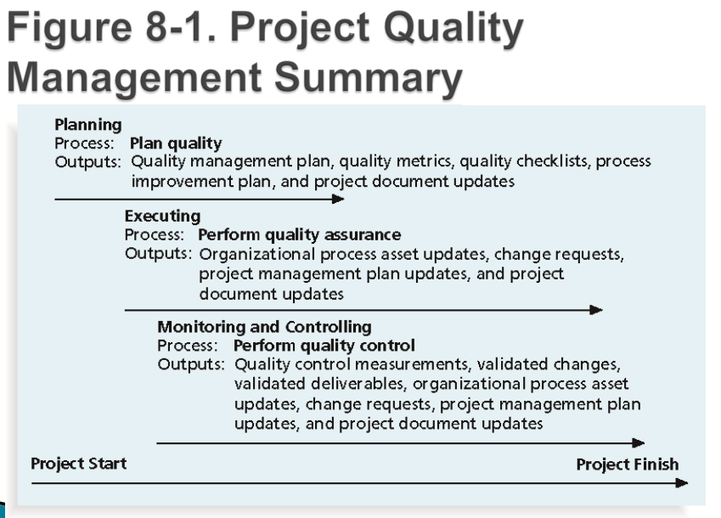
Q: what is project quality, what is project quality management?
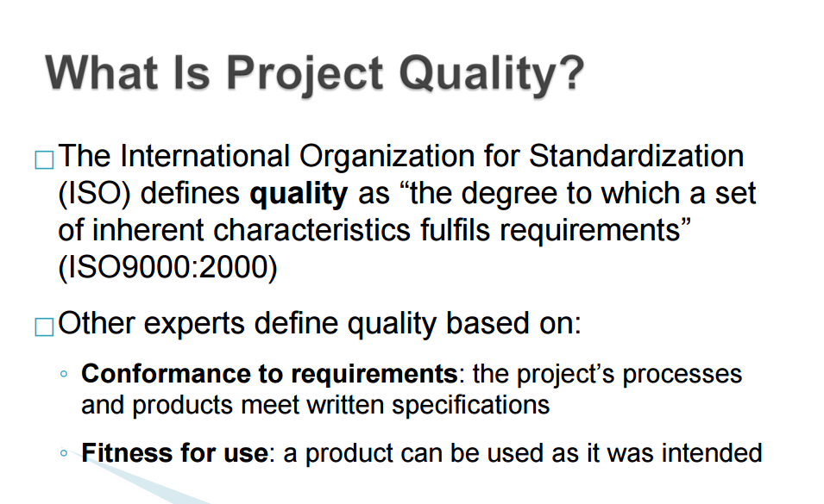
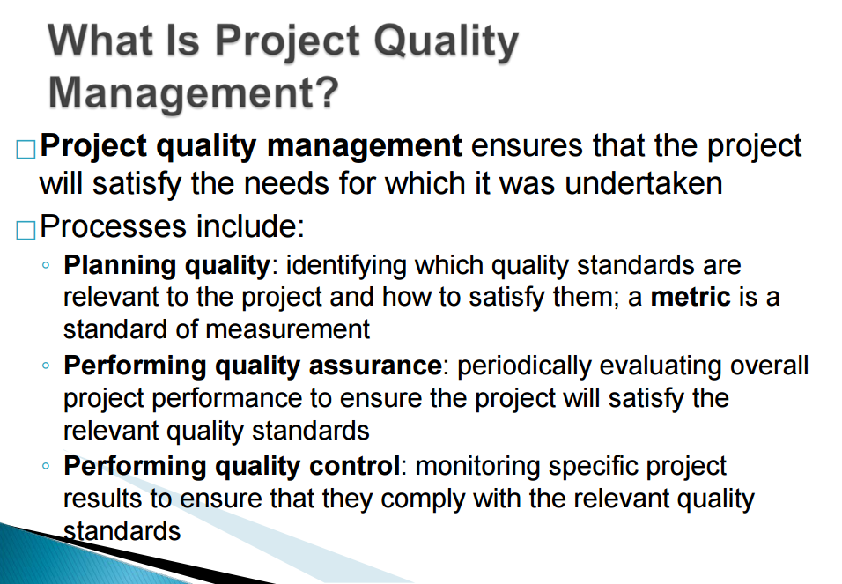

Design the experiment :
is a quality planning technique that helps identify which variables have the most influence on the overall outcome of a process

Also applies to project management issues, such as cost and schedule trade-offs

Involves documenting important factors that directly contribute to meeting customer requirements

Features related to quality:

- Functionality is the degree to which a system performs its intended function
- Features are the system’s special characteristics that appeal to users
- System outputs are the screens and reports the system generates
- Performance addresses how well a product or service performs the customer’s intended use
- Reliability is the ability of a product or service to perform as expected under normal conditions
- Maintainability addresses the ease of performing maintenance on a product

Q what is quality assurance and what is quality control?

Quality Assurance
- Quality assurance includes all the activities related to satisfying the relevant quality standards for a project
- Another goal of quality assurance is continuous quality improvement
- Benchmarking generates ideas for quality improvements by comparing specific project practices or product characteristics to those of other projects or products within or outside the performing organization

- A quality audit is a structured review of specific quality management activities that help identify lessons learned that could improve performance on current or future projects
Quality control
The main outputs of quality control are:
◦ Acceptance decisions
◦ Rework
◦ Process adjustments
There are Seven Basic Tools of Quality that help in performing quality control
Q; Explain cause-and-effect diagram?
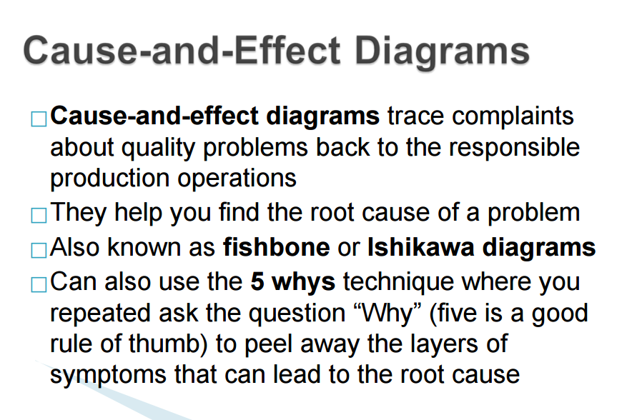
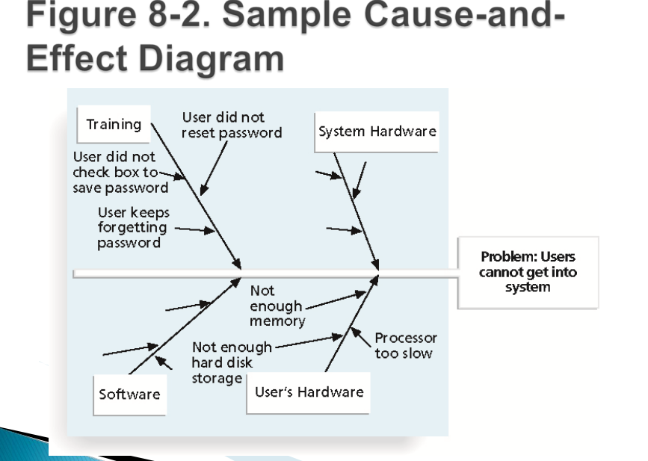
Q what are the quality control charts?

They are ( all important)

A control chart is a graphic display of data that illustrates the results of a process over time
The main use of control charts is to prevent defects, rather than to detect or reject them
Quality control charts allow you to determine whether a process is in control or out of control
-When a process is in control, any variations in the results of the process are created by random events; processes that are in control do not need to be adjusted -When a process is out of control, variations in the results of the process are caused by non-random events; you need to identify the causes of those non-random events and adjust the process to correct or eliminate them

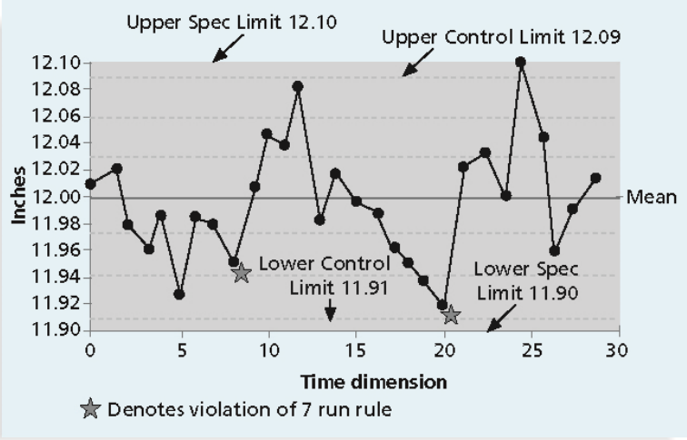
The seven run rule states that if seven data points in a row are all below the mean, above the mean, or are all increasing or decreasing, then the process needs to be examined for non-random problems

You can use quality control charts and the seven run rule to look for patterns in data

A run chart displays the history and pattern of variation of a process over time

- It is a line chart that shows data points plotted in the order in which they occur
- Can be used to perform trend analysis to forecast future outcomes based on historical patterns
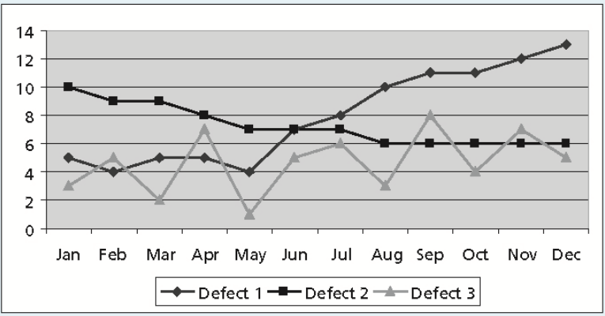

A scatter diagram helps to show if there is a relationship between two variables
The closer data points are to a diagonal line, the more closely the two variables are related

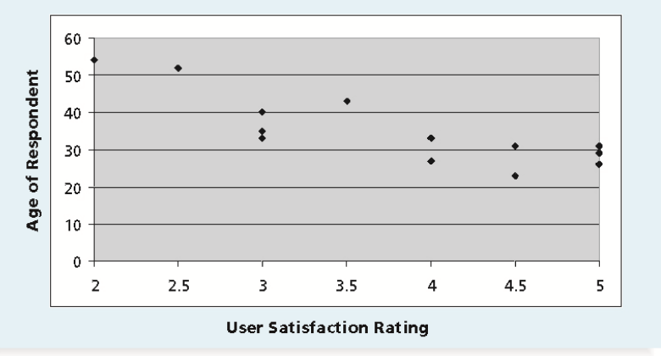

A histogram is a bar graph of a distribution of variables
Each bar represents an attribute or characteristic of a problem or situation, and the height of the bar represents its frequency

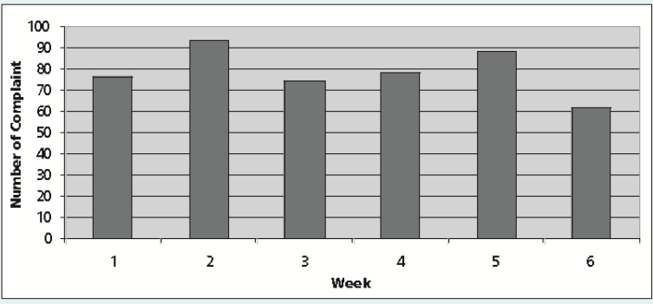

A Pareto chart is a histogram that can help you identify and prioritize problem areas

Pareto analysis is also called the 80-20 rule, meaning that 80 percent of problems are often due to 20 percent of the causes

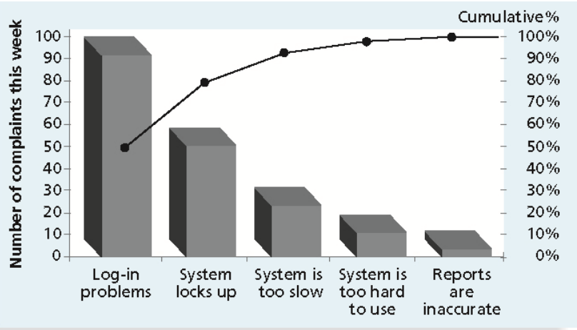

Flowcharts are graphic displays of the logic and flow of processes that help you analyze how problems occur and how processes can be improved

They show activities, decision points, and the order of how information is processed

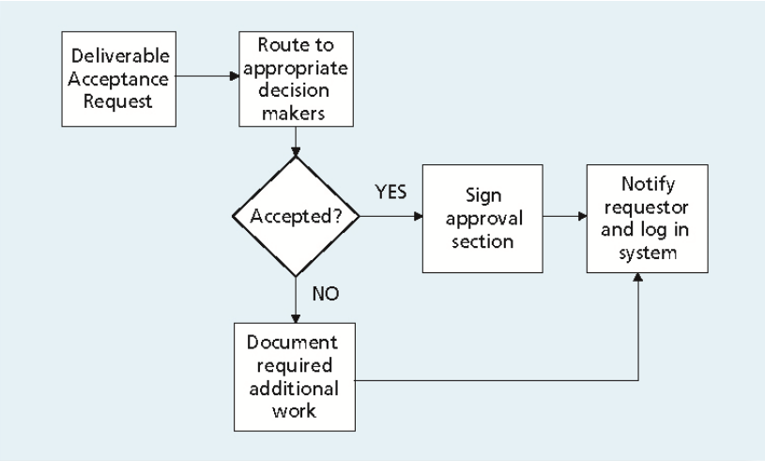

Q: what is six sigma

Six Sigma is “a comprehensive and flexible system for achieving, sustaining, and maximizing business success. Six Sigma is uniquely driven by close understanding of customer needs, disciplined use of facts, data, and statistical analysis, and diligent attention to managing, improving, and reinventing business processes.”*

- Six sigma is very hard quality protocol (The target for perfection is the achievement of no more than 3.4 defects per million opportunities)
- The principles can apply to a wide variety of processes
- Six Sigma projects normally follow a five-phase improvement process called DMAIC
DMAIC is a systematic, closed-loop process for continued improvement that is scientific and fact based
DMAIC stands for:
◦ Define: define the problem/opportunity, process, and customer requirements
◦ Measure: define measures, then collect, compile, and display data
◦ Analyze: scrutinize process details to find improvement opportunities
◦ Improve: generate solutions and ideas for improving the problem
◦ Control: track and verify the stability of the improvements and the predictability of the solution

Q; what is the uniqueness of quality six sigma control ?
- It requires an organization-wide commitment
- Training follows the “Belt” system
- Six Sigma organizations have the ability and willingness to adopt contrary objectives, such as reducing errors and getting things done faster
- It is an operating philosophy that is customer focused and strives to drive out waste, raise levels of quality, and improve financial performance at breakthrough levels

What is six 9s of quality?
Six 9s of quality is a measure of quality control equal to 1 fault in 1 million opportunities

In the telecommunications industry, it means 99.9999 percent service availability or 30 seconds of down time a year

This level of quality has also been stated as the target goal for the number of errors in a communications circuit, system failures, or errors in lines of code

Q: what is testing, and what are the type of testing?

Testing should be done during almost every phase of the IT product development life cycle

Types of testing:
- Unit testing tests each individual component (often a program) to ensure it is as defect-free as possible
- Integration testing occurs between unit and system testing to test functionally grouped components
- System testing tests the entire system as one entity
- User acceptance testing is an independent test performed by end users prior to accepting the delivered system

Q:What is ISO standard?
ISO 9000 is a quality system standard that:

- Is a three-part, continuous cycle of planning, controlling, and documenting quality in an organization
- Provides minimum requirements needed for an organization to meet its quality certification standards
- Helps organizations around the world reduce costs and improve customer satisfaction
Q:what are the five cost categories related to quality?

- Prevention cost: cost of planning and executing a project so it is error-free or within an acceptable error range
- Appraisal cost: cost of evaluating processes and their outputs to ensure quality
- Internal failure cost: cost incurred to correct an identified defect before the customer receives the product
- External failure cost: cost that relates to all errors not detected and corrected before delivery to the customer
- Measurement and test equipment costs: capital cost of equipment used to perform prevention and appraisal activities

Q: what is maturity models?
Maturity models are frameworks for helping organizations improve their processes and systems
  - The Software Quality Function Deployment Model(SQFD) focuses on defining user requirements and planning software projects

  - The Software Engineering Institute’s Capability Maturity Model Integration (CMMI) is a process improvement approach that provides organizations with the essential elements of effective processes
  - The Project Management Maturity Model
CMMI levels, from lowest to highest, are:
◦ Incomplete
◦ Performed
◦ Managed
◦ Defined
◦ Quantitatively Managed
◦ Optimizing

Companies may not get to bid on government projects unless they have a CMMI Level 3

___________________________________________________________
CHAPTER 9
Project Human Resources Management

Q: What human resourse managment mean, why its important?

Making the most effective use of the people involved with a project
Processes include:
◦ Developing the human resource plan: identifying and documenting project roles, responsibilities, and reporting relationships
◦ Acquiring the project team: getting the needed personnel assigned to and working on the project
◦ Developing the project team: building individual and group skills to enhance project performance
◦ Managing the project team: tracking team member performance, motivating team members, providing timely feedback, resolving issues and conflicts, and coordinating changes to help enhance project performance

Q: what is human resource management process and output?
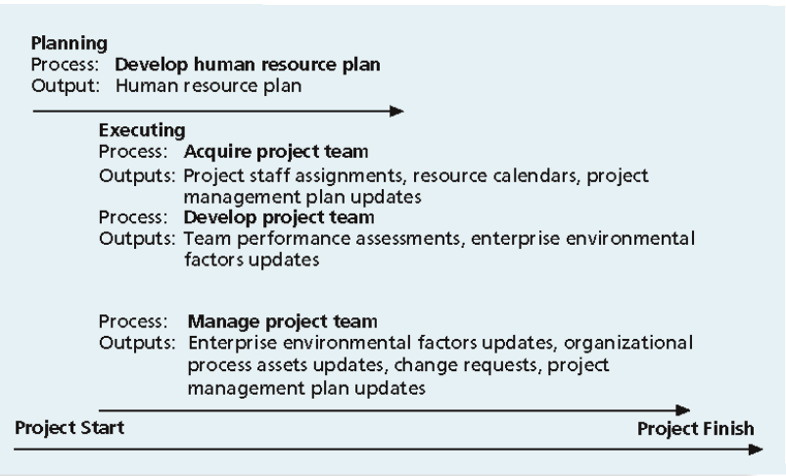
Q: what are intrinsic and extrinsic motivation?
Intrinsic motivation causes people to participate in an activity for their own enjoyment
Extrinsic motivation causes people to do something for a reward or to avoid a penalty

For example, some children take piano lessons for intrinsic motivation (they enjoy it) while others take them for extrinsic motivation (to get a reward or avoid punishment)

Q: what are motivation theories?
( each theory could come in individual question)

( first motivation theory) Maslows hierarchy of needs

Abraham Maslow argued that humans possess unique qualities that enable them to make independent choices, thus giving them control of their destiny

Maslow developed a hierarchy of needs which states that people’s behaviors are guided or motivated by a sequence of needs
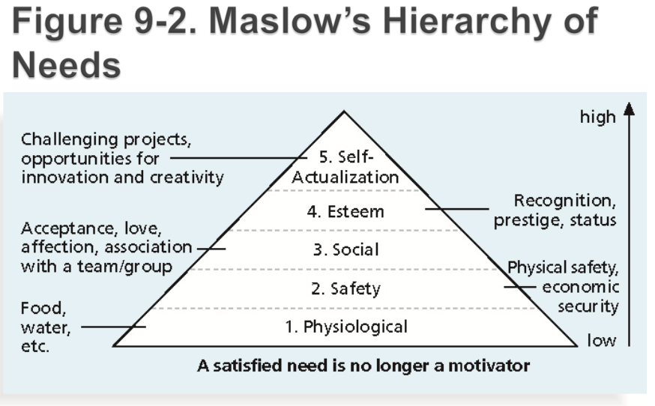
(second motivation theory) Herzberg's motivational and Hygiene factors:
Frederick Herzberg wrote several famous books and articles about worker motivation; he distinguished between:
- Motivational factors: achievement, recognition, the work itself, responsibility, advancement, and growth, which produce job satisfaction
- Hygiene factors: cause dissatisfaction if not present, but do not motivate workers to do more; examples include larger salaries, more supervision, and a more attractive work environment
( Third motivation theory ) McClelland's Acquired-Need theory

Specific needs are acquired or learned over time and shaped by life experiences, including:
◦ Achievement (nAch): achievers like challenging projects with achievable goals and lots of feedback
◦ Affiliation (nAff): people with high nAff desire harmonious relationships and need to feel accepted by others, so managers should try to create a cooperative work environment for them
◦ Power (nPow): people with a need for power desire either personal power (not good) or institutional power (good for the organization); provide institutional power seekers with management opportunities

(FOurth motivation theory) McGregor's theory X and Y

- Douglas McGregor popularized the human relations approach to management in the 1960s
- Theory X: assumes workers dislike and avoid work, so managers must use coercion, threats, and various control schemes to get workers to meet objectives
- Theory Y: assumes individuals consider work as natural as play or rest and enjoy the satisfaction of esteem and self-actualization needs
- Theory Z: introduced in 1981 by William Ouchi and is based on the Japanese approach to motivating workers, emphasizing trust, quality, collective decision making, and cultural values

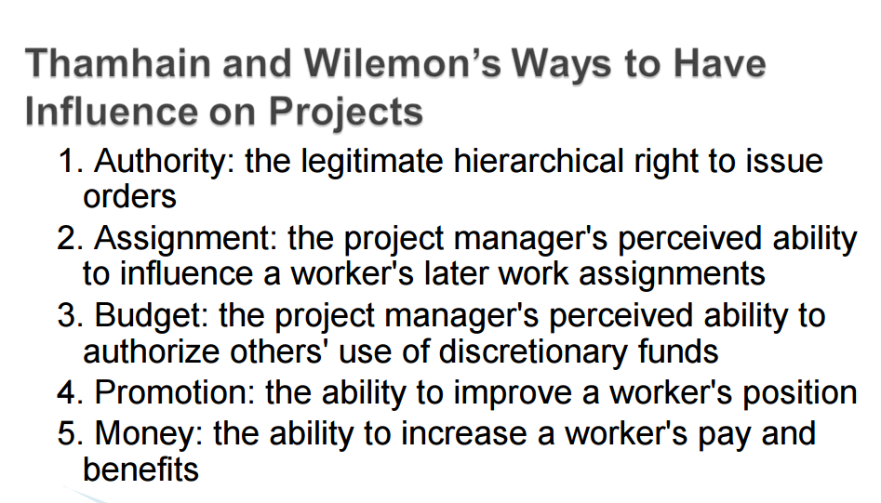
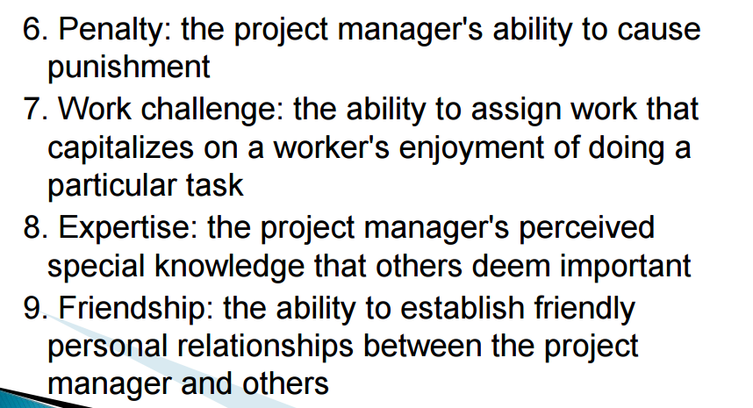
Q: how to improve the effectiveness of human resource management?
Project managers can apply Covey’s 7 habits to improve effectiveness on projects
- ◦ Be proactive
- ◦ Begin with the end in mind
- ◦ Put first things first
- ◦ Think win/win
- ◦ Seek first to understand, then to be understood
- ◦ Synergize
- ◦ Sharpen the saw

Q: what is A responsibility assignment matrix (RAM)?
A responsibility assignment matrix (RAM) is a matrix that maps the work of the project as described in the WBS to the people responsible for performing the work as described in the OBS
Can be created in different ways to meet unique project needs
- Shows people in one side of the table
- Shows activity on another side of the table
- show a responsibilities
Q: what is A staffing management plan?
A staffing management plan describes when and how people will be added to and taken off the project team

What is resource assignment, Resource loading and resource leveling?
Staffing plans and good hiring procedures are important, as are incentives for recruiting and retention
◦ Some companies give their employees one dollar for every hour a new person they helped hire works
◦ Some organizations allow people to work from home as an incentive

Resource loading refers to the amount of individual resources an existing schedule requires during specific time periods
Resource leveling is a technique for resolving resource conflicts by delaying tasks

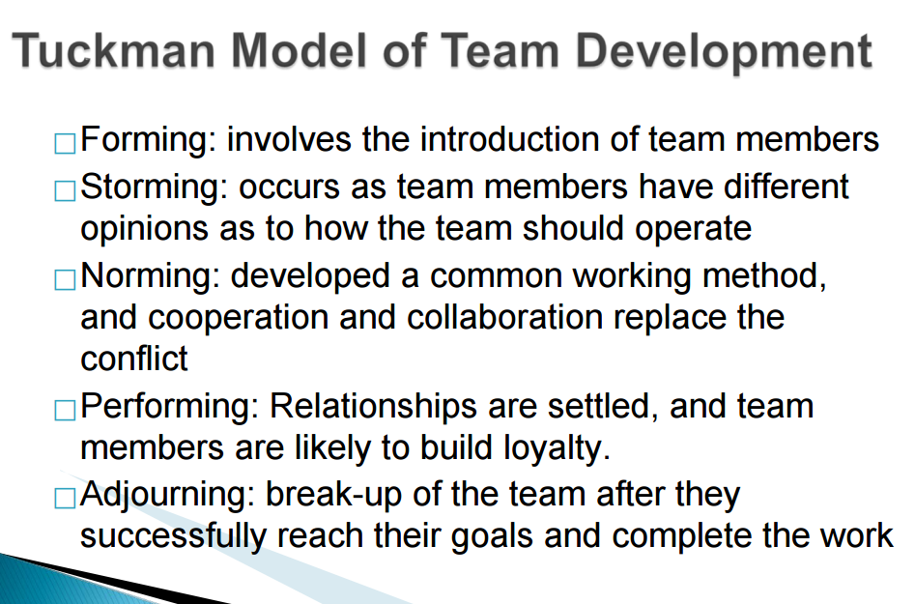
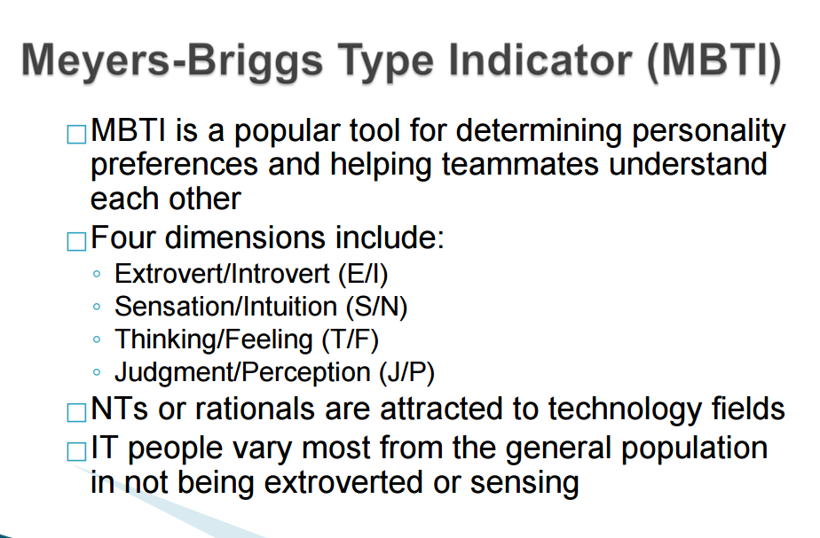
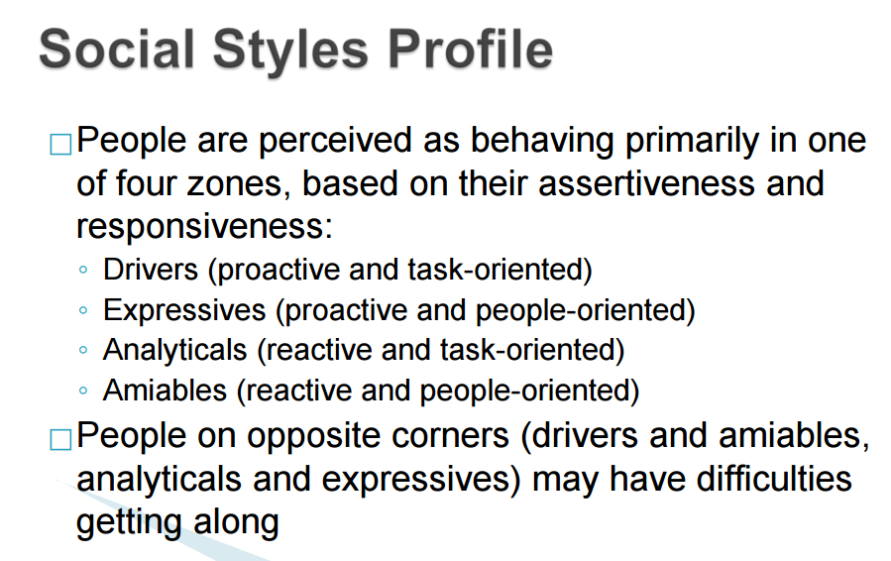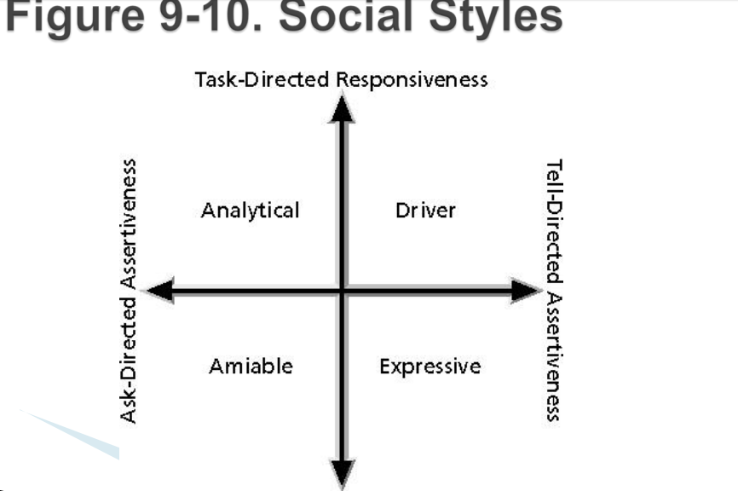
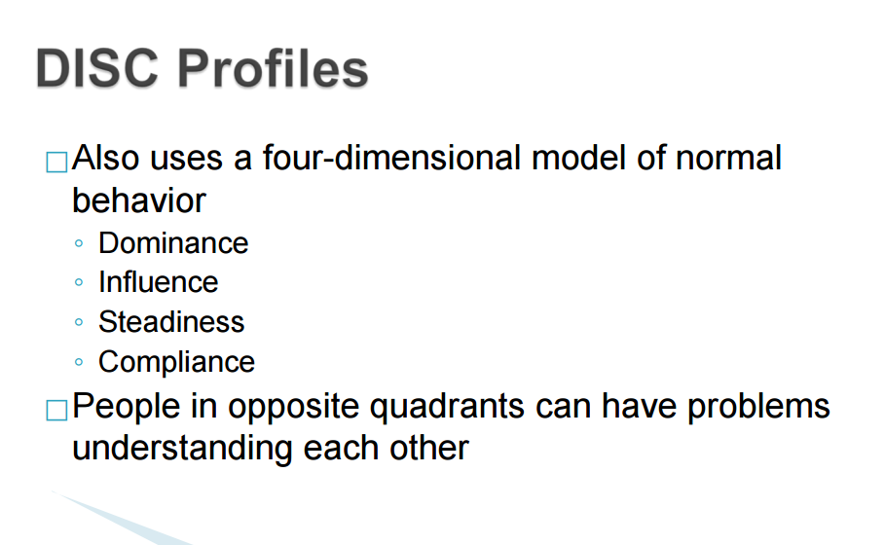
The five dysfunctions of teams are?
1. Absence of trust
2. Fear of conflict
3. Lack of commitment
4. Avoidance of accountability
5. Inattention to results
___________________________________
CHAPTER 10
Project communication management

Q: what is Project communication management process and the output?
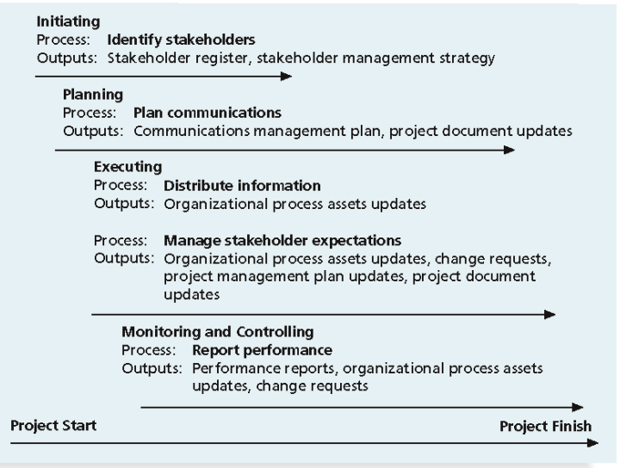
Identifying stakeholders: identifying everyone involved in or affected by the project and determining the best ways to manage relationships with them
Planning communications: determining the information and communications needs of the stakeholders
Distributing information: making needed information available to project stakeholders in a timely manner
Managing stakeholder expectations: managing communications to satisfy the needs and expectations of project stakeholders and to resolve issues
Reporting performance: collecting and disseminating performance information, including status reports, progress measurement, and forecasting

Q:What is the importance of good communication?
The greatest threat to many projects is a failure to communicate
▪ Our culture does not portray IT professionals as being good communicators
▪ Research shows that IT professionals must be able to communicate effectively to succeed in their positions
▪ Strong verbal skills are a key factor in career advancement for IT professionals

Q: what is the importance of face to face communication ?
▪ Research says that in a face-to-face interaction:
▪ 58 percent of communication is through body language
▪ 35 percent of communication is through how the words are said
▪ 7 percent of communication is through the content or words that are spoken
▪ Pay attention to more than just the actual words someone is saying
▪ A person’s tone of voice and body language say a lot about how he or she really feels

Q: why its important to understand group and individual communication ?

In group communication: only discuss the issues that will affect the whole group.
In Individual communication discuss issues that only related to that person person.

Formula for determining the number of communication channel:
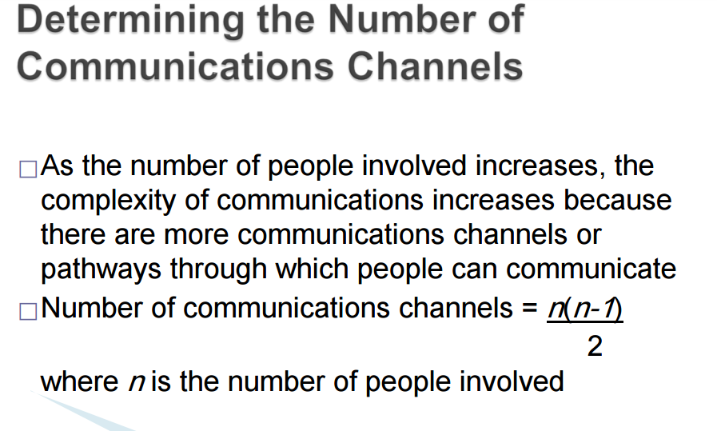

Q:how to manage stakeholders:
Project managers must understand and work with various stakeholders
Need to devise a way to identify and resolve issues
An expectations management matrix can help clarify expectation

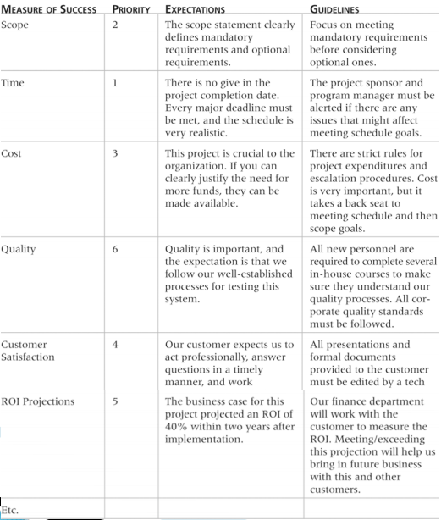

Q: what are the different kinds of reports?
Performance reporting keeps stakeholders informed about how resources are being used to achieve project objectives:
◦ Status reports describe where the project stands at a specific point in time
◦ Progress reports describe what the project team has accomplished during a certain period of time
◦ Forecasts predict future project status and progress based on past information and trends

Q:How can we improve project communication?
- Manage conflicts effectively
- Develop better communication skills
- Run effective meetings
- Use e-mail and other technologies effectively
- Use templates for project communications

Q: what are the conflict handling modes?
1. Confrontation: directly face a conflict using a problem solving approach
2. Compromise: use a give-and-take approach
3. Smoothing: de-emphasize areas of difference and emphasize areas of agreement
4. Forcing: the win-lose approach
5. Withdrawal: retreat or withdraw from an actual or potential disagreement
6. Collaborating: decision makers incorporate different viewpoints and insights to develop consensus and commitment

Q:How to develop better communication skills?
- Companies and formal degree programs for IT professionals often neglect the importance of speaking, writing, and listening skills
- As organizations become more global, they realize they must invest in ways to improve communication with people from different countries and cultures
- It takes leadership to improve communication
____________________________________________________
CHAPTER 11
Project Risk Management

Q:What is risk management and what is it important?
Project risk management is the art and science of identifying, analyzing, and responding to risk throughout the life of a project and in the best interests of meeting project objectives

Risk management is often overlooked in projects, but it can help improve project success by helping select good projects, determining project scope, and developing realistic estimates

Q:what are processes associated with risk management ?
- Planning risk management: deciding how to approach and plan the risk management activities for the project
- Identifying risks: determining which risks are likely to affect a project and documenting the characteristics of each
- Performing qualitative risk analysis: prioritizing risks based on their probability and impact of occurrence
- Performing quantitative risk analysis: numerically estimating the effects of risks on project objectives
- Planning risk responses: taking steps to enhance opportunities and reduce threats to meeting project objectives
- Monitoring and controlling risks: monitoring identified and residual risks, identifying new risks, carrying out risk response plans, and evaluating the effectiveness of risk strategies throughout the life of the project
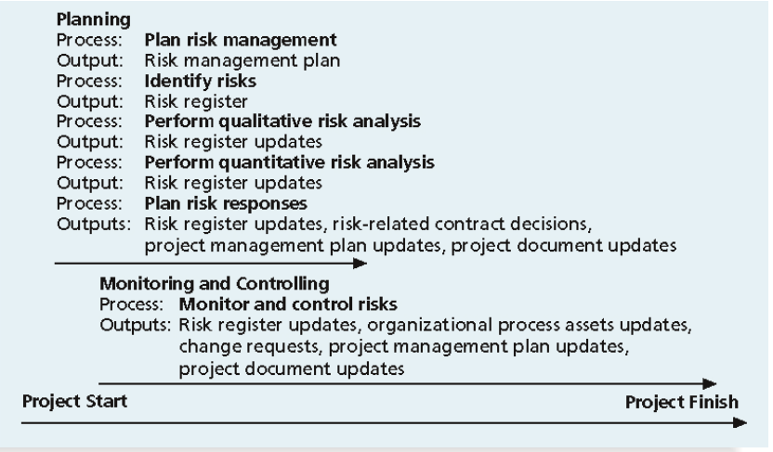
The main output of risk management planning is a risk management plan, a plan that documents the procedures for managing risk throughout a project

Q:what are the major benefits of risk management ?
Unlike crisis management, good project risk management often goes unnoticed
Well-run projects appear to be almost effortless, but a lot of work goes into running a project well
Project managers should strive to make their jobs look easy to reflect the results of well-run projects
Q:what is risk utility or risk tolerance ?
Risk utility or risk tolerance is the amount of satisfaction or pleasure received from a potential payoff
◦ Utility rises at a decreasing rate for people who are riskaverse
◦ Those who are risk-seeking have a higher tolerance for risk, and their satisfaction increases when more payoff is at stake
◦ The risk-neutral approach achieves a balance between risk and payoff
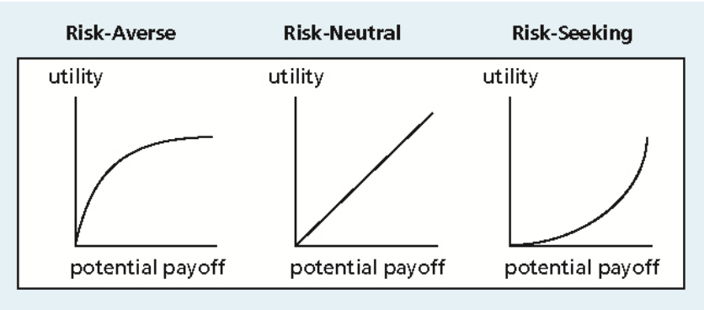
Q:what is Contingency plans and Contingency reserves?

Contingency plans are predefined actions that the project team will take if an identified risk event occurs

Fallback plans are developed for risks that have a high impact on meeting project objectives and are put into effect if attempts to reduce the risk are not effective

Contingency reserves or allowances are provisions held by the project sponsor or organization to reduce the risk of cost or schedule overruns to an acceptable level
Q:what are the common sources of risk , what are major category of risk
Several studies show that IT projects share some common sources of risk The Standish Group developed an IT success potential scoring sheet based on potential risks Other broad categories of risk help identify potential risks
Broad category of risks :
Market risk
Financial risk
Technology risk
People risk
Structure/process risk

Q: what are the four technique of risk
risks is the process of understanding what potential events might hurt or enhance a particular project
Risk identification tools and techniques include:
◦ Brainstorming
◦ The Delphi Technique
◦ Interviewing
◦ SWOT analysis

Brainstorming is a technique by which a group attempts to generate ideas or find a solution for a specific problem by amassing ideas spontaneously and without judgment

The Delphi Technique is used to derive a consensus among a panel of experts who make predictions about future developments
interviewing is a fact-finding technique for collecting information in face-to-face, phone, email, or instant-messaging discussions
SWOT analysis (strengths, weaknesses, opportunities, and threats) can also be used during risk identification Helps identify the broad negative and positive risks that apply to a project

Q what is the risk register and Risk events?
A risk register is:
◦ A document that contains the results of various risk management processes and that is often displayed in a table or spreadsheet format
◦ A tool for documenting potential risk events and related information
Risk events : refer to specific, uncertain events that may occur to the detriment or enhancement of the project
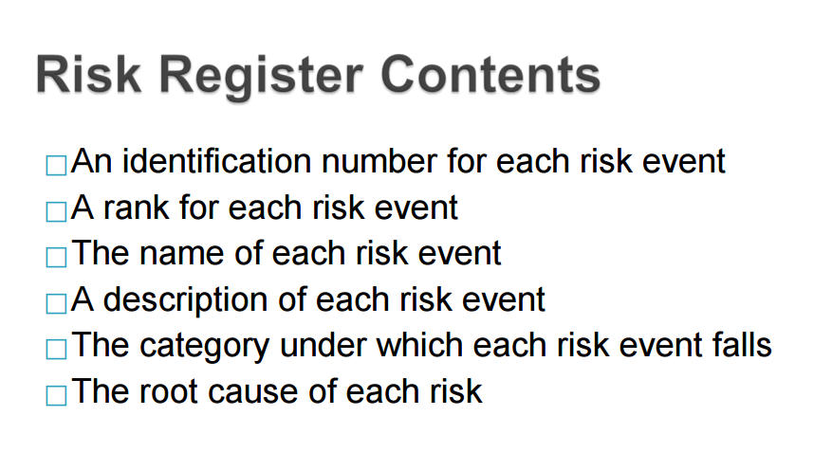
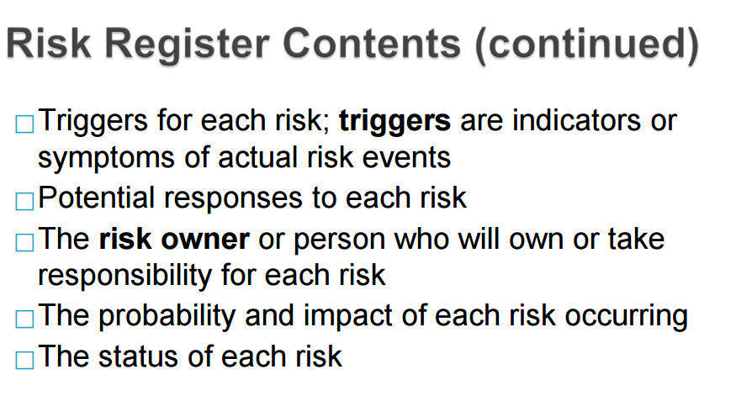

Q:what do we mean by quantitative and qualitative risk analysis and their major methods
Qualitative :Assess the likelihood and impact of identified risks to determine their magnitude and priority
Risk quantification tools and techniques include:
◦ Probability/impact matrixes
◦ The Top Ten Risk Item Tracking
◦ Expert judgment

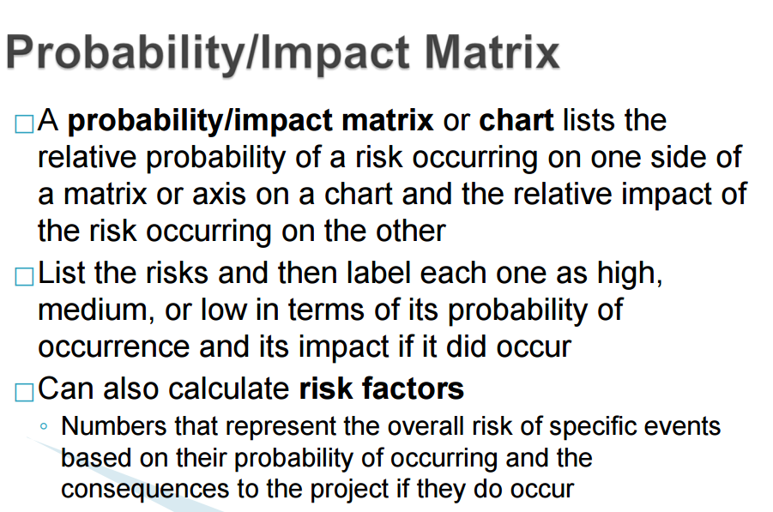
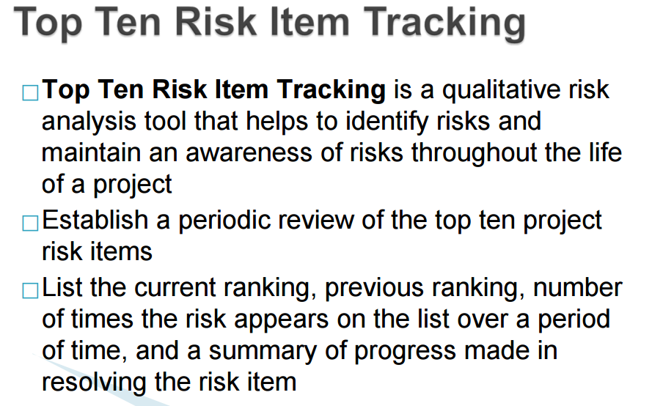

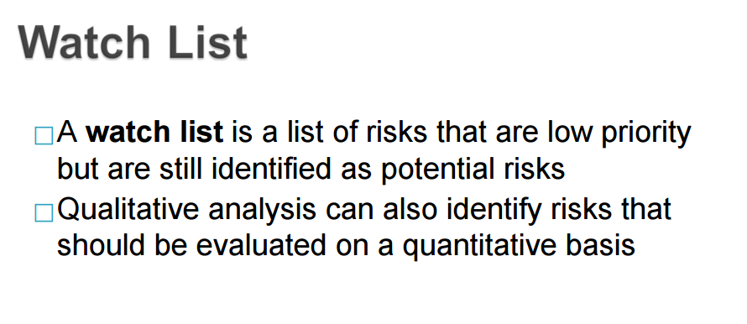
Quantitative Risk analysis:
Main techniques include:
◦ Decision tree analysis
◦ Simulation
◦ Sensitivity analysis
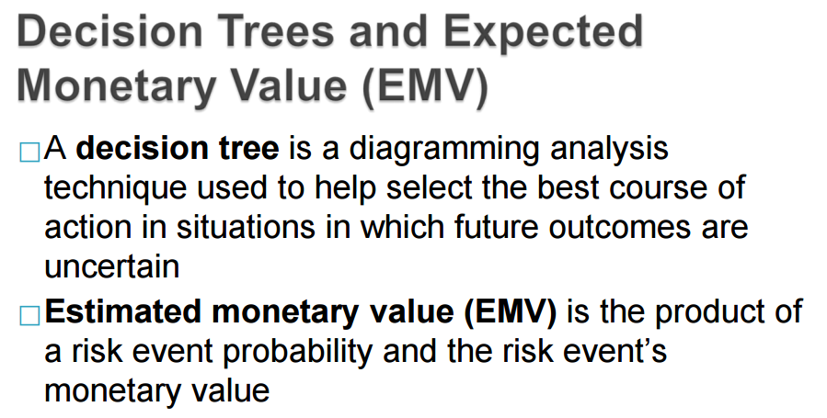
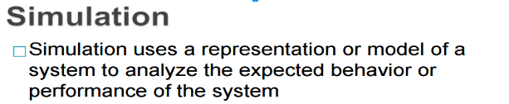
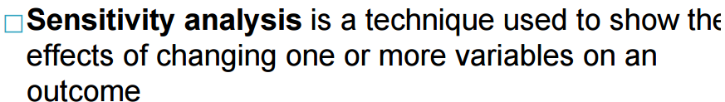
Q:what are the response strategies for the negative risks,response strategies for the positive risks

Four main response strategies for negative risks
- Risk avoidance
- Risk acceptance
- Risk transference
- Risk mitigation
Four response strategies for positive risks
- Risk exploitation
- Risk sharing
- Risk enhancement
- Risk acceptance

Hawraa s130054088@seu.edu.sa
ID#130054088
This is an editable profile Good luck :)

