
part-1
Chapter1 to chapter6

IT-270
s130043581@seu.edu.sa
Mashael AlOtaibi

CHAPTER#1 VERY IMPRTANT
What is the Project management and what is advantages?
Project management is “the application of knowledge, skills, tools and techniques to project activities to meet project requirements”.
advantages
- Better control of financial, physical, and human resources
- Improved customer relations
- Shorter development times
- Lower costs
- Higher quality and increased reliability
- Higher profit margins
- Improved productivity
- Better internal coordination
- Higher worker morale
What is a project? Low probability
Is“a temporary endeavor undertaken to create a unique product, service, or result”
The Triple constraint of project Management
(scope, time, and cost)

9 project Management Knowledge areas
Knowledge areas describe the key competencies that project managers must develop
◦ 4 core knowledge areas lead to specific project objectives
(scope, time, cost, and quality)
◦ 4 facilitating knowledge areas are the means through
which the project objectives are achieved (human resources, communication, risk, and procurement management
◦ 1 knowledge area (project integration management) affects and is affected by all of the other knowledge areas
What helps projects succeed?
1.Executive support
2. User involvement
3. Experienced project manager
4. Clear business objectives
5. Minimized scope
6. Standard software infrastructure
7. Firm basic requirements
8. Formal methodology
9. Reliable estimates
10. Other criteria, such as small milestones, proper planning, competent staff, and ownership

A program is “a group of related projects managed in a coordinated way to obtain benefits and control not available from managing them individually”.

As part of project portfolio and management, organizations group and manage projects programs as a portfolio of investments that contribute to the entire enterprise’s success
_ Portfolio managers help their organizations make wise investment decisions by helping to select and analyze projects from a strategic perspective

Suggested skills for project mangers
Project managers need a wide variety of skills
_ They should:
◦ Be comfortable with change
◦ Understand the organizations they work in and with
◦ Be able to lead teams to accomplish project goals.

Ten most important skills and competencies for project managers
1. People skills
2. Leadership
3. Listening
4. Integrity, ethical behavior, consistent
5. Strong at building trust
6. Verbal communication
7. Strong at building teams
8. Conflict resolution, conflict management
9. Critical thinking, problem solving
10. Understands, balances priorities

CHAPTER #2
Three sphere model for system Management

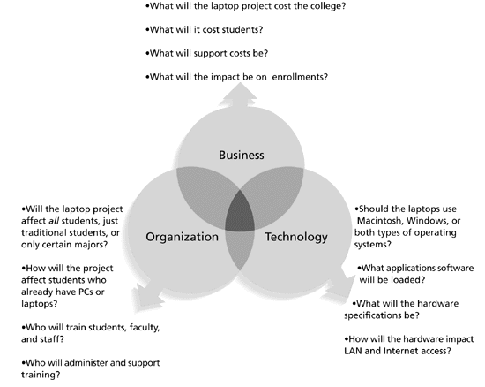
Understanding Organization. IMPORTANT
Structural frame: Focuses on roles and responsibilities, coordination and control. Organization charts help define this frame.
Human resources frame: Focuses on providing harmony between needs of the organization and needs of people.
Political frame: Assumes organizations are coalitions composed of varied individuals and interest groups. Conflict and power are key issues.
Symbolic frame: Focuses on symbols and meanings related to events. Culture is important

Organizational Structures. Low Probability
3 basic organization structures
  - Functional: functional managers report to the CEO
  - Project: program managers report to the CEO
  - Matrix: middle ground between functional and project structures; personnel often report to two or more bosses; structure can be weak, balanced, or strong matrix.

Ten characteristics of organizational culture ( with simple explain).
Member identity*
Group emphasis*
People focus
Unit integration*
*Control
Risk tolerance*
Reward criteria*
Conflict tolerance*
Means-ends orientation
Open-systems focus*
Project life cycle: A collection of project phases, such as concept, development, implementation, and close-out

Products life cycles
The Systems Development Life Cycle (SDLC) is a framework for describing the phases involved in developing and maintaining information systems
Systems development projects can follow
Predictive life cycle: the scope of the project can be clearly articulated and the schedule and cost can be predicted
Adaptive Software Development (ASD) life cycle: requirements cannot be clearly expressed, projects are mission driven and component based, using time-based cycles to meet target dates.

Outsourcing: outsourcing is when an organization acquires goods and/or sources from an outside source;
Offshoring is sometimes used to describe outsourcing from another country
Virtual teams: a virtual team is a group of individuals who work across time and space using communication technologies.

CHAPTER#3
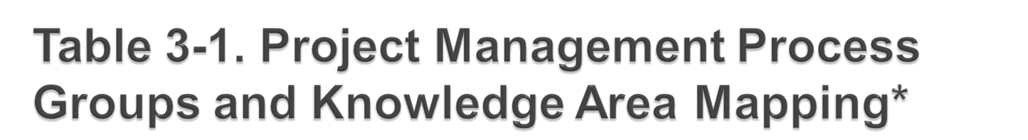
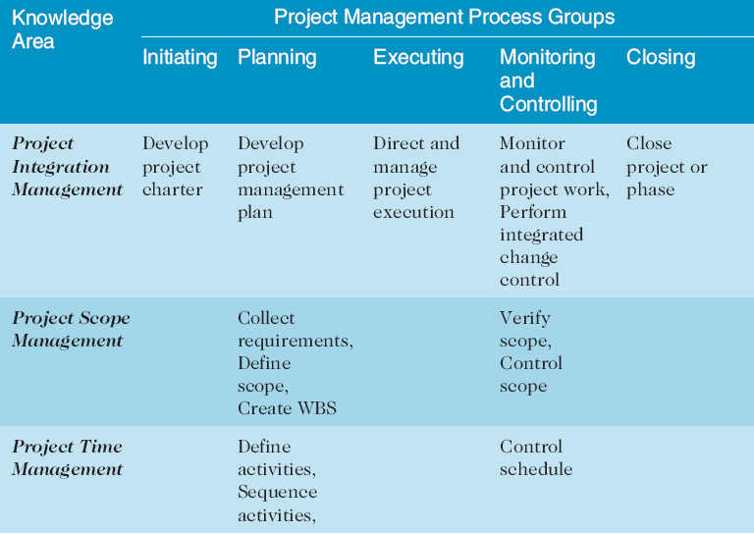
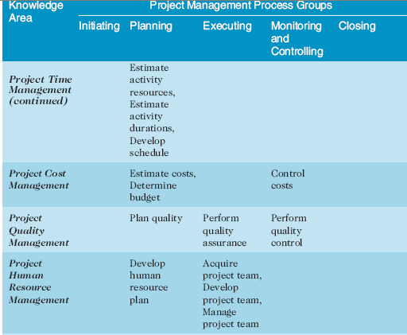
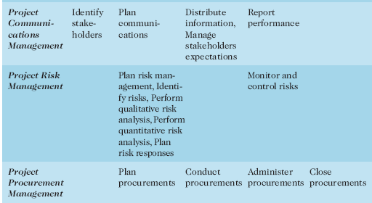
ASK ABOUT give Example of Knowledge area with its projects management process group.
NO NEED to know which process belong to which the knowledge area
Project charters and kick-off meeting

Charters are normally short and include key project information and stakeholder signatures.
It’s good practice to hold a kick-off meeting at the beginning of a project so that stakeholders can meet each other, review the goals of the project, and discuss future plans.

Chapter# 4 & Chapter#5 & Chapter#6 (VERY IMPOTANT)

CHAPTER#4
Project Integration management process
Develop the project charter: working with stakeholders to create the document that formally authorizes a project—the charter
Develop the project management plan: coordinating all planning efforts to create a consistent, coherent document—the project management plan
Direct and manage project execution: carrying out the project management plan by performing the activities included in it.
Monitor and control the project work: overseeing project work to meet the performance objectives of the project
Perform integrated change control: coordinating changes that affect the project’s deliverables and organizational process assets
Close the project or phase: finalizing all project activities to formally close the project or phase.

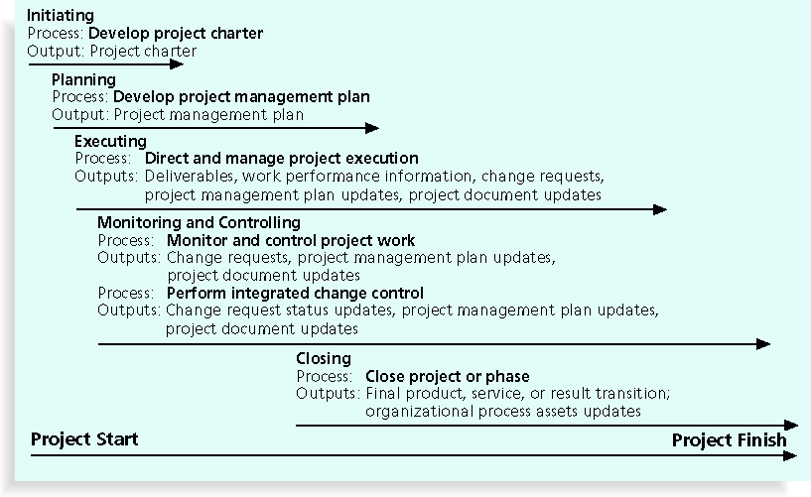
Very important name of process and its output

Strategic planning involves determining long-term objectives, predicting future trends, and projecting the need for new products and services
Organizations often perform a SWOT analysis
Analyzing Strengths, Weaknesses, Opportunities, and Threats
As part of strategic planning, organizations:
- Identify potential projects
- Use realistic methods to select which projects to work on
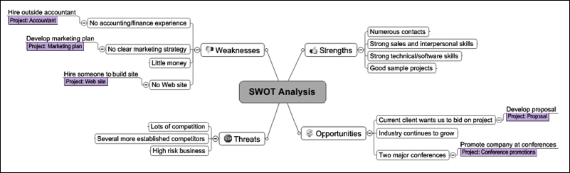
- Formalize project initiation by issuing a project charter

Net present value analysis : in the mid Exam LOW probability
Net present value (NPV) analysis is a method of calculating the expected net monetary gain or loss from a project by discounting all expected future cash inflows and outflows to the present point in time
Projects with a positive NPV should be considered if financial value is a key criterion
The higher the NPV, the better

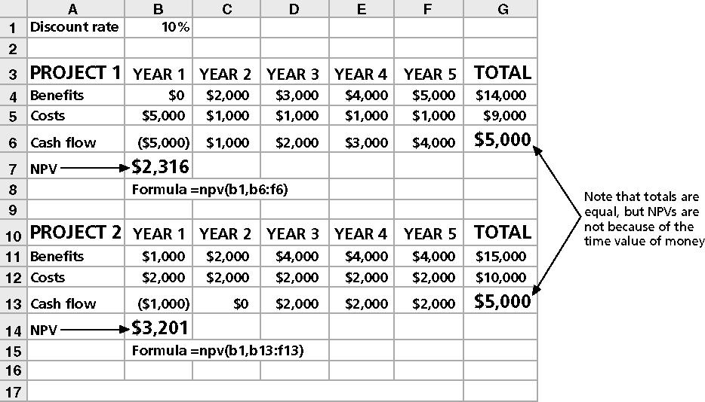
Example:

Weighted Soring Model
A weighted scoring model is a tool that provides a systematic process for selecting projects based on many criteria
- Identify criteria important to the project selection process
- Assign weights (percentages) to each criterion so they add up to 100%
- Assign scores to each criterion for each project
- Multiply the scores by the weights and get the total weighted scores
The higher the weighted score, the better

Project charter: very Important
After deciding what project to work on, it is important to let the rest of the organization know
A project charter is a document that formally recognizes the existence of a project and provides direction on the project’s objectives and management
Key project stakeholders should sign a project charter to acknowledge agreement on the need and intent of the project; a signed charter is a key output of project integration management
Slides from 43 to 48 VERY IMPOTANT
Integrated change control
Three main objectives are:
- Influencing the factors that create changes to ensure that changes are beneficial
- Determining that a change has occurred
- Managing actual changes as they occur

Change control on information technology project
Former view: the project team should strive to do exactly what was planned on time and within budget
Problem: stakeholders rarely agreed up-front on the project scope, and time and cost estimates were inaccurate
Modern view: project management is a process of constant communication and negotiation
Solution: changes are often beneficial, and the project team should plan for them

Change control system
- A formal, documented process that describes when and how official project documents and work may be changed
- Describes who is authorized to make changes and how to make them

Change control board (CCB)
- A formal group of people responsible for approving or rejecting changes on a project
- CCBs provide guidelines for preparing change requests, evaluate change requests, and manage the implementation of approved changes
- Includes stakeholders from the entire organization

Making timely changes
- Some CCBs only meet occasionally, so it may take too long for changes to occur
- Some organizations have policies in place for time-sensitive changes
- 48-hour policy” allows project team members to make decisions; then they have 48 hours to reverse the decision pending senior management approval
- Delegate changes to the lowest level possible, but keep everyone informed of changes

Configuration Management
- Ensures that the descriptions of the project’s products are correct and complete
- Involves identifying and controlling the functional and physical design characteristics of products and their support documentation
- Configuration management specialists identify and document configuration requirements, control changes, record and report changes, and audit the products to verify conformance to requirements

CHAPTER#5

Project scope management processes
Collecting requirements: defining and documenting the features and functions of the products produced during the project as well as the processes used for creating them
Defining scope: reviewing the project charter, requirements documents, and organizational process assets to create a scope statement
Creating the WBS: subdividing the major project deliverables into smaller, more manageable components
Verifying scope: formalizing acceptance of the project deliverables
Controlling scope: controlling changes to project scope throughout the life of the project

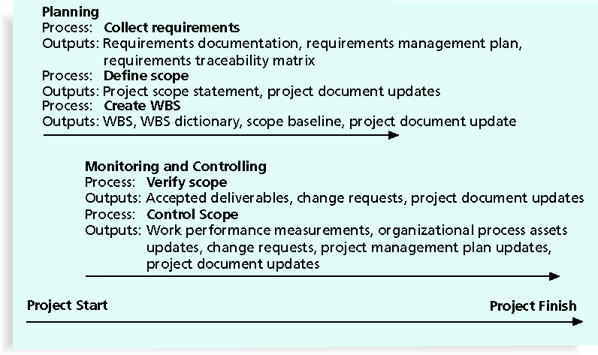
Name of process and its output (Very Imprtant)

Methods of collecting requirement
- Interviewing
- Focus groups and facilitated workshops
- Using group creativity and decision-making techniques
- Questionnaires and surveys
- Observation
- Prototyping
- Software tools

Defining Scope

- Key inputs for preparing the project scope statement include the project charter, requirements documentation, and organizational process assets such as policies and procedures related to scope statements as well as project files and lessons learned from previous, similar projects
- As time progresses, the scope of a project should become more clear and specific

Creating the work breakdown structure (WBS)
- A WBS is a deliverable-oriented grouping of the work involved in a project that defines the total scope of the project
- WBS is a foundation document that provides the basis for planning and managing project schedules, costs, resources, and changes
- Decomposition is subdividing project deliverables into smaller pieces
- A work package is a task at the lowest level of the WBS

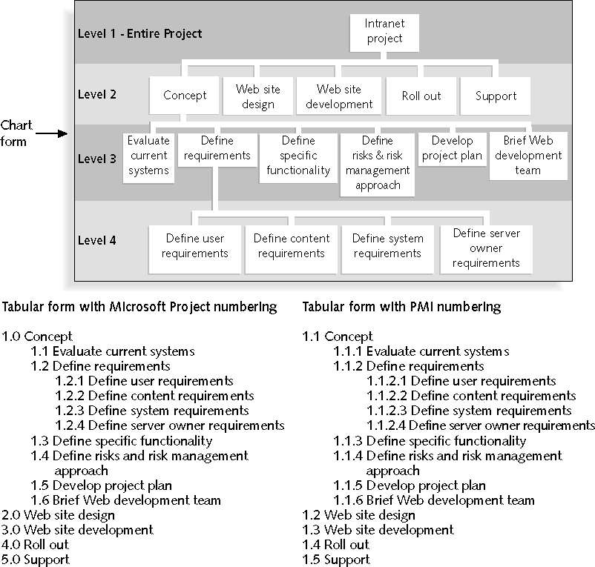
Figure 5-4. Sample Intranet WBS Organized by Phase

Advice for Creating a WBS and WBS Dictionary

- A unit of work should appear at only one place in the WBS
- The work content of a WBS item is the sum of the WBS items below it
- A WBS item is the responsibility of only one individual, even though many people may be working on it
- The WBS must be consistent with the way in which work is actually going to be performed; it should serve the project team first and other purposes only if practical
- Project team members should be involved in developing the WBS to ensure consistency and buy-in
- Each WBS item must be documented in a WBS dictionary to ensure accurate understanding of the scope of work included and not included in that item
- The WBS must be a flexible tool to accommodate inevitable changes while properly maintaining control of the work content in the project according to the scope statement.
Best Practices for Avoiding Scope Problems
1. Keep the scope realistic. Don’t make projects so large that they can’t be completed. Break large projects down into a series of smaller ones.
2. Involve users in project scope management. Assign key users to the project team and give them ownership of requirements definition and scope verification.
3. Use off-the-shelf hardware and software whenever possible. Many IT people enjoy using the latest and greatest technology, but business needs, not technology trends, must take priority.
4. Follow good project management processes. As described in this chapter and others, there are well-defined processes for managing project scope and others aspects of projects.
Suggestions for Improving User Input
- Develop a good project selection process and insist that sponsors are from the user organization
- Have users on the project team in important roles
- Have regular meetings with defined agendas, and have users sign off on key deliverables presented at meetings
- Deliver something to users and sponsors on a regular basis
- Don’t promise to deliver when you know you can’t
- Co-locate users with developers
Suggestions for Reducing Incomplete and Changing Requirements
- Develop and follow a requirements management process
- Use techniques such as prototyping, use case modeling, and JAD to get more user involvement
- Put requirements in writing and keep them current
- Create a requirements management database for documenting and controlling requirements

CHATER#6
Defining activities: identifying the specific activities that the project team members and stakeholders must perform to produce the project deliverables
Sequencing activities: identifying and documenting the relationships between project activities
Estimating activity resources: estimating how many resources a project team should use to perform project activities
Estimating activity durations: estimating the number of work periods that are needed to complete individual activities
Developing the schedule: analyzing activity sequences, activity resource estimates, and activity duration estimates to create the project schedule
Controlling the schedule: controlling and managing changes to the project schedule

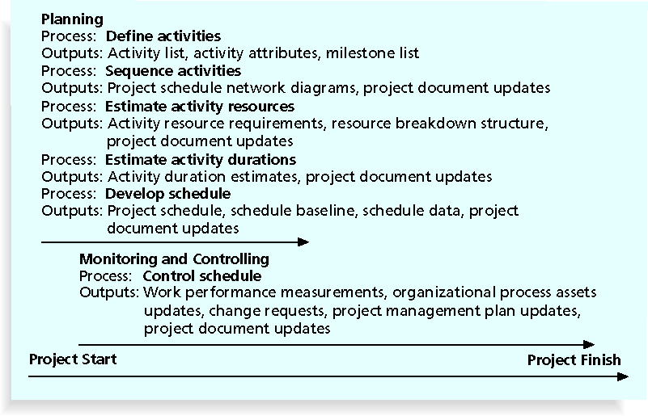
Name of process and its output (Very Imprtant)


An activity or task is an element of work normally found on the work breakdown structure (WBS) that has an expected duration, a cost, and resource requirements
Activity definition involves developing a more detailed WBS and supporting explanations to understand all the work to be done so you can develop realistic cost and duration estimates


A milestone is a significant event that normally has no duration
It often takes several activities and a lot of work to complete a milestone
They’re useful tools for setting schedule goals and monitoring progress
Examples include obtaining customer sign-off on key documents or completion of specific products


- Mandatory dependencies: inherent in the nature of the work being performed on a project, sometimes referred to as hard logic
- Discretionary dependencies: defined by the project team; sometimes referred to as soft logic and should be used with care since they may limit later scheduling options
- External dependencies: involve relationships between project and non-project activities


- Network diagrams are the preferred technique for showing activity sequencing
- A network diagram is a schematic display of the logical relationships among, or sequencing of, project activities
- Two main formats are the arrow and precedence diagramming methods

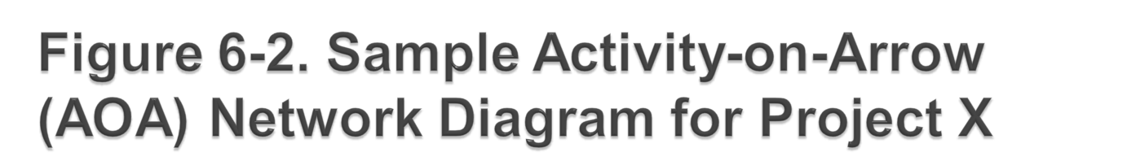
Very Important
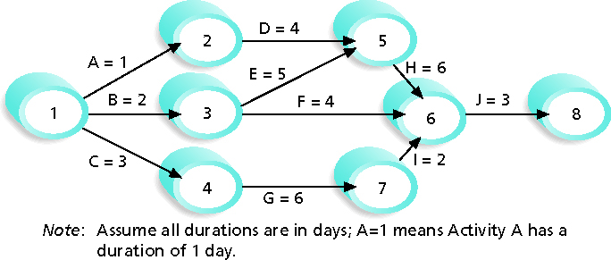



Also called activity-on-arrow (AOA) network diagrams
Activities are represented by arrows
Nodes or circles are the starting and ending points of activities
Can only show finish-to-start dependencies
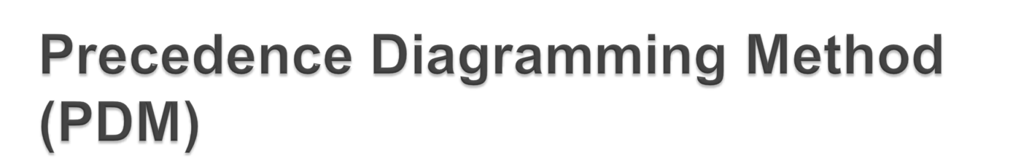
- Activities are represented by boxes
- Arrows show relationships between activities
- More popular than ADM method and used by project management software
- Better at showing different types of dependencies

ملاحظة: يجب معرفة النوعين جيدا. في حالة لم يحدد اي ميثود في السؤال الحل حسب الطريقه المناسبة لك


- Instead of providing activity estimates as a discrete number, such as four weeks, it’s often helpful to create a three-point estimate
- An estimate that includes an optimistic, most likely, and pessimistic estimate, such as three weeks for the optimistic, four weeks for the most likely, and five weeks for the pessimistic estimate
- Three-point estimates are needed for PERT and Monte Carlo simulations

- Gantt charts provide a standard format for displaying project schedule information by listing project activities and their corresponding start and finish dates in a calendar format
- Symbols include:
- Black diamonds: milestones
- Thick black bars: summary tasks
- Lighter horizontal bars: durations of tasks
- Arrows: dependencies between tasks

- CPM is a network diagramming technique used to predict total project duration
- A critical path for a project is the series of activities that determines the earliest time by which the project can be completed
- The critical path is the longest path through the network diagram and has the least amount of slack or float
- Slack or float is the amount of time an activity may be delayed without delaying a succeeding activity or the project finish date ( important)

 (Important)

- First develop a good network diagram
- Add the duration estimates for all activities on each path through the network diagram
- The longest path is the critical path
- If one or more of the activities on the critical path takes longer than planned, the whole project schedule will slip unless the project manager takes corrective action

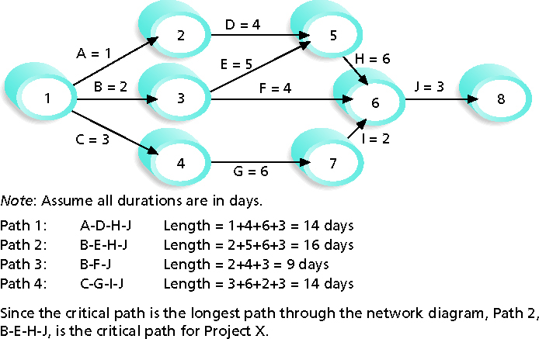

- A buffer is additional time to complete a task
- Murphy’s Law states that if something can go wrong, it will Important
- Parkinson’s Law states that work expands to fill the time allowed Important
- In traditional estimates, people often add a buffer to each task and use it if it’s needed or not
- Critical chain scheduling removes buffers from individual tasks and instead creates:
- Project buffers or additional time added before the project’s due date
- Feeding buffers or additional time added before tasks on the critical path

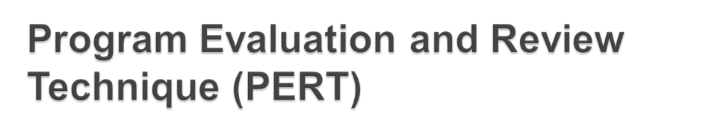

- PERT is a network analysis technique used to estimate project duration when there is a high degree of uncertainty about the individual activity duration estimates
- PERT uses probabilistic time estimates
- Duration estimates based on using optimistic, most likely, and pessimistic estimates of activity durations, or a three-point estimate

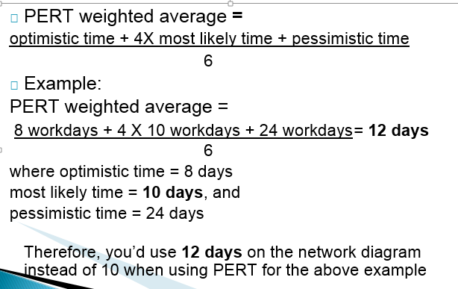

رابط المراجعه
https://www.youtube.com/watch?v=eerC1AxL1gc&spfreload=10
دعواتكم
قـــــــــــــــــــــــــــــــــــــابل للتعـــــــــــــــــــــــــــــــــــــــــــــــــــديل
للملاحظات S 130043581@seu.edu.sa
مشاعل العتيبي

