
Mona Saad
S130077951

Answer for Q1:-
This output for q1 is syntax error
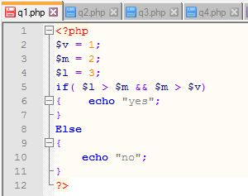
I have another answer for this question when edit like this
The output will be yes

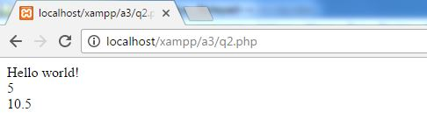
Answer for Q2:-

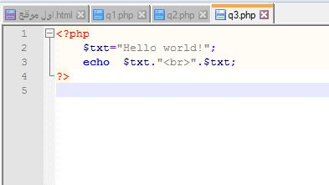

Answer for Q3:-

Answer for Q4:-

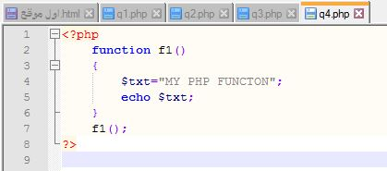

Answer for Q5:-
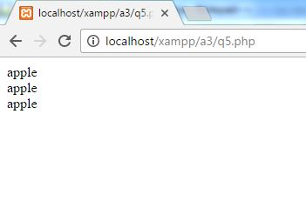

Answer for Q6:-
COOKIE
A cookie is commonly used to determine a user. A cookie could be a small file that the server embeds on the user's computer. Every time identical computer requests a page with a browser, it'll send the cookie too. With PHP, you'll be able to each produce and retrieve cookie values.
SESSION
Session values square measure store in server facet not in user’s machine. A session is offered as long because the browser is opened. User couldn’t be disabled the session. we might store not solely strings however also objects in session.
There are some differences between them
session data is store on server and the identifier to locate particular user session whereas the cookies store the data on visitor browser also use only store strings whereas session Storing objects that useful to my experience. We might be save cookie for future reference, however session couldn’t. Once users shut their browser, they additionally lost the session.
Set cookie
Example
setcookie("StudentID", "2");
Creates a cookie named " StudentID " with the value “2”
Retrieve cookie
Example
Retrieve the value of the cookie Use the global variable $_COOKIE
echo $_COOKIE["StudentID "];

Answer for Q7:-
Creating connection with MySQL


