
Mona Saad
S130077951
Answer for Q1:-
alert () :-
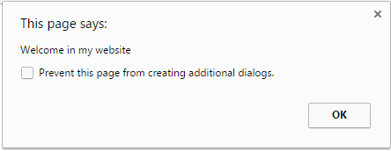
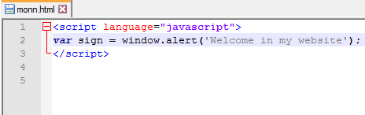
This function displays the message on the net page for the users. During this case the users would like nothing to do except click to close to that. (Example)
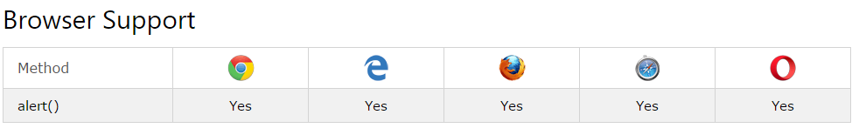
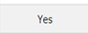


prompt() :
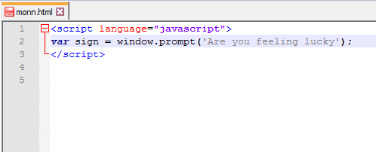
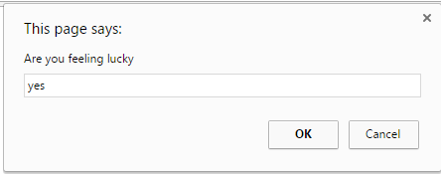
This function displays the message for the users however during this the users also can input data within the input box. (Example)

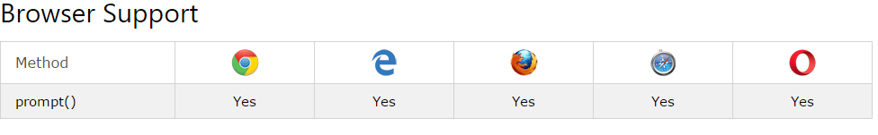
The Limitations alert and prompt dialog boxes are modal windows; they stop the user from accessing the remainder of the program's interface till the dialog box is closed.
Also alert onclick is that the only event that every one major screen readers recognizes and handle properly different events need testing for compatibility with screen readers and value we enter into the text box portion of the prompt box are going to be displayed in JavaScript Alert box and if we tend to enter nothing into text box or immediately click on the cancel button we are going to receive inadequate results.
Answer for Q2:-
Variables declared among a JavaScript function, become local to the function. Local variables they will only be accessed among the function. Since local variables are only recognized within their functions, variables with a similar name will be utilized in completely different functions. Local variables are created once a function starts, and deleted once the function is completed.
A variable declared outside a operate, becomes global. A global variable has global scope: All scripts and functions on an internet page will access it. Also global variables exist from the start of execution of a program till the program terminates, whereas a local variable exists solely from the time the operate declaring the variable is termed till the operate returns. If a operate is termed multiple times, new copies of its local variables are created on every occasion the function is called.
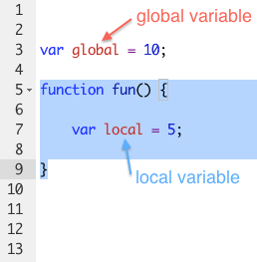

Answer for Q3:-
An event is an event of one thing doubtless fascinating to a script.
The JavaScript applications perform actions as a response to events.
An HTML intrinsic event attribute is used to specify a script to be referred to as once an event happens.
Events are ordinarily used in combination with functions, and also operate won't be executed before the event happens.
When JavaScript is used in html pages, JavaScript will "react" on these events.
An event handler is wont to handle, and verify, user input, user actions, and browser actions.

There are many varieties of events. (Example)

DOM events that are initiated by DOM-elements for example, a click event happens once a part is clicked, a mouse
There are many varieties of events.
DOM events that are initiated by DOM-elements for example, a click event happens once a part is clicked, a mouseover - once a mouse pointer comes over a part,
Window events for example, size - once a browser window is resized,
Other events, like load, ready state change.
DOM events connect JavaScript code with the document, providing the means that for building dynamical interfaces. over - once a mouse pointer comes over a part,
Window events for example, size - once a browser window is resized,
Other events like load, ready state change.
DOM events connect JavaScript code with the document, providing the means that for building dynamical interfaces.
onfocus The element has simply received the keyboard focus (this attribute pertains only to sure elements, as well as a, label, input, select, textarea, and button).
onblur The element has simply lost the keyboard focus (attribute pertains only to identical elements as onfocus). (Example)

