

COLLEGE OF COMPUTING AND INFORMATICS
Assignment – 4
Course Title : Web Technologies Course Code: IT230
Note:
- Submission Deadline: 31/12/2016 at 23:59
- 4 Marks
- Copied assignment will be graded zero mark.

Q1. Which of the following is a "well formed" XML document: [1.0 Mark]
- <firstElement>some text goes here
<secondElement>another text goes here</secondElement>
</firstElement>
No
- <firstElement>some text goes here</firstElement>
<secondElement> another text goes here</secondElement>
No
- <?xml version="1.0"?>
<to>Sam</to>
<from>John</from>
<heading>Reminder</heading>
<body>Please save my mobile number !</body>
No
- <?xml version="1.0"?>
<note>
<to>Sam</to>
<from>John</from>
<heading>Reminder</heading>
<body>Save my Mobile Number!</body>
</note>
Yes

Q2: Using XML, Design your class schedule for this semester. Each class has: Title, Start time, End time and Instructor. [1.0 Mark]
Answer: (varies with each student)
<?xml version=”1.0”?>
<class_schedule>
<class>
<title>IT230</title>
<start_time>15:00</start_time>
<end_time>15:50</end_time>
<instructor>XXXXX</instructor>
</class>
<class>
<title>IT270</title>
<start_time>16:00</start_time>
<end_time>16:50</end_time>
<instructor>XXXXX</instructor>
</class>
</class_schedule>

Q3. Given the XHTML page “Main.html”, Write the corresponding JSP page that displays congratulation message if grade > 60 and sorry message if grade < 60 and error message of grade > 100 as the following: [1.0 Mark]
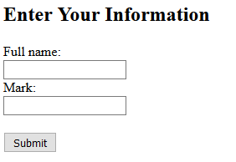
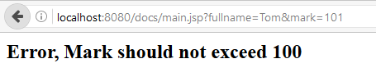
Figure 1 Main.html
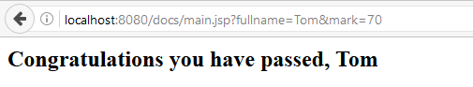
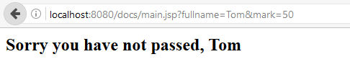
Figure 2 Main.jsp
Main.html
<!DOCTYPE html>
<html>
<body>
<h2>Enter Your Information</h2>
<form action="main.jsp">
Full name:<br>
<input type="text" name="fullname">
<br>
Mark:<br>
<input type="text" name="mark">
<br><br>
<input type="submit" value="Submit">
</form>
</body>
</html>
Main.jsp
<html
xmlns="http://www.w3.org/1999/xhtml"
xmlns:jsp="http://java.sun.com/JSP/Page"
xmlns:c="http://java.sun.com/jsp/jstl/core">
<jsp:directive.page contentType="text/html"/>
<head>
<title>main.jsp</title>
</head>
<body>
<%
int mark = Integer.parseInt(request.getParameter("mark"));
String fullname = request.getParameter("fullname");
if (mark > 100) {
%>
<h2>Error, Mark should not exceed 100 <lh2>
<%
}
else if (mark >= 60) {
%>
<h2>Congratulations you have passed, <%= fullname %></h2>
<%
}
Q4. Write a simple servlet that displays the input of the following form: [1.0 Mark]
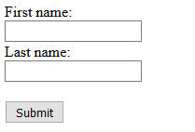
Figure 3 HTML form

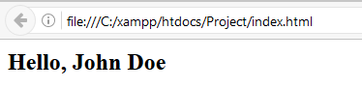
Figure 4 Servlet output

public class HelloWorld extends HttpServlet {
public void doPost(HttpServletRequest request,HttpServletResponse response)
throws ServletException, IOException {
String firstName = request.getParameter(“first”);
String lastName = request.getParameter(“last”);
response.setContentType(“text/html; charset=\”UTF-8\””);
PrintWriter out = response.getWriter();
out.println("<!DOCTYPE html \n" +
" PUBLIC \"-//W3C//DTD XHTML 1.0 Strict//EN\" \n" +
" \"http://www.w3.org/TR/xhtml1/DTD/xhtml1-strict.dtd\"> \n" +
"<html xmlns='http://www.w3.org/1999/xhtml'> \n" +
" <head> \n" +
" <title> \n" +
" Hello.java \n" +
" </title> \n" +
" </head> \n" +
" <body> \n" +
" <h2>" +
" Hello, " + firstName + " " + lastName +
" </h2> </body> \n" +
"</html> ");
out.close();
}
}

