Assignment NO. 1 week1-week4

Stat101
- True or False:
- True
- True
- False
- False
- True
- True

- Multiple Choice Questions:
- D
- D
- C
- C
- A
- D

Essay Questions:
1 | 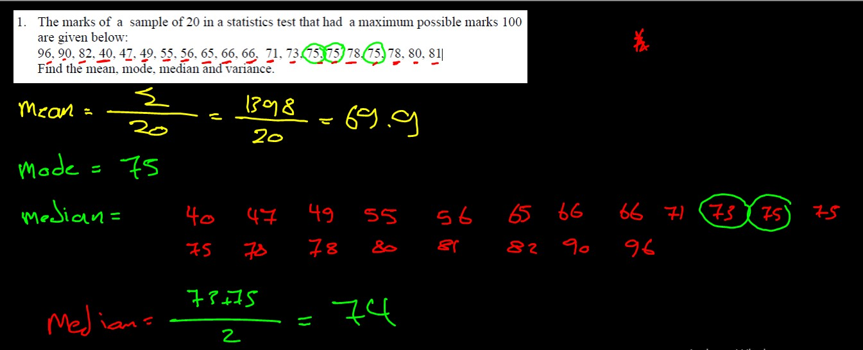  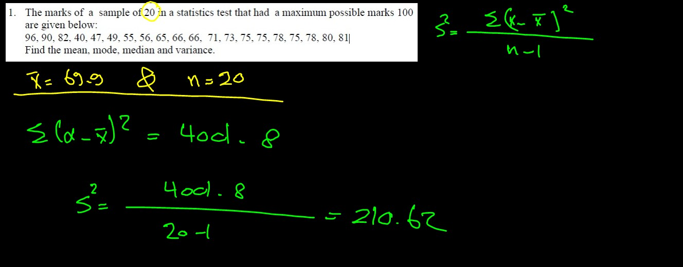
2 | 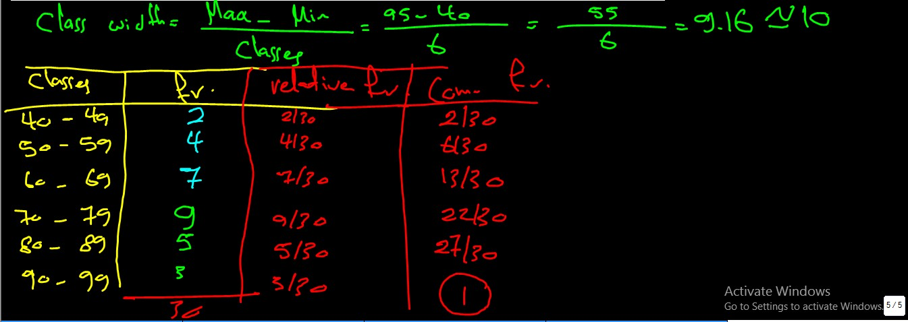
3 | 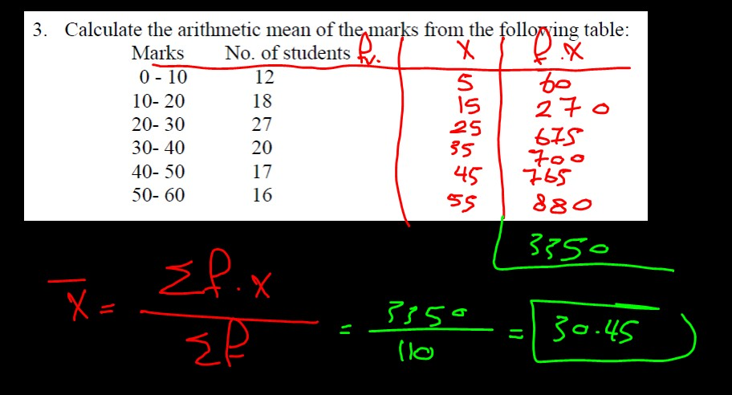
4 | 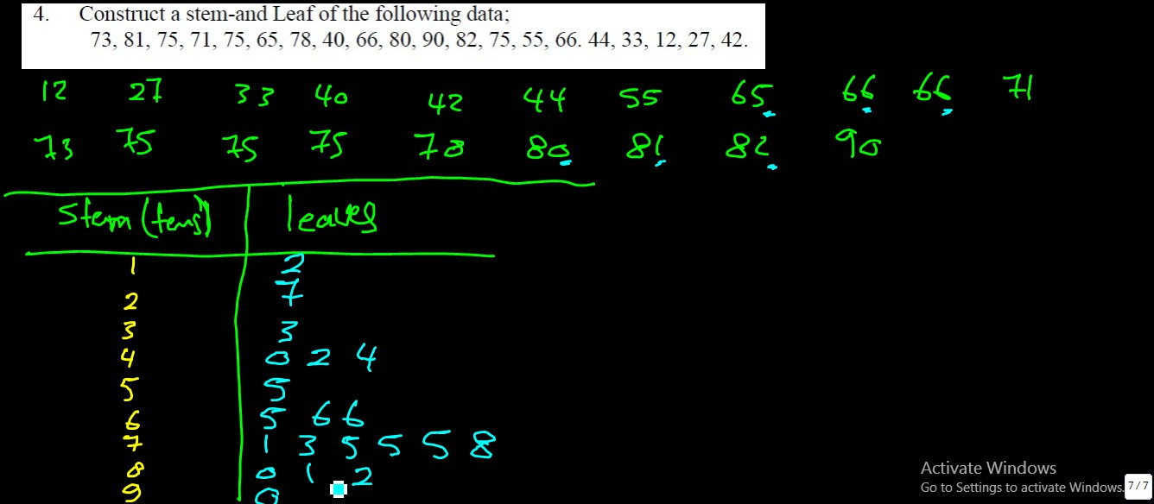
5 | 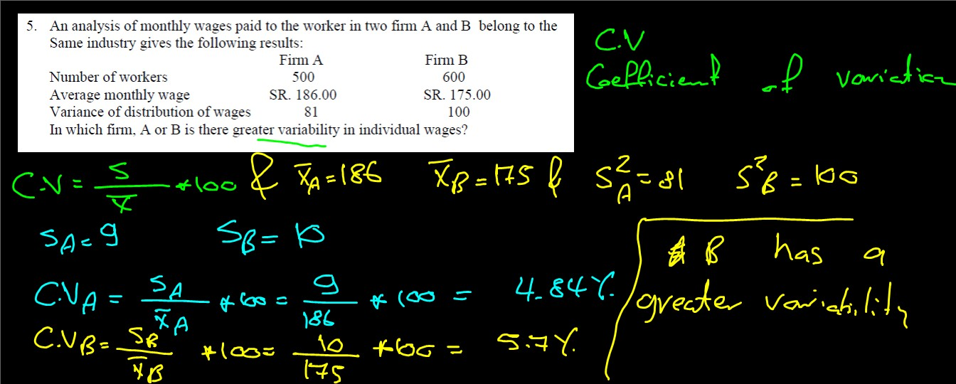
6 | 