Chapter Nine
Human Resource Management: Getting the Right People for Managerial Success

Major Questions You Should Be Able to Answer
9.1 How do effective managers view the role of people in their organization’s success?
9.2 To avoid exposure to legal liabilities, what areas of the law do I need to be aware of?
9.3 How can I reduce mistakes in hiring and find great people who might work for me?
9.4 Once people are hired, what’s the best way to see that they do what they’re supposed to do?
9.5 How can I assess employees’ performance more accurately and give more effective feedback?
9.6 What are the various forms of compensation?
9.7 What are some guidelines for handling promotions, transfers, disciplining, and dismissals?
9.8 What are the principal processes and issues involved in organizing labor unions?

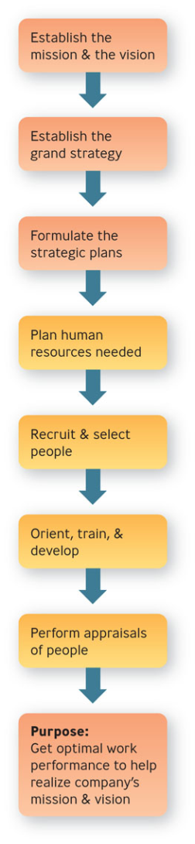
Strategic Human Resource Management

- Human Resource Management
  - consists of the activities managers perform to plan for, attract, develop, and retain an effective workforce

Planning the Human Resources Needed

- Strategic human resource planning
  - consists of developing a systematic, comprehensive strategy for understanding current employee needs and predicting future employee needs

Understanding Current Employee Needs

- Job analysis
  - determining the basic elements of a job by observation and analysis

- Job description
  - summarizes what the holder of a job does and why they do it

- Job specification
  - describes the minimum qualifications a person must have to perform a job successfully

Question?
Joe, a human resources specialist for Jersey Office Supplies Co., rides along with the furniture delivery people to observe the problems they were encountering and what activities they were required to perform. Joe was performing a:
- Personality test
- Performance appraisal
- BARS
- Job analysis

Predicting Future Employee Needs
- Human resource inventory
  - report listing your organization’s employees by name, education, training, languages, and other important information

Labor Relations

- National Labor Relations Board
  - enforces procedures whereby employees may vote for a union and collective bargaining
- Collective bargaining
  - negotiations between management and employees about disputes over compensation, benefits, working conditions, and job security
Compensation & Benefits
- Fair Labor Standards Act of 1938
  - established minimum living standards for workers engaged in interstate commerce, including provision of a federal minimum wage
Equal Employment Opportunity

- Equal Employment Opportunity Commission
  - job is to enforce antidiscrimination and other employment related laws

- Discrimination
  - occurs when people are hired or promoted - or denied hiring or promotion - for reasons not relevant to the job

- Affirmative action
  - focuses on achieving equality of opportunity within an organization including establishment of minority hiring goals

- Sexual harassment
  - consists of unwanted sexual attention that creates an adverse work environment

- Quid pro quo – tangible economic injury
- Hostile environment – offensive work environment

Workplace Discrimination

- Adverse impact
  - occurs when an organization uses an employment practice or procedure that results in unfavorable outcomes to a protected class

- Disparate treatment
  - results when employees from protected groups are intentionally treated differently.

Question?
Stan is constantly telling off-color jokes and using profanity in front of his administrative assistant. This could be considered a _____________.
- Difficult atmosphere
- Hostile work environment
- Intimidating surroundings
- This for that

Recruitment

- Recruitment
  - process of locating and attracting qualified applicants for jobs open in the organization

  - internal, external
    - Internal recruiting means making people already employed by the organization aware of job openings
    - External recruiting means attracting job applicants from outside the organization
- Realistic job preview

  - gives a candidate a picture of both the positive and negative features of the job and the organization before he is hired

  - people tend to quit less frequently and be more satisfied

Question?
Melanie scheduled a special interview with Gina before Gina was hired, in which Melanie painted a picture of both the positive and negative features of the job. Mel was performing a:
- Structured interview
- Unstructured interview
- Performance appraisal
- Realistic job preview

Selection
- Selection process
  - screening of job applicants to hire the best candidate
  - application forms, résumés, reference checks
- Unstructured interview
  - no fixed set of questions and no systematic scoring procedure
  - involves asking probing questions to find out what the applicant is like
- Structured interview
  - involves asking each applicant the same questions and comparing their responses to a standardized set of answers
  - Situational – focuses on hypothetical situations
  - Behavioral – explore what applicants have actually done in the past
- Employment tests
  - legally considered to consist of any procedure used in the employment selection decision process
  - ability, performance, personality
  - reliability, validity

Example: Finish Line
- At Finish Line, store managers use the results of web-based personality tests developed by Unicru to screen applicants
- Applicants are scored as green, yellow, or red

Orientation, Training, & Development
- Orientation
  - helping the newcomer fit smoothly into the job and the organization
  - designed to give employees the information they need to be successful

Following orientation, the employee should emerge with information about:
- The job routine
- The organization’s mission and operations
- The organization’s work rules and employee benefits

Five Steps in the Training Process

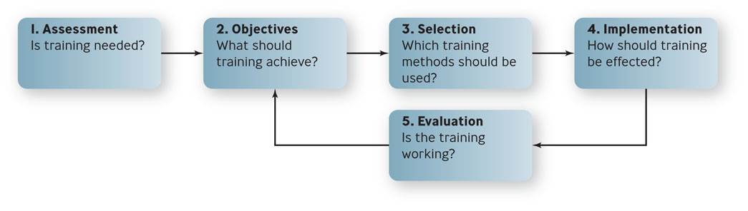
Orientation, Training, & Development
- Training
  - educating technical and operational employees in how to better do their current jobs
- Development
  - educating professionals and managers in the skills they need to do their jobs in the future

Question?
Artie is designing a training class that is aimed at improving teamwork among people on task forces. What method should he choose?
- Lectures
- Role plays
- Workbooks
- Videotapes

Example: E-Learning
- Millions of people are taking short-term, practical courses related to their careers
- Advantages
  - No transportation is needed
  - You can follow a flexible schedule
  - You can work at your own pace

Performance Appraisal
- Performance management
  - the continuous cycle of improving job performance through goal setting, feedback and coaching, and rewards and positive reinforcement
- Performance appraisal
  - consists of assessing an employer’s performance and providing him with feedback
- Objective appraisal
  - based on fact and often numerical
  - measure results
  - harder to challenge legally
  - also called results appraisal

Question?
Luann is conducting a performance appraisal on Bill. The form her company uses asks her to list the objectives that she and Bill agreed to last year, and indicate how well he met each objective. Luann's company is using a(n) ________ system of performance appraisal.
- Objective
- BARS
- Trait
- Informal

Performance Appraisal
- Subjective appraisal
  - based on a manager’s perceptions of an employees traits and behaviors
  - BARS - rates employee gradations in performance according to scales of specific behaviors

Who Should Make Performance Appraisals?
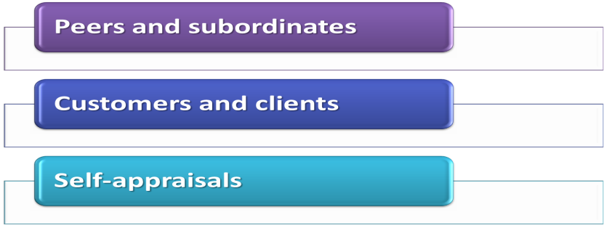

Performance Appraisal
- Forced ranking
  - all employees within a business unit are ranked against one another and grades are distributed
along some sort of bell curve

Effective Performance Appraisal
- Formal appraisal
  - conducted at specific times throughout the year and based on performance measures that have been established in advance
- Informal appraisal
  - conducted on an unscheduled basis and consists of less rigorous indications of employee performance

Compensation & Benefits
- Compensation
  - wages or salaries, incentives, and benefits
- Base pay
  - basic wage or salary paid employees in exchange for doing their jobs

Managing Promotions, Transfers, Disciplining, & Dismissals
- Promotion – moving upward
- Transfer – moving sideways
- Disciplining & Demotion – the threat of moving downward
- Dismissal – moving out of the organization

Labor-Management Issues
- Labor unions
  - organizations of employees formed to protect and advance their members’ interests by bargaining with management over job-related issues

Union Security
- Union security clause
  - the part of the labor-management agreement that states that employees who receive union benefits must join the union, or at least pay dues to it

Workplace Labor Agreements

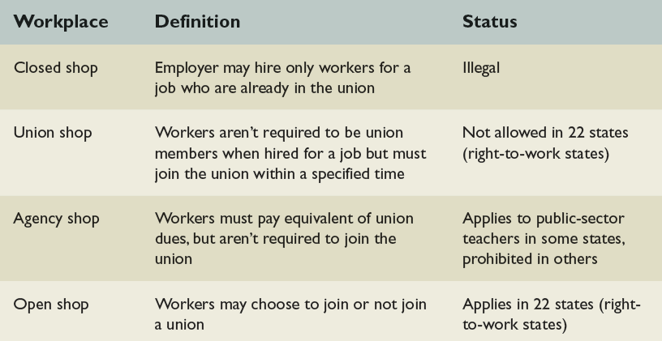

Compensation
- Two-tier wage contracts
  - new employees are paid less or receive lesser benefits than veteran employees have
- Cost-of-living adjustment (COLA)
  - clause during the period of the contract ties future wage increases to increases in the cost of living
- Givebacks
  - the union agrees to give up previous wage or benefit gains in return for something else

Settling Labor-Management Disputes
- Grievance
  - a complaint by an employee that management has violated the terms of the labor-management agreement
- Mediation
  - process in which a neutral third party, a mediator, listens to both sides in a dispute, makes suggestions, and encourages them to agree on a solution.
- Arbitration
  - process in which a neutral third party, an arbitrator, listens to both parties in a dispute and makes a decision that the parties have agreed will be binding on them

