Managing Individual Differences & Behavior: Supervising People as People

Personality & Individual Behavior
- Personality
  - the stable psychological traits and behavioral attributes that give a person his or her identity

The Big Five Personality Dimensions

- Extroversion
  - how outgoing, talkative, sociable, and assertive a person is
- Agreeableness
  - how trusting, good-natured, cooperative, and soft-hearted one is
- Conscientiousness
  - how dependable, responsible, achievement-oriented, and persistent one is
- Emotional stability
  - how relaxed, secure, and unworried one is
- Openness to experience
  - how intellectual, imaginative, curious, and broad-minded one is

Question?
Susan loves going to parties, where she talks to everyone there. Susan is probably high in:
- Emotional stability
- Conscientiousness
- Extroversion
- Agreeableness

Do Personality Tests Work for the Workplace?

- Extroversion has been associated with success for managers and salespeople
- Conscientiousness has been found to have the strongest positive correlation with job performance and training performance

Cautions About Using Personality Testing in the Workplace

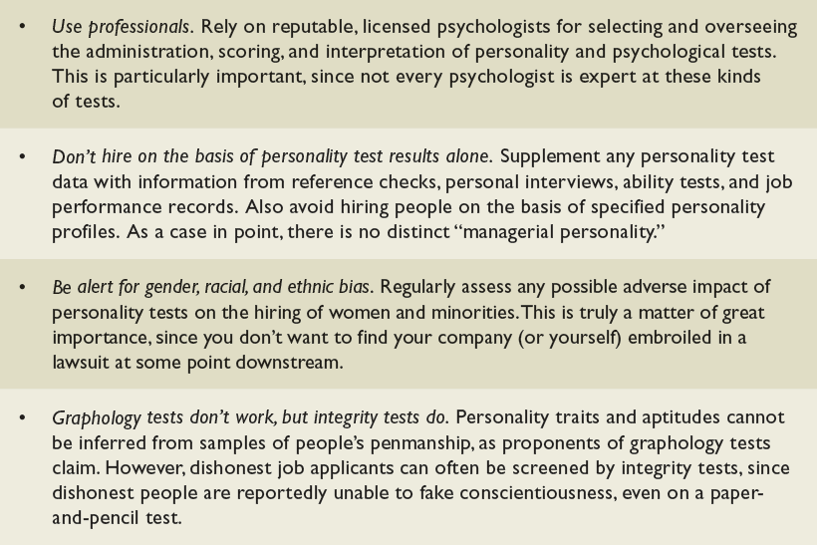

Proactive Personality

- Proactive personality
  - someone who is more apt to take initiative and persevere to influence the environment

Five Traits Important in Organizations

- Locus of control
  - indicates how much people believe they control their fate through their own efforts
  - internal, external
- Expect different degrees of structure and compliance for each type
- Employ different reward systems for each type

- Self-efficacy
  - belief in one’s ability to do a task
  - learned helplessness // Learned helplessness, the debilitating lack of faith in one’s ability to control one’s environment

- Self-esteem
  - the extent to which people like or dislike themselves, their overall self-evaluation

- Self-monitoring
  - the extent to which people are able to observe their own behavior and adapt it to external situations
- Emotional intelligence
  - ability to cope, empathize with others, and be self-motivated

Some Ways That Managers Can Boost Employee Self-Esteem

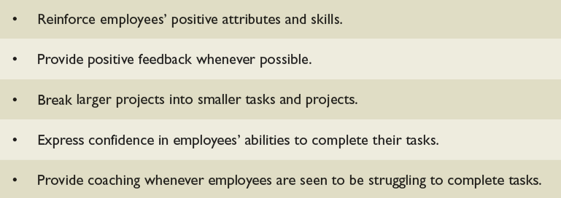

The Traits of Emotional Intelligence

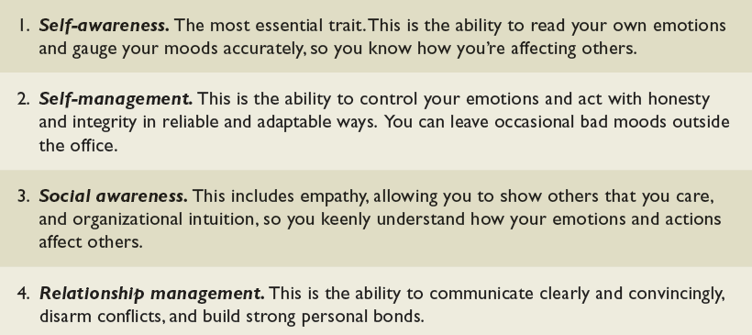

Organizational Behavior
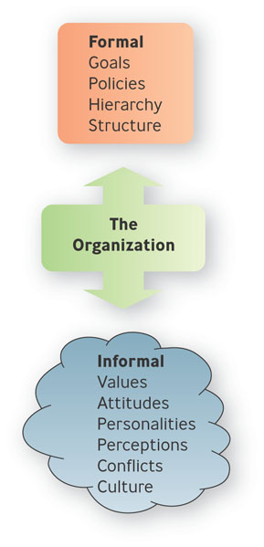
- Organizational Behavior
  - tries to help managers not only explain workplace behavior but also to predict it, so that they can better lead and motivate
their employees to perform
productively
  - individual, group behavior

Values and Attitudes

- Values
  - abstract ideals that guide one’s thinking and behavior across all situations

- Attitude
  - a learned predisposition toward a given object

Three Components of Attitudes

- Affective
  - consists of feelings or emotions one has about a situation
- Cognitive
  - beliefs and knowledge one has about a situation
- Behavioral
  - refers to how one intends or expects to behave toward a situation
Question?

The statement, “I am never going to eat at this restaurant again,” reflects the ___________ component of an attitude.
- Behavioral
- Decisional
- Cognitive
- Affective

Attitudes
- Cognitive dissonance
  - the psychological discomfort a person experiences between his or her cognitive attitude and incompatible behavior
  - Importance, control, rewards

Ways to Reduce Cognitive Dissonance

- Change attitude or behavior
- Belittle importance of the inconsistent behavior
- Find consonant elements that outweigh dissonant ones

Example: Thinking Beyond Profit to Create Value for Society

- IBM celebrated its 100th anniversary in June 2011 by offering a global service day, with 300,000 IBM employees signing up to perform 2.6 million hours of service to the world
- In West Africa Procter & Gamble set up Pampers mobile clinics

Perception
- Perception
  - process of interpreting and understanding one’s environment

The Four Steps in the Perceptual Process

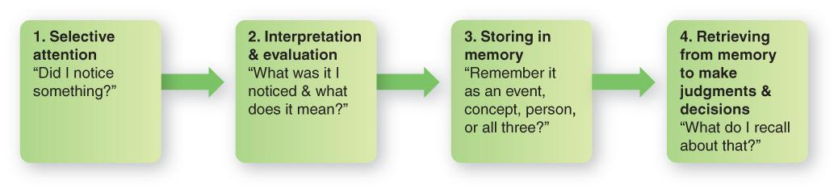

Distortions in Perception

- Stereotyping
  - tendency to attribute to an individual the characteristics one believes are typical of the group to which that individual belongs
  - sex-role, age, race/ethnicity
- Halo effect
  - forming an impression of an individual based on a single trait
Question?

John is interviewing Bambi for a job opening at his accounting firm. He notices that she has several tattoos visible on both arms. He does not believe that people with tattoos can be good accountants. John is engaged in ____________.
- Counseling
- Stereotyping
- Behavioral interviewing
- Situational interviewing

Distortions in Perception

- Recency effect
  - Tendency to remember recent information better than earlier information
- Causal attributions
  - activity of inferring causes for observed behaviors
  - fundamental, self-serving bias

- Two tendencies that distort an individual’s interpretation of behavior are fundamental attribution bias (occurs when people attribute another person’s behavior to his or her personal characteristics rather than situational factors) and self-serving bias (occurs when people take more personal responsibility for success than for failure)

Example: Are Attractive Men & Women Paid More than Ordinary People

- Being good looking seems to be strongly associated with self-confidence
- Employers showed higher estimates for beautiful people’s productivity
- Good-looking people are good communicators

Self-Fulfilling Prophecy

- Self-Fulfilling prophecy
  - the phenomenon in which people’s expectations of themselves or others lead them to behave in ways that make those expectations come true
  - also called the Pygmalion effect
Work-Related Attitudes

- Employee engagement
  - an individual’s involvement, satisfaction, and enthusiasm for work
- Job satisfaction
  - extent to which you feel positively or negatively about various aspects of your work
  - Job involvement
  - extent to which you identify or are personally involved with your job

- Organizational commitment
  - reflects the extent to which an employee identifies with an organization and is committed to its goals
  - Strong positive relationship between organizational commitment and job satisfaction
Important Workplace Behaviors

- Performance and productivity
- Absenteeism and turnover
- Organizational citizenship behaviors
- Counterproductive work behaviors

- Organizational citizenship behaviors are those employee behaviors that are not directly part of employees’ job descriptions—that exceed their work-role requirements.
- Counterproductive work behaviors (CWB), types of behavior that harm employees and the organization as a whole

Question?
Herman spends his lunch hour drinking beer in his car in the parking lot. This is an example of a(n) _____________.
- Evaluating behavior
- Discerning behavior
- Counterproductive work behavior
- Destructive work behavior

The New Diversified Workforce

- Diversity
  - represents all the ways people are unlike and alike—the differences and similarities in age, gender, race, religion, ethnicity, sexual orientation, capabilities, and socioeconomic background

The Diversity Wheel
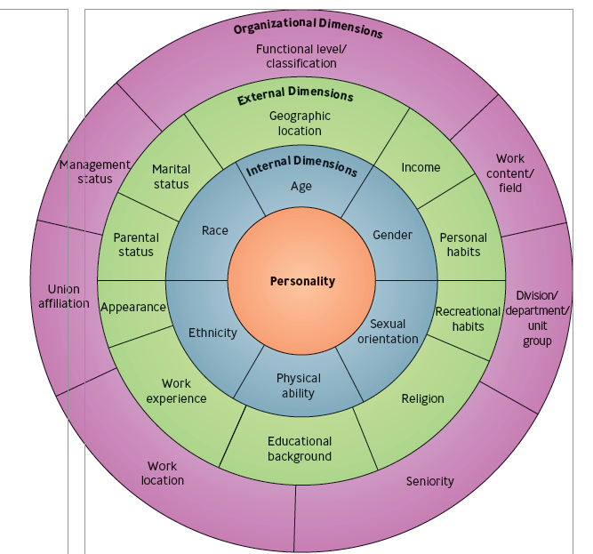
The Diversity Wheel

- Internal dimensions
  - those human differences that exert a powerful, sustained effect throughout every stage of our lives
  - gender, age, ethnicity, race, sexual orientation, physical abilities

- External dimensions
  - consist of the personal characteristics that people acquire, discard, or modify throughout their lives
  - educational background, marital status, parental status, religion, income, geographic location, work experience, recreational habits, appearance, personal habits.

Trends in Workforce Diversity

- Age: More Older People in the Workforce
- Gender: More Women Working
- Race & Ethnicity: More People of Color in the Workforce
- Sexual Orientation: Gays & Lesbians Become More Visible
- People with Differing Physical & Mental Abilities
- Educational Levels: Mismatches Between Education & Workforce Needs

Barriers to Diversity
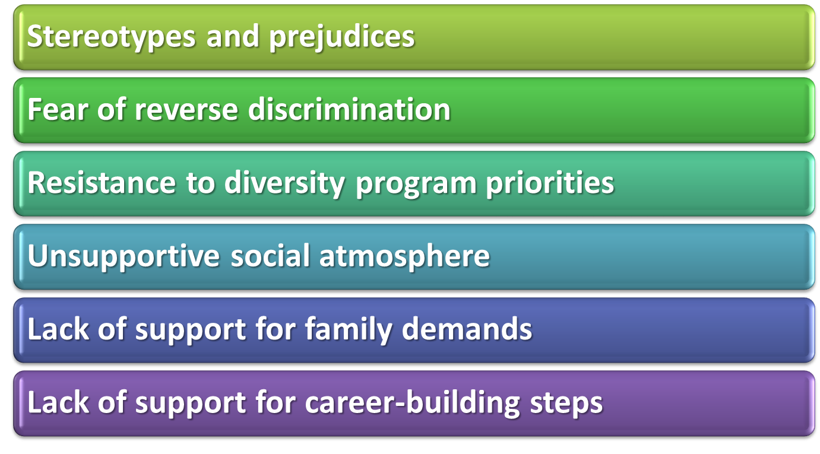
- Ethnocentrism is the belief that one’s native country, culture, language, abilities, or behavior is superior to those of another culture.
What is Stress?
- Stress
  - the tension people feel when they are facing or enduring extraordinary demands, constraints, or opportunities and are uncertain about their ability to handle them effectively

Sources of Job-Related Stress

- Demands created by individual differences,
- Individual task demands
- Individual role demands
- Group demands,
- Organizational demands
- Nonwork demands.

Question?
Your boss expects you to stay late to cover the workload of a coworker who is out sick, but you are supposed to help your mother with some work on her house tonight. You are suffering from:
- Role overload
- Role conflict
- Role ambiguity
- Burnout

Symptom of Stress
- Physiological
  - backaches, headaches, sweaty palms, nausea
- Psychological
  - boredom, irritability, nervousness, anger, anxiety, depression
- Behavioral
  - sleeplessness, changes in eating habits, increased smoking/alcohol/drug abuse

Consequences of Stress
- Burnout
  - state of emotional, mental, and even physical exhaustion

Reducing Stressors in Organizations

- Roll out employee assistance programs
- Recommend a holistic wellness approach
- Create a supportive environment
- Make jobs interesting
- Make career counseling available

