Organizational Change & Innovation: Lifelong Challenges for the Exceptional Manager

Ways to Deal With Change and Innovation
- Allow room for failure
- Give one consistent explanation for the change
- Look for opportunities in unconventional ways
- Have the courage to follow your ideas
- Allow grieving, then move on
Collins’s Five Stages of Decline
Stage 1 Hubris Born of Success
Stage 2 Undisciplined Pursuit of More
Stage 3 Denial of Risk and Peril
Stage 4 Grasping for Salvation
Stage 5 Capitulation to Irrelevance or Death

Fundamental Change: What Will You Be Called Upon to Deal With?
- The marketplace is becoming more segmented & moving toward more niche products
- There are more competitors offering targeted products, requiring faster speed-to-market
- Some traditional companies may not survive radically innovative change
- China, India, & other offshore suppliers are changing the way we work
- Knowledge, not information, is becoming the new competitive advantage

Two Types of Change

- Reactive change
  - making changes in response to problems or opportunities as they arise

- Proactive change
  - involves making carefully thought-out changes in anticipation of possible or expected problems or opportunities
  - also called planned change

Forces For Change Outside and Inside the Organization
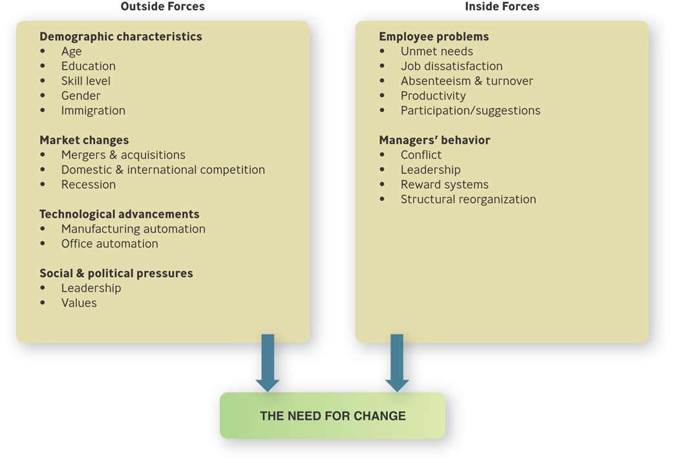
The Forces for Change: Outside the Organization
- Demographic characteristics
- Market changes
- Technological advancement
- Shareholder & customer demands
- Supplier practices
- Social & political pressures

Question?
Tony, the owner of Cirodi Pasta restaurant on Cape Cod is open during the “high season” from May until October. He has always hired college students on summer vacation. In recent years, the number of workers who quit mid-summer has risen significantly. When he asks, they say they are quitting because they “have enough money” or “want the time off”. This is probably an example of a(n) ________ change.
- Market
- Social or political
- Economic
- Technological

Forces Originating Inside the Organization:
- Employee problems
- Managers’ behavior

Areas in Which Change is Often Needed:
- Changing people
  - Perceptions, attitudes, performance, skills
- Changing technology
- Changing structure
- Changing strategy

Changing Technology
- Technology
  - any machine or process that enables an organization to gain a competitive advantage in changing materials used to produce a finished product
  - not just computer technology

A Model of Resistance to Change
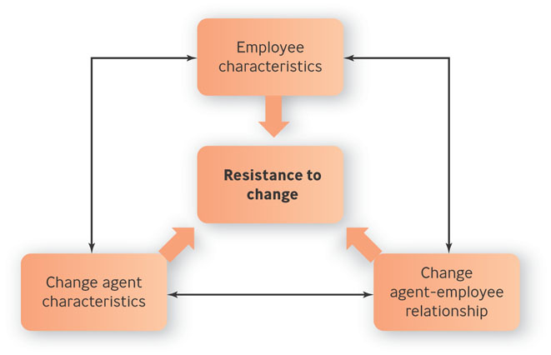
The Causes of Resistance to Change
- Resistance to change
  - an emotional/behavioral response to real or imagined threats to an established work routine.

The Degree to Which Employees Fear Change

- Least threatening: Adaptive change
  - Reintroduction of a familiar practice
- Somewhat threatening: Innovative change
  - Introduction of a practice that is new to the organization

- Very threatening: Radically innovative change
  - Involves introducing a practice that is new to the industry

Question?
At the Big Peaches Department Store, employees generally know that during annual inventory, they are required to work overnight shifts. This is an example of a(n) __________ change.
- Adaptive
- Reactive
- Innovative
- Proactive

Reasons Employees Resist Change

- Individual’s predisposition toward change
- Surprise and fear of the unknown
- Climate of mistrust
- Fear of failure
- Loss of status or job security
- Peer pressure
- Disruption of cultural traditions or group relationships
- Personality conflicts
- Lack of tact or poor timing
- Non-reinforcing reward system

Lewin’s Change Model

- Unfreezing
  - creating the motivation to change
- Changing
  - learning new ways of doing things
- Refreezing
  - making the new ways normal

Steps to Leading Organizational Change:
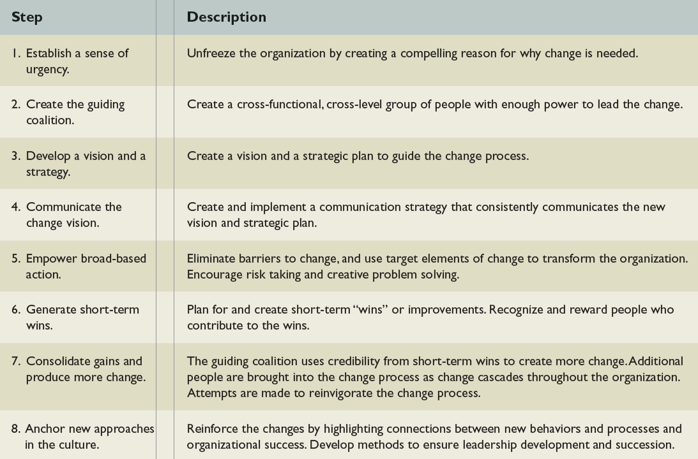
Organization Development

- Organization development (OD)
  - set of techniques for implementing planned change to make people and organizations more effective

- Change agent
  - a consultant with a background in behavioral sciences who can be a catalyst in helping organizations deal with old problems in new ways

What Can OD Be Used For?

- Managing conflict
- Revitalizing organizations
- Adapting to mergers

The OD Process
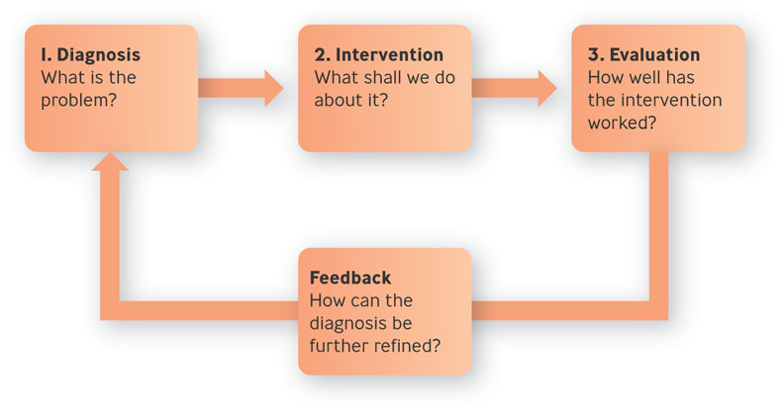

How OD Works:

- Diagnosis: What is the problem?
- Intervention: What shall we do about it?
  - Intervention – attempt to correct the diagnosed problem
- Evaluation: How well has the intervention worked?

Question?
Fred, an OD consultant, is designing a survey of employee attitudes to be given to workers at the Lemon Automobile Company. Fred is in the _________ stage of OD.
- Intervention
- Diagnosis
- Evaluation
- Process consultation

Example: Patagonia Tries to Become Greener

- Patagonia has long been a supporter of the environmental movement
- Company wondered how “green” the origins and handling of if products were
- Transportation took little energy, but manufacturing sometimes produced ecologically unfriendly by-products
- Patagonia did not want to sacrifice quality for environmental reasons

The Effectiveness of OD

- Multiple interventions
- Management support
- Goals geared to both short and long term results
- OD is affected by culture

Two Myths about Innovation:

- Myth No. 1: Innovation happens in a “Eureka!” moment
- Myth No. 2: Innovation can be systematized

Seeds of Innovation
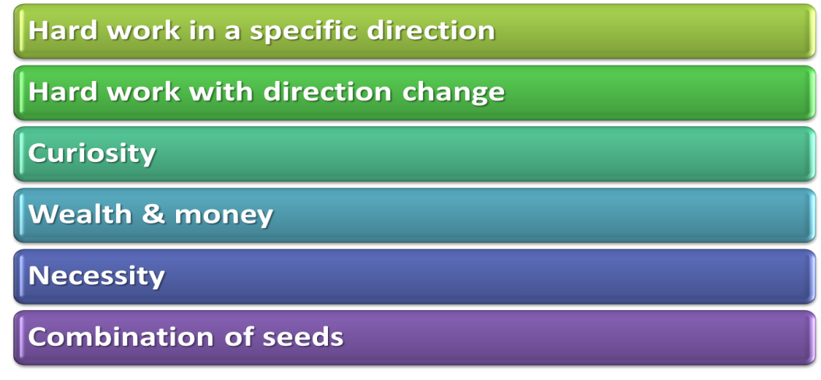

Types of Innovation

- Product innovation
  - change in the appearance or performance of a product or the creation of a new one

- Process innovation
  - change in the way a product is conceived, manufactured, or disseminated

- Incremental innovation
  - creation of products, services, or technologies that modify existing ones

- Radical innovation
  - creation of products, services, or technologies that replace existing ones
Question?
Wendy's created display screens at its drive-thru windows that show customers their orders and prices. This is an example of a(n) _________ innovation.
- Product
- Process
- Adaptive
- Reactive

Celebrating Failure: Factors Encouraging Innovation:

- Organizations can make innovation happen by providing 1) the right organizational culture, 2) the appropriate resources, and 3) the correct reward system

- Culture: Is innovation viewed as a benefit or a boondoggle?
- Resources: Do managers put money where their mouths are?
- Rewards: Is experimentation reinforced in ways that matter?

Four Steps For Fostering Innovation:
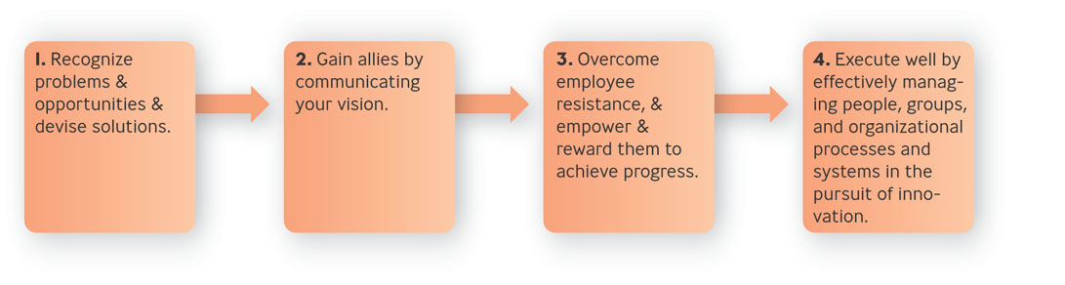

Gain Allies by Communicating Your Vision:

- Showing how the product or service will be made
- Showing how potential customers will be reached
- Demonstrating how you’ll beat your competitors
- Explaining when the innovation will take place

