Chapter Eight
Organizational Culture, Structure, & Design: Building Blocks of the Organization
Major Questions You Should Be Able to Answer
8.1 How do I find out about an organization’s “social glue,” its normal way of doing business?
8.2 What can be done to an organization’s culture to increase its economic performance?
8.3 How are for-profit, nonprofit, and mutual-benefit organizations structured?
8.4 When I join an organization, what seven elements should I look for?
8.5 How would one describe the three types of organizational design?
8.6 What factors affect the design of an organization’s structure?

What Is an Organizational Culture?
- Organizational culture
  - system of shared beliefs and values that develops within an organization and guides the behavior of its members
  - Also called corporate culture

Culture Plus Structure
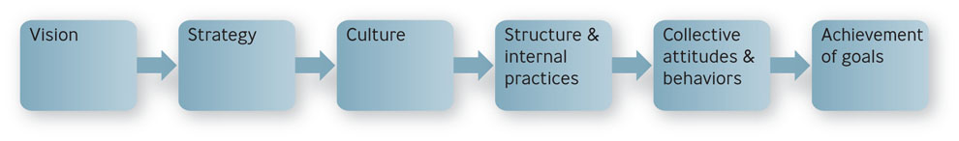
Competing Values Framework
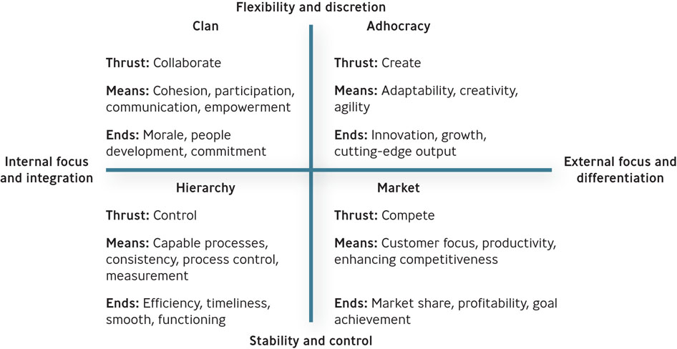

Four Types of Organizational Culture:
- Clan culture
  - Internal focused
  - values flexibility rather than stability
  - encourages collaboration among employees
- Adhocracy culture
  - attempts to create innovative products by being adaptable, creative, and quick to respond to changes in the marketplace
- Market culture
  - focused on the external environment
  - driven by competition and a strong desire to deliver results
- Hierarchy culture
  - apt to have a formalized structured work environment aimed at achieving effectiveness through a variety of control mechanisms
The Three Levels of Organizational Culture
Level 1: Observable artifacts
  - physical manifestations such as manner of dress, awards, myths and stories about the company
  - visible behavior exhibited by managers and employees
Level 2: Espoused Values
- Espoused values
  - explicitly stated values and norms preferred by an organization
- Enacted values
  - represent the values and norms actually exhibited in the organization
Level 3: Basic Assumptions
  - represent the core values of the organization’s culture
  - those taken for granted and highly resistant to change
How Employees Learn Culture
- Symbol
  - an object, act, quality, or event that conveys meaning to others
- Story
  - narrative based on true events, which is repeated – and sometimes embellished upon – to emphasize a particular value
- Hero
  - person whose accomplishments embody the values of the organization
- Rites and rituals
  - activities and ceremonies, planned an unplanned, that celebrate important occasions and accomplishments in the organization’s life
Question?
In the Mary Kay Cosmetics Co., the best salespeople receive pink Cadillacs in special awards ceremonies. This is an example of a:
- Symbol
- Value
- Rite or ritual
- Both A and C

Four Functions of Organizational Culture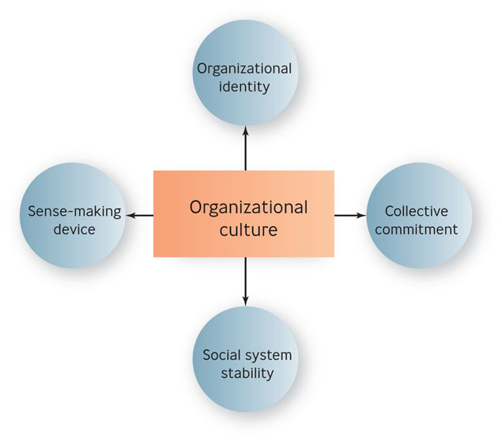
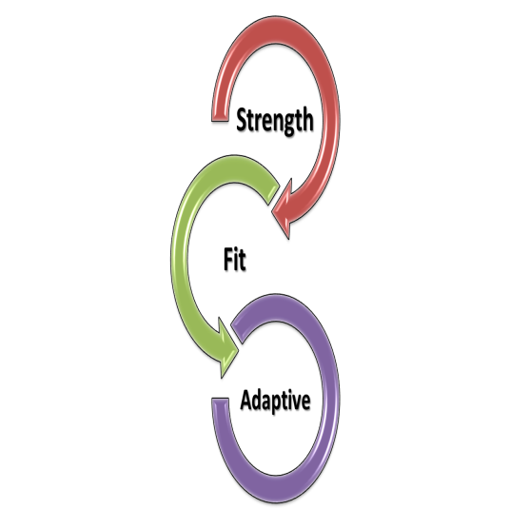
Cultures For Enhancing Economic Performance: Three Perspectives
- The strength perspective assumes that the strength of a corporate culture is related to a firm’s long-term financial performance.
- The fit perspective assumes that an organization’s culture must align with its business or strategic context
- The adaptive perspective assumes that the most effective cultures help organizations anticipate and adapt to environmental changes

The Process of Cultural Change
- Formal statements
- Slogans & sayings
- Stories, legends, & myths
- Leader reaction to crises
- Role modeling, training, & coaching
- Physical design
- Rewards, titles, promotions, & bonuses
- Organizational goals & performance criteria
- Measurable & controllable activities
- Organizational structure
- Organizational systems & procedures

Organizational Structure
- Organization
  - a system of consciously coordinated activities or forces of two or more people
  - For-profit, nonprofit,
mutual-benefit
Question?
The United Way, a charitable organization, is considered a ______ organization.
- For-profit
- Nonprofit
- Mutual-benefit
- May be any one of the above

The Organization Chart
- Organization Chart
  - box-and-lines illustration showing the formal lines of authority and the organization’s official positions or work specializations

Organization Chart
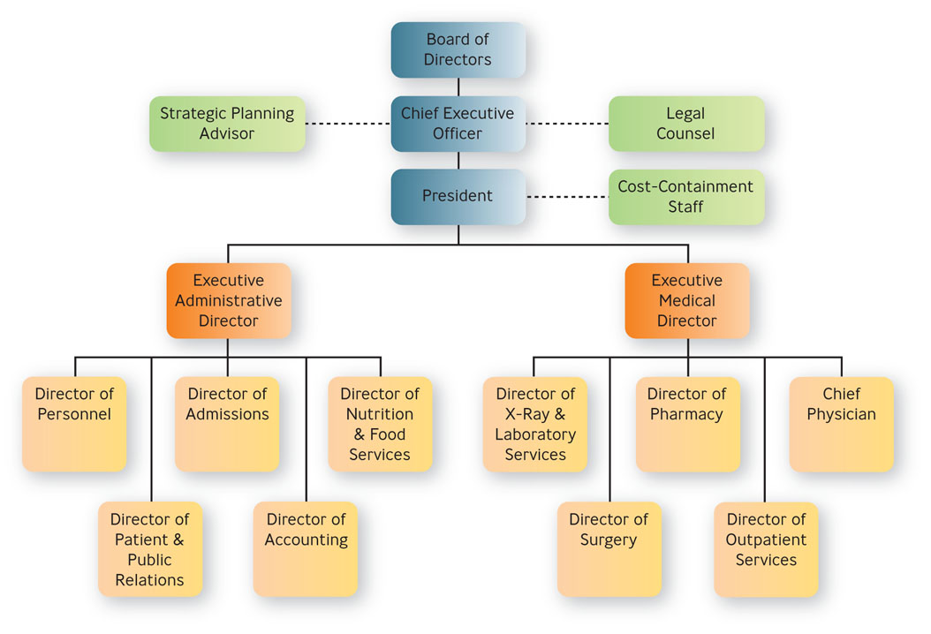

Common Elements of Organizations

- Common purpose - unifies employees or members and gives everyone an understanding of the organization’s reason for being
- Coordinated effort – the coordination of individual effort into group wide effort
- Division of labor – arrangement of having discrete parts of a task done by different people
- Hierarchy of authority - control mechanism for making sure the right people do the right things at the right time
  - Unity of command
- Span of control - refers to the number of people reporting directly to a given manager
  - Narrow, wide
- Authority, responsibility, & delegation
  - Authority – rights inherent in a managerial position to make decisions and utilize resources
  - Accountability – managers must report and justify work results to the managers above them
- Authority, responsibility, & delegation (cont.)
  - Responsibility – obligation you have to perform the tasks assigned to you
  - Delegation – process of assigning managerial authority and responsibility to managers and employees lower in the hierarchy
- Centralization versus decentralization of authority
  - Centralized authority – important decisions are made by higher-level managers
  - Decentralized authority – important decisions are made by middle-level and supervisory-level managers
  - Line managers have the authority to make decisions and usually have people reporting to them
  - Staff personnel have authority functions; they provide advice, recommendations, and research to the line managers

Line and Staff
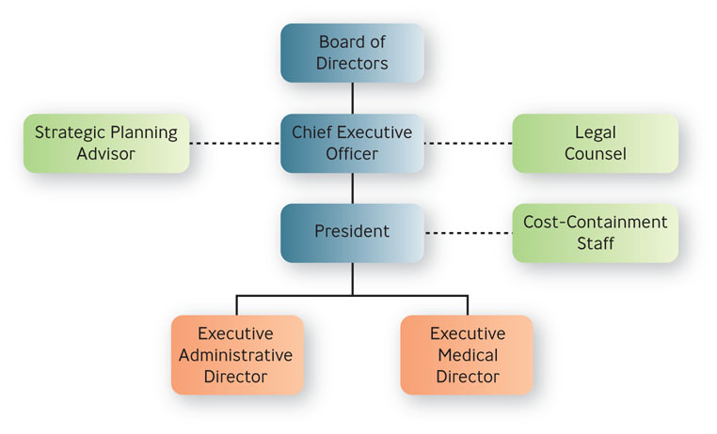

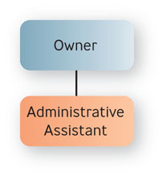
Basic Types of Organizational Structures

- Simple structure
  - authority is centralized in a single person with few rules and low work specialization
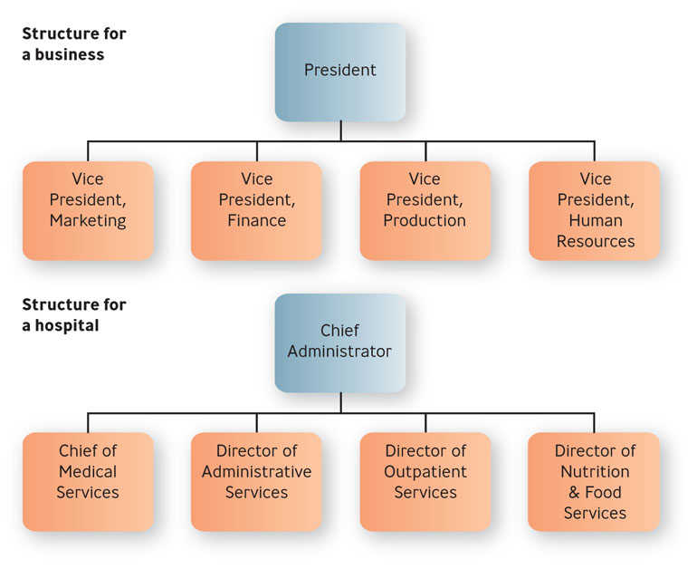
- Functional structure
  - people with similar occupational specialties are put together in formal groups

Question?
XYZ Hospital has a Chief of Medical Services, a Director of Administrative Services, and a Director of Outpatient Services. XYZ has a ___________ structure.
- Functional
- Simple
- Divisional
- Matrix

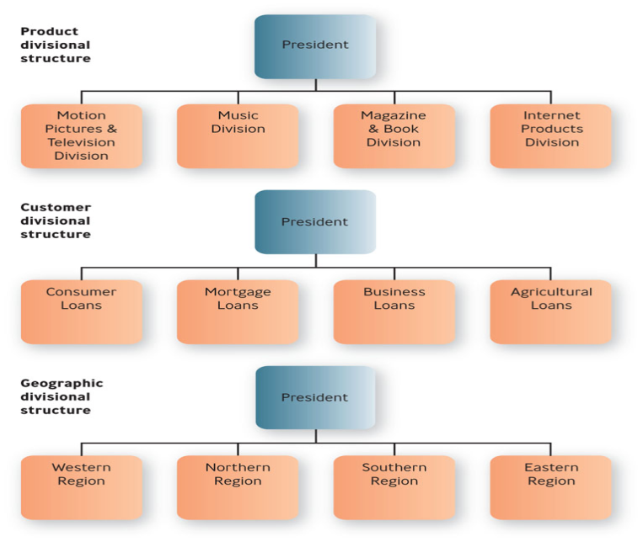
Basic Types of Organizational Structures ( cont.)
- Divisional structure
  - people with diverse occupational specialties are put together in formal groups by similar products, customers or geographic regions

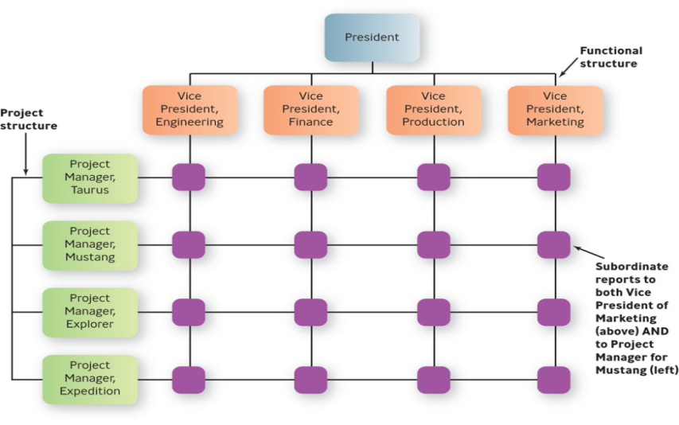
- Matrix structure
  - an organization combines functional and divisional chains of command in a grid so that there are two command structures-vertical and horizontal

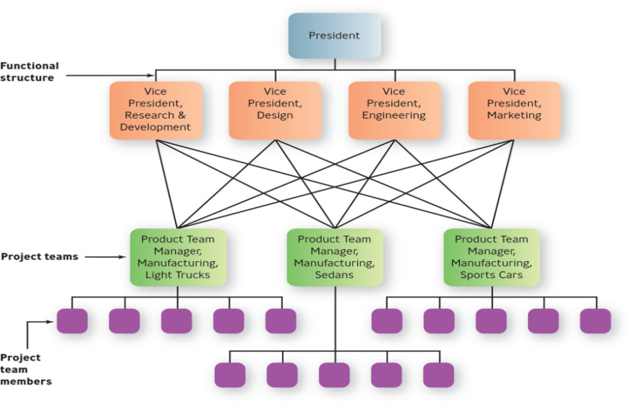
- Horizontal design
  - Teams or workgroups, either temporary or permanent, are used to improve collaboration and work on shared tasks by breaking down internal boundaries.

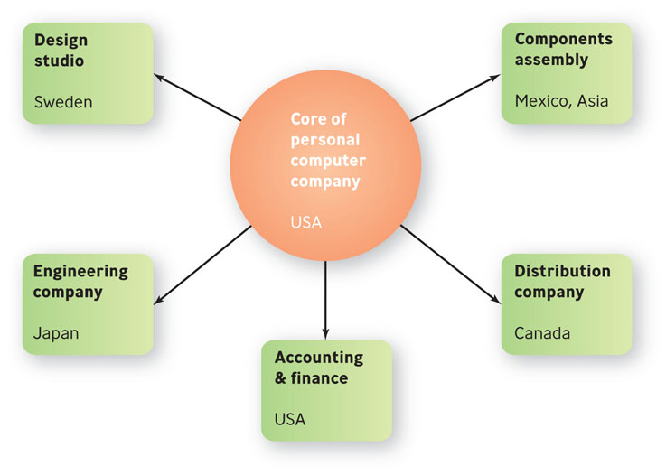
- Hollow structure
  - the organization has a central core of key functions and outsources other functions to vendors who can do them cheaper or faster

- Modular structure
  - firm assembles product chunks, or modules, provided by outside
contractors

Example: MySQL

- MySQL employs 320 workers in 25 countries
- 70% work from home
- Productivity is measured strictly by output
- MySQL hires strictly for skill, not “the ability to play nicely with other

Mechanistic vs. Organic Organizations

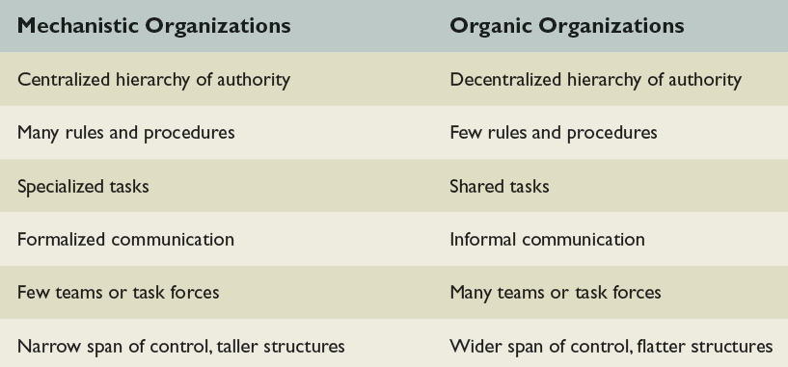

Differentiation vs. Integration

- Differentiation
  - tendency of the parts of an organization to disperse and fragment
- Integration
  - tendency of the parts of an organization to draw together to achieve a common purpose

Stages in the Life of an Organization

Stage 1: Birth stage – the organization is created
Stage 2: Youth stage – growth and expansion
Stage 3: Midlife stage – period of growth evolving into stability
Stage 4: Maturity stage -organization becomes very bureaucratic, large, and mechanistic

