Individual & Group Decision Making
How Managers Make Things Happen

Major Questions You Should Be Able to Answer
7.1 How do people know when they’re being logical or illogical?
7.2 How can I improve my decision making using evidence-based management and business analytics?
7.3 How do I decide to decide?
7.4 What guidelines can I follow to be sure that decisions I make are not just lawful but ethical?
7.5 Trying to be rational isn’t always easy. What are the barriers?
7.6 How do I work with others to make things happen?

Two Kinds of Decision Making
- Decision
  - choice made from among available alternatives
- Decision making
  - process of identifying and choosing alternative courses of action

Rational Decision Making
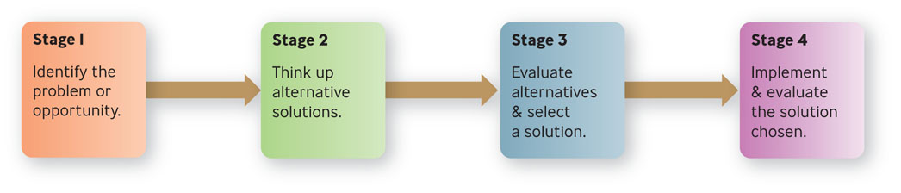
Rational Decision Making
- Rational model of decision making
  - explains how managers should make decisions
  - assumes managers will make logical decisions that will be optimum in furthering the organization’s interest
  - also called the classical model
Example: What Do Warren Buffett & Female Investors Have in Common?
- Buffett and female investors have something in common.
- Women trade much less often than men, do a lot more research, and tend to base their investment decisions on more than just numbers.
- Men tend to be frazzled, frenetic day traders.

Assumptions of the Rational Model
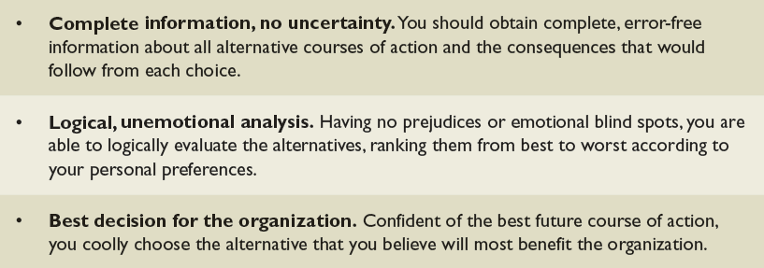

Nonrational Decision Making
- Nonrational models of decision making
  - assume that decision making is nearly always uncertain and risky, making it difficult for managers to make optimal decisions

Bounded Rationality
- Bounded Rationality
  - suggests that the ability of decision makers to be rational is limited by numerous constraints
  - complexity, time and money, cognitive capacity

Some Hindrances to Perfectly Rational Decision Making
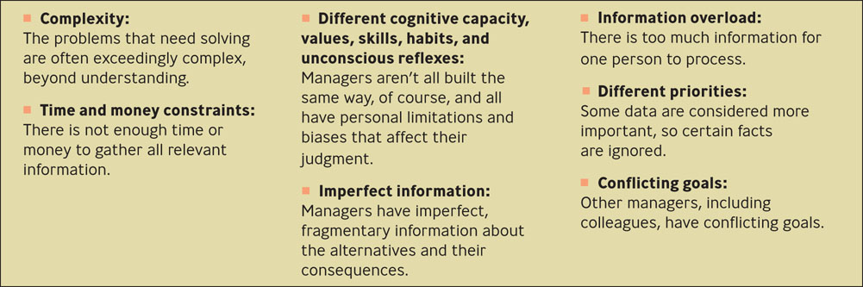

Satisficing and Incremental Models
- Satisficing Model
  - managers seek alternatives until they find one that is satisfactory, not optimal
- Incremental Model
  - managers take small, short-term steps to alleviate a problem

Intuition Model
- Intuition
  - making a choice without the use of conscious thought or logical inference
  - sources are expertise and feelings
Question?
Bill has been a manager for 14 years. He has seen many different situations with his employees. He often makes decisions without really thinking about them. This is called __________.
- Intuition
- Satisficing
- Bounded rationality
- Unbounded rationality

Implementation Principles of Evidence-Based Decision Making
- Treat your organization as an unfinished prototype.
- No brag, just facts.
- See yourself and your organization as outsiders do.
- Evidence-based management is not just for senior executives.
- Like everything else, you still need to sell it
- If all else fails, slow the spread of bad practice
- The best diagnostic question: What happens when people fail?
What Makes It Hard to Be Evidence Based
- There’s too much evidence.
- There’s not enough good evidence.
- The evidence doesn’t quite apply.
- People are trying to mislead you.
- You are trying to mislead you.
- The side effects outweigh the cure.
- Stories are more persuasive anyway.
Question?
Norma is trying to decide on a new contract for copier services. One of the salespeople has an excellent bid, but Norma feels that there are things he is not telling her. Why does this make it hard for her to use evidence-based decision making?
- There’s too much evidence.
- There’s not enough good evidence.
- People are trying to mislead you.
- The evidence doesn’t quite apply.

Analytics
- Analytics
  - sophisticated forms of business data analysis
  - portfolio analysis, time-series forecast
  - also called business analytics
Example: The Oakland A’s Play Moneyball
- The A’s could not afford superstar free agents
- Looked for players that could contribute in ways other clubs didn’t value as much
- Found that indicators of success lay in on-base percentage and slugging percentage

Key Attributes Among Analytics Competitors
- Use of modeling: going beyond simple descriptive statistics
- Having multiple applications, not just one
- Support from the top

General Decision-Making Styles
- Risk propensity
  - the willingness to gamble or to undertake risk for the possibility of gaining an increased payoff
- Decision-making style
  - reflects the combination of how an individual perceives and responds to information
  - value orientation
  - tolerance for ambiguity
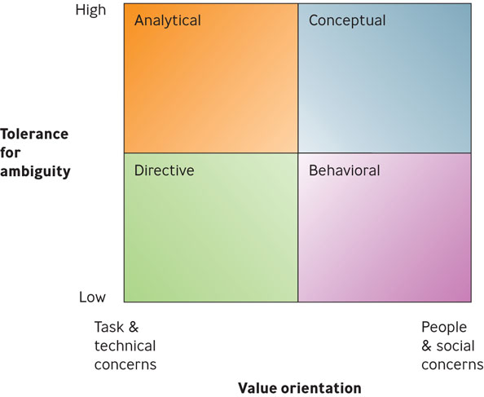
Decision-Making Styles

Decision-Making Styles
- Directive
  - people are efficient, logical, practical, and systematic in their approach to solving problems
  - action-oriented, decisive, and likes to focus on facts
- Analytical
  - considers more information and alternatives
- Conceptual
  - takes a broad perspective to problem solving
  - likes to consider many options and future possibilities
- Behavioral
  - supportive, receptive to suggestions, show warmth
  - prefer verbal to written information
Question?
Bill is supportive of his employees and prefers to have verbal conversations rather than written memos. His style is:
- Analytical
- Behavioral
- Conceptual
- Directive
Which Style Do You Have?
Knowledge of your decision-making style:
- Helps you to understand yourself
- Can increase your ability to influence others
- Gives you an awareness of how people can take the same information and yet arrive at different decisions

Road Map to Ethical Decision Making: A Decision Tree
- Is the proposed action legal?
- If “yes,” does the proposed action maximize shareholder value?
- If “yes,” is the proposed action ethical?
- If “no,” would it be ethical not to take the proposed action?

The Ethical Decision Tree
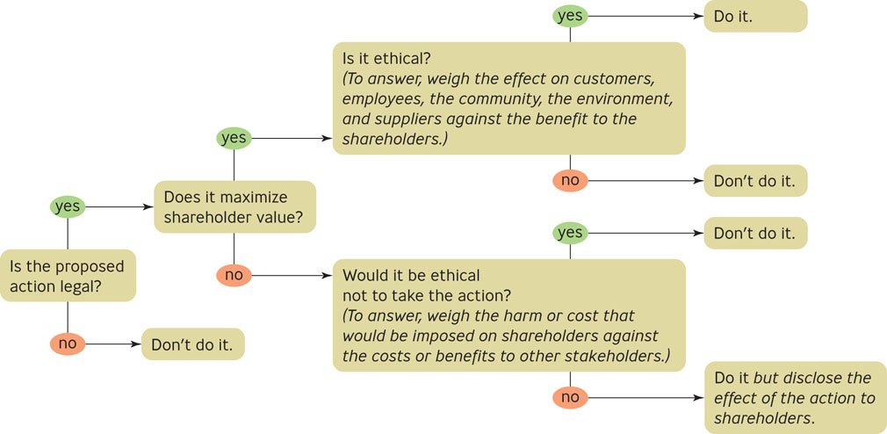

Ineffective Responses to a Decision Situation
- Relaxed avoidance
- Relaxed change
- Defencive avoidance
- Panic
Three Effective Reactions: Deciding to Decide
- Importance
  - “How high priority is this situation?”
- Credibility
  - “How believable is the information about the situation?”
- Urgency
  - “How quickly must I act on the information about the situation?”

Common Decision-Making Biases
- Availability bias
- Confirmation bias
- Representativeness bias
- Sunk cost bias
- Anchoring and adjustment bias
- Escalation of commitment bias

Advantages of Group Decision Making
- Greater pool of knowledge
- Different perspectives
- Intellectual stimulation
- Better understanding of decision rationale
- Deeper commitment to the decision

Disadvantages of Group Decision Making
- A few people dominate or intimidate
- Groupthink
- Satisficing
- Goal displacement

Groupthink
- Groupthink
  - occurs when group members strive to agree for the sake of unanimity and thus avoid accurately assessing the decision situation

What Managers Need to Know About Groups & Decision Making
- They are less efficient.
- Their size affects decision quality.
- They may be too confident.
- Knowledge counts.

When a Group Can Help in Decision Making
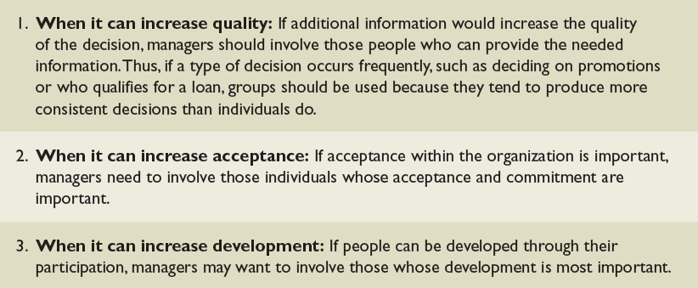

Participative Management
- Participative Management
  - process of involving employees in setting goals, making decisions, solving problems, and making changes in the organization

Group Problem-Solving Techniques
- Consensus
  - occurs when members are able to express their opinions and reach agreement to support the final decision
- Brainstorming
  - technique used to help groups generate multiple ideas and alternatives for solving problems

Computer-Aided Decision Making
- Chauffeur-driven systems
  - ask participants to answer predetermined questions on electronic keypads or dials
- Group-driven systems
  - involves a meeting within a room of participants who express their ideas anonymously on a computer network
  - for anonymous networkin

