Strategic Management:
How Exceptional Managers Realize a Grand Design

Major Questions You Should Be Able to Answer
6.1 Am I really managing if I don’t have a strategy?
6.2 What’s the five-step recipe for the strategic management process?
6.3 How can competitive intelligence, SWOT, and forecasting help me establish my strategy?
Major Questions You Should Be Able to Answer
6.4 How can four techniques—Porter’s competitive forces, competitive strategies, diversification and synergy, and the BCG matrix—help me formulate strategy?
6.5 How does effective execution help managers during the strategic-management process?

The Dynamics of Strategic Planning
- Strategy
  - large-scale action plan that sets the direction for an organization
- Strategic management
  - process that involves managers from all parts of the organization in the formulation and the implementation of strategies and strategic goals
Question?
Wal-Mart is guided by the following credo: “Find out what customers want, then provide it to them as cheaply and quickly as possible.” This is Wal-Mart's:
- Mission
- Vision
- Strategy
- Forecast

Why Strategic Management & Strategic Planning are Important
- Provide direction and momentum
- Encourage new ideas
- Develop a sustainable competitive advantage

Why Strategic Management & Strategic Planning are Important
Sustainable competitive advantage occurs when an organization can stay ahead in four areas:
- Being responsive to customers
- Innovation
- Quality
- Effectiveness

Example: Developing Competitive Advantage
- “Ford is transforming the car into a powerful smartphone”
- Ford has developed the Sync in-dash communications platform
- Ford is introducing voice-activated apps
- A driver can say “I’m hungry” and receive advice on nearby restaurants

What Is an Effective Strategy?
- Strategic positioning
  - attempts to achieve sustainable competitive advantage by preserving what is distinctive about a company
  - “performing different activities from rivals, or performing similar activities in different ways”

What Is an Effective Strategy?
- Strategy is the creation of a unique & valuable position
- Strategy requires trade-offs in competing
- Strategy involves creating a “fit” among activities

The Strategic-Management Process
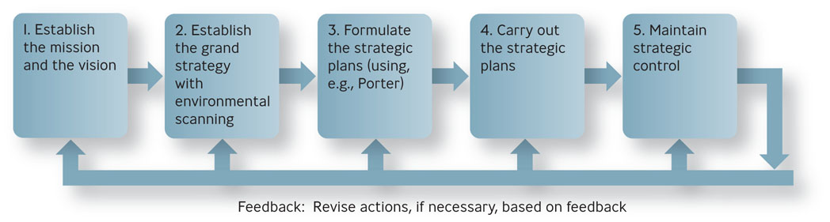
Question?
Zach manages a small video rental store. In order to determine if strategic planning will be likely to help his business, Zach should assess:
- How many competitors he has
- Foot traffic by his location
- His profitability in the prior six months
- Industry trends

Common Grand Strategies
- Growth strategy
  - involves expansion - as in sales revenues, market share, number of employees, or number of customers
- Stability
  - involves little or no significant change
- Defensive
  - involves reduction in the organization’s efforts
  - retrenchment

How Companies Can Implement Grand Strategies
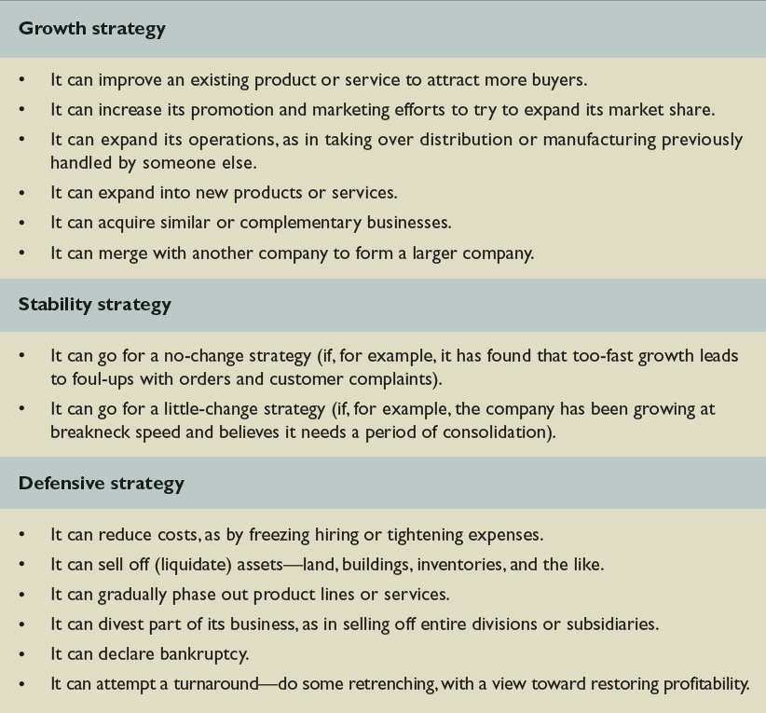

The Strategic Management Process
- Strategy formulation
  - process of choosing among different strategies and altering them to best fit the organization’s needs
- Strategy implementation
  - putting strategic plans into effect
- Strategic control
  - consists of monitoring the execution of strategy and making adjustments, if necessary
- Engage people
- Keep it simple
- Stay focused
- Keep moving

Competitive Intelligence
- Competitive intelligence
  - means gaining information about one’s competitors’ activities so that you can anticipate their moves and react appropriately
  - public prints and advertising, investor information, informal sources
SWOT Analysis
- Environmental scanning
  - careful monitoring of an organization’s internal and external environments to detect early signs of opportunities and threats that may influence the firm’s plans

SWOT Analysis
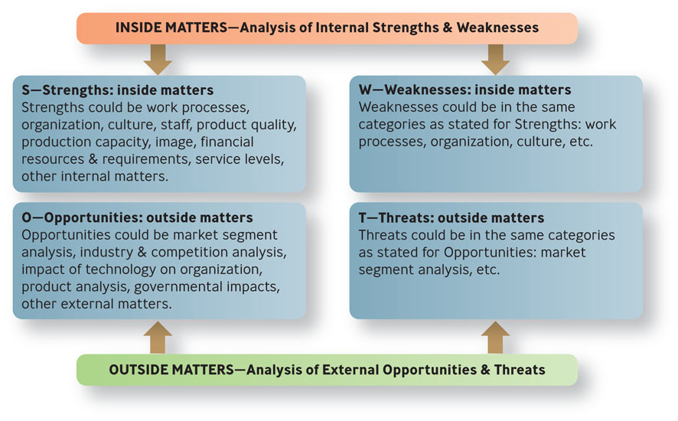
SWOT Analysis
- Organizational strengths
  - skills and capabilities that give the organization special competencies and competitive advantages in executing strategies in pursuit of its mission
- Organizational weaknesses
  - drawbacks that hinder an organization in executing strategies in pursuit of its mission
Question? When analyzing the “W” in SWOT analysis, Roberta, the manager might be assessing:
- Possible challenges in the market
- Competitors' actions
- High turnover of employees
- Good financial resources of the firm
SWOT Analysis
- Organizational opportunities
  - environmental factors that the organization may exploit for competitive advantage
- Organizational threats
  - environmental factors that hinder an organization’s achieving a competitive

Example: How Would You Analyze Toyota?
- Internal strengths
  - attention to detail and a frugality that shuns waste of every kind
- Internal weaknesses
  - parts were supplied by outside companies rather than trusted traditional suppliers
- External opportunities
  - stressed commitment to customers
  - still ranks high in quality

Forecasting: Predicting the Future
- Trend analysis
  - hypothetical extension of a past series of events into the future
- Contingency planning
  - creation of alternative hypothetical but equally likely future conditions
  - also called scenario planning and scenario analysis
Porter’s Five Competitive Forces
- Threat of new entrants
- Bargaining power of suppliers
- Bargaining power of buyers
- Threat of substitute products or services
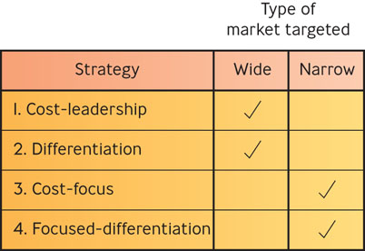
- Rivalry among competitors

Porter’s Four Competitive Strategies

Porter’s Four Competitive Strategies
- Cost-leadership strategy
  - keep the costs, and hence prices, of a product or service below those of competitors and to target a wide market
Question? The company's CEO puts pressure on the firm's R&D managers to develop products that can be created cheaply. The firm would be following a ________ strategy:
- Cost leadership
- Differentiation
- Cost focus
- Retrenchment

Porter’s Four Competitive Strategies
- Differentiation strategy
  - offer products that are of unique and superior value compared to those of competitors but to target a wide market
- Cost-focus strategy
  - keep the costs of a product below those of competitors and to target a narrow market
- Focused-differentiation
  - offer products that are of unique and superior value compared to those of competitors and to target a narrow market

Single-Product versus Diversification
- Single-product strategy
  - company makes and sells only one product within its market
  - Benefit-focus
  - Risk-vulnerability

The Diversification Strategy
- Diversification
  - operating several businesses under one ownership that are not related to one another
  - Related, unrelated
    - Unrelated diversification - operating several businesses under one ownership that are not related to one another
    - Related diversification - an organization under one ownership operates separate businesses that are related to one another.
Advantages of Related Diversification
- Reduced risk
  - because more than one product
- Management efficiencies
  - administration spread over several businesses
- Synergy
  - the sum is greater than the parts

The BCG Matrix
- BCG matrix
  - a means of evaluating strategic business units on the basis of (1) their business growth rates and (2) their share of the market.
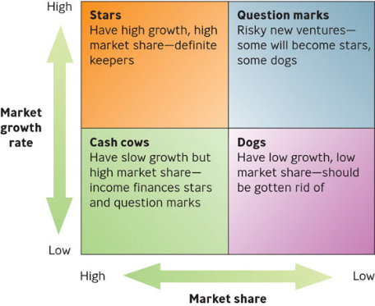
The BCG Matrix

Execution: Getting Things Done
- Execution
  - consists of using questioning, analysis, and follow-through in order to mesh strategy with reality, align people with goals, and achieve results promised
  - central part of any company’s strategy
Question?
John owns a piano sales and tuning store. He wants to be the biggest retailer in the Midlands. Adding salespeople would be part of his strategic __________.
- Locution
- Execution
- Efficacy
- Efficiency

The Three Core Processes of Business
- People
  - Consider who will benefit you in the future
- Strategy
  - Consider how success will be accomplished
- Operations
  - Consider what path will be followed

What Questions Should a Strong Strategic Plan Address?
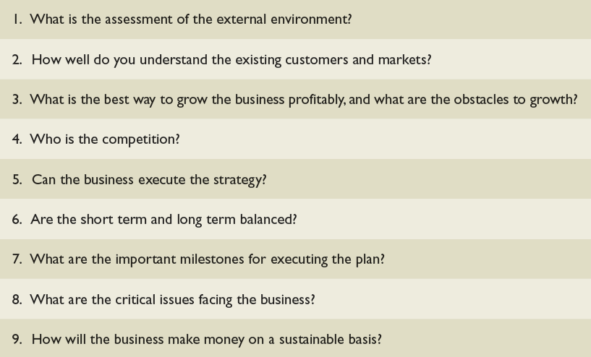

Building a Foundation of Execution
- Know Your People & Your Business: “Engage Intensely with Your Employees”
- Insist on Realism: “Don’t Let Others Avoid Reality”
- Set Clear Priorities: “Focus on a Few Rather Than Many Goals”
- Follow Through: “Establish Accountability & Check on Results”
- Reward the Doers: “Show Top Performers That They Matter”
- Expand People’s Capabilities: “Develop the Talent”
- Know Yourself: “Do the Hard Work of Understanding Who You Are”

