Planning:
The Foundation of Successful Management

Major Questions You Should Be Able to Answer
5.1 How do I tend to deal with uncertainty, and how can planning help?
5.2 What are mission and vision statements and what are three types of planning and goals?
5.3 What are SMART goals and MBO, and how can they be implemented?
5.4 How does the planning/control cycle help keep a manager’s plans headed in the right direction?
Planning & Uncertainty

- Planning
  - coping with uncertainty by formulating future courses of action to achieved specified results
  - setting goals and deciding how to achieve them

Planning & Strategic Management
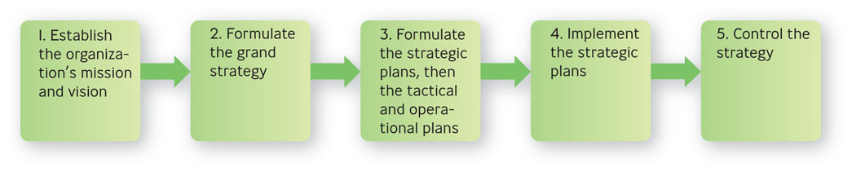
Why Not Plan?
- Planning requires you to set aside the time to do it
- You may have to make some decisions without a lot of time to plan

How Planning Helps You
- Helps you check on your progress
- Helps you coordinate activities
- Helps you think ahead
- Helps you cope with uncertainty

Four Basic Strategy Types
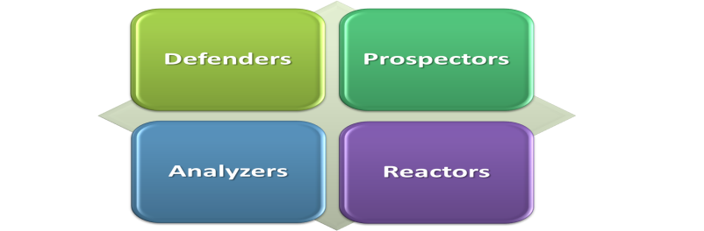
Four Basic Strategy Types
- Defenders
  - expert at producing and selling narrowly defined products
- Prospectors
  - focus on developing new products and in seeking out new markets, rather than waiting for things to happen
- Analyzers
  - let other organizations take the risks of product development and marketing and then imitate what seems to work best
- Reactors
  - make adjustments only when finally forced to by environmental pressures

Question?
Fredhandbag Photography scans it environment regularly. However, it does not tend to seek opportunities outside its present markets. This company would most likely be a (n):
- Reactor
- Prospector
- Analyzer
- Defender

The Adaptive Cycle
- Adaptive Cycle
  - businesses are continuously cycling through decisions about three kinds of business problems: (1) entrepreneurial, (2) engineering, and (3) administrative
  - Entrepreneurial – selecting and making adjustments of products and markets
  - Engineering – producing and delivering the products
  - Administrative – establishing roles, relationships, and organizational processes
Making Plans
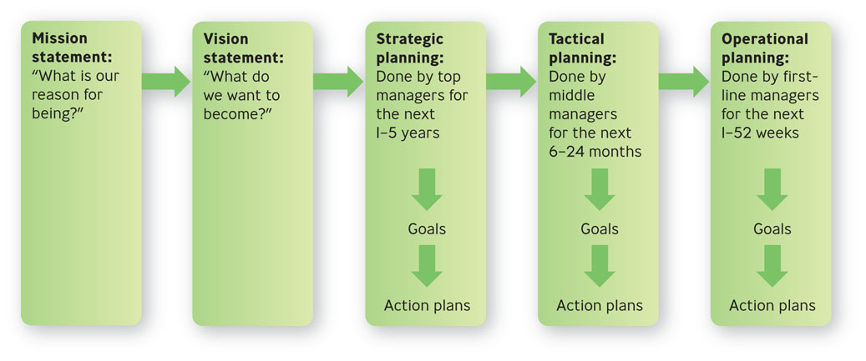
Mission & Vision Statements
- Mission statement
  - expresses the purpose of the organization
- Vision statement
  - long-term goal describing “what” an organization wants to become
  - clear sense of the future and the actions needed to get there

Example: Nest Fresh Eggs
“NestFresh strives to provide you and your family with a more sustainable, humane alternative to conventional eggs, which are produced in caged facilities. We insist on producing cage free and organic eggs to create awareness about the need for humane treatment of egg laying hens and the importance of environmental responsibility.”

Three Types of Planning for Three Levels of Management
- Strategic planning
  - determine what the organization’s long-term goals should be for the next 1-5 years with the resources they expect to have available

Question?
Danny is participating with other managers in a discussion about what his organization's goals should be for the next decade. He is participating in:
- Strategic planning
- Operational planning
- Tactical planning
- Controlling

Three Types of Planning for Three Levels of Management
- Tactical planning
  - determine what contributions their departments or similar work units can make during the next 6-24 months
- Operational planning
  - determine how to accomplish specific tasks with available resources within the next 1-52 weeks

Three Levels of Management, Three Types of Planning
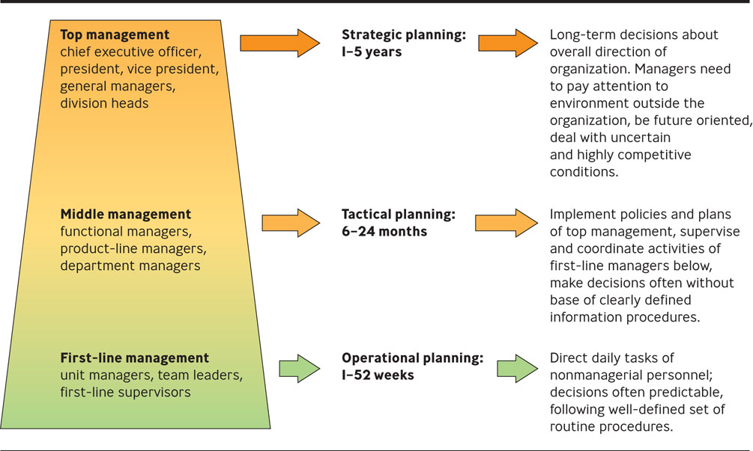

Goals, Action Plans & Operating Plans
- Goals
  - specific commitment to achieve a measurable result within a stated period of time
  - also known as an objective
  - strategic, tactical, operational
Goals
- Strategic goals
  - set by and for top management and focus on objectives for the organization as a whole.
- Tactical goals
  - set by and for middle managers and focus on the actions needed to achieve strategic goals.

- Operational goals
  - set by and for first-line managers and are concerned with short-term matters associated with realizing tactical goals.
- Action plan
  - defines the course of action needed to achieve the stated goal

- Operating plan
  - designed for a 1-year period
  - defines how you conduct your business based on the action plan
  - identifies clear targets such as revenue, cash flow, and market share

Standing Plans: Policies, Procedures, & Rules
- Standing plans
  - plans developed for activities that occur repeatedly over a period of time
  - consist of policies, procedures, and rules.
- Policy
  - outlines the general response to a designated problem or situation
- Procedure
  - outlines the response to a particular problem or circumstances
- Rule
  - designates specific required action

Single-Use Plans: Programs & Projects
- Single-use plans
- plans developed for activities that are not likely to be repeated in the future
- Program
  - encompasses a range of projects or activities
- Project
  - plan of less scope and complexity than a program

SMART Goals
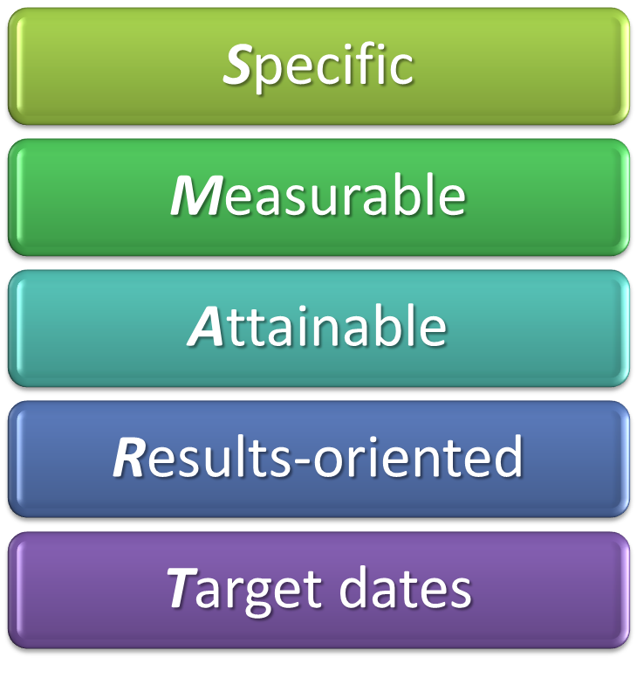
Relationship Between Goal Difficulty and Performance
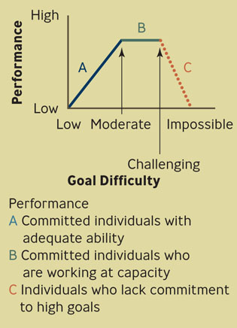

What Is MBO?
- Jointly set objectives
- Develop action plan
- Periodically review performance
- Give performance appraisal and rewards, if any

Three Types of Objectives Used in MBO

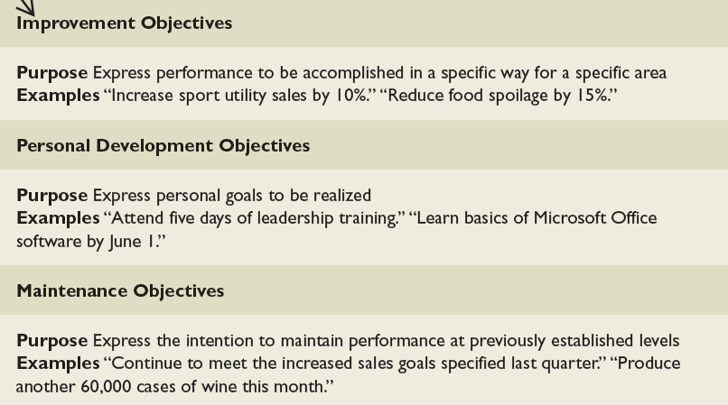

Cascading Objectives: MBO from the Top Down
- Top management must be committed
- It must be applied organization-wide
- Objectives must “cascade”

Example: Wal-Mart Setting Objectives for Change
- In 2008 Walmart CEO, Lee Scott, laid out new environmental, health, and ethical goals
- Walmart would continue to promote energy-saving in more products
- Walmart would apply cost-cutting skills to helping other companies deliver health care for its employees

Question?
Melissa wants her employee, Ralph, to turn in his monthly sales report by the 5th of every month. This meets the ____________ requirement of SMART goals.
- Specific
- Measurable
- Attainable
- Target dates

The Planning/Control Cycle
- Make the plan
- Carry out the plan
- Control the direction by comparing results with the plan
- Control the direction by taking corrective action in two ways
  - Correcting deviations
  - Improving future plans

The Planning/Control Cycle
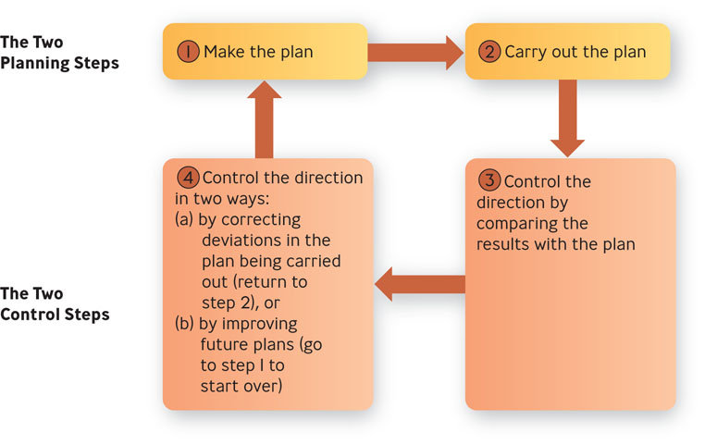
Question?
Apple has fired employees who have leaked news about unannounced products. Which step of the Planning/Control is this?
- Make the plan
- Carry out the plan
- Take corrective action
- Document the plan

