Chapter Four
Global Management: Managing Across Borders
Major Questions You Should Be Able to Answer
4.1 What three important developments of globalization will probably affect me?
4.2 Why learn about international management, and what characterizes the successful international manager?
4.3 Why do companies expand internationally, and how do they do it?
4.4 What are barriers to free trade, and what major organizations and trading blocs promote trade?
4.5 What are the principal areas of cultural differences?

Globalization: The Collapse of Time & Distance

- Globalization
  - the trend of the world economy toward becoming a more interdependent system

- E-commerce
  - the buying and selling of products and services through computer networks

- U.S. retail e-commerce sales were estimated at $48.2 billion in the third quarter of 2011.

One Big World Market: The Global Economy

- Global economy
  - the increasing tendency of the economies of the world to interact with one another as one market instead of many national markets

- Positive effects
  - more markets for American exports

- Negative effects
  - vast surplus funds from global investments flowed into the U.S. that were invested badly in subprime mortgages

Why Learn About International Management?

- Multinational corporation
  - business firm with operations in several countries

- Multinational organization
  - nonprofit organization with operations in several countries

The Successful International Manager

- Ethnocentric managers
  - believe that their native country, culture, language, and behavior are superior to all others

- Parochialism
  - narrow view in which people see things solely through their own perspective

- Polycentric managers
  - take the view that native managers in the foreign offices best understand native personnel and practices, and so the home office should leave them alone

- Geocentric managers
  - accept that there are differences and similarities between home and foreign personnel and
practices and that they should use whatever techniques are most effective

Five Ways of Expanding Internationally
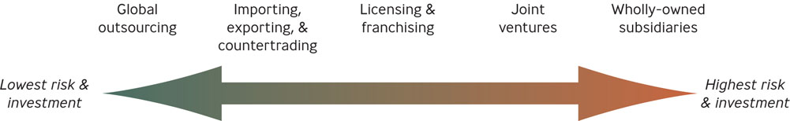
How Companies Expand Internationally
- Global outsourcing
  - using suppliers outside the U.S. to provide labor, goods, or services
- Importing
  - a company buys goods outside the country and resells them domestically
- Exporting
  - a company produces goods domestically and sells them outside the country
- Countertrading
  - bartering goods for goods
- Licensing
  - a firm allows a foreign company to pay it a fee to make or distribute the firm’s product or service
- Franchising
  - a firm allows a foreign company to pay it a fee and a share of the profit in return for using the firm’s brand name and a package of materials and services

