The Manager's Changing Work Environment & Ethical Responsibilities
Doing the Right Thing
- The Community of Stakeholders Inside the Organization:
✦ Stakeholders
The people whose interests are affected by an organization’s activities Internal, external.

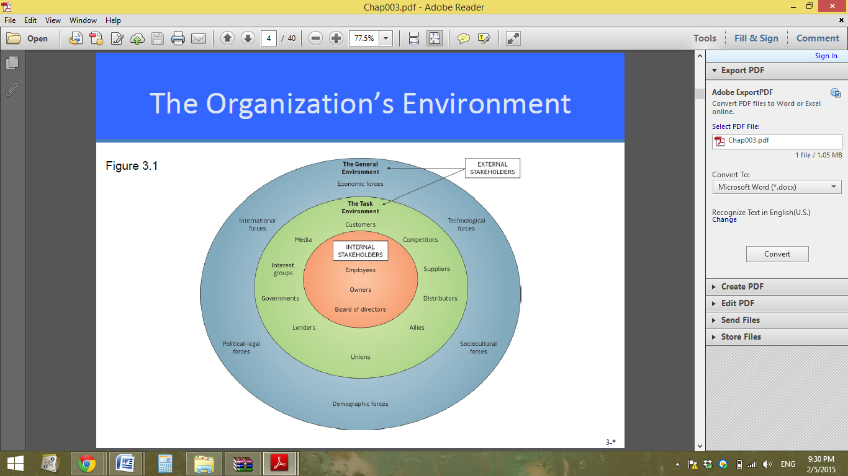
- The Organization’s Environment:

- The Community of Stakeholders Inside the Organization:
✦ Internal stakeholders (Employees)
consist of employees, owners, and the board of directors.
✦ Owners
consist of all those who can claim the organization as their legal property.
✦ Board of directors
members elected by the stockholders to see that the company is being run according o their interests.
- Question?
Two drug companies agree to work together to pool their research and development funds to develop a new drug for arthritis. In doing so, these two organizations have:
- Formed a union
- Formed a strategic alliance
- Analyzed their internal environment
- Influenced the mass media

- The Community of Stakeholders Outside the Organization:
✦ External stakeholders
people or groups in the organization’s external environment that are affected by it Task, general environment.

- The Task Environment:
✦ Customers
those who pay to use an organization’s goods or services.
✦ Competitors
people or organizations that compete for customers or services.
✦ Suppliers
A person or organization that provides raw materials, services, equipment, labor or energy to other organizations.

Example: Amazon.com and the Customer Experience:
✦ Jeff Bezos, founder and CEO of Amazon.com is obsessed with customer service.
✦ Believes that company’s success is driven by the customer experience.
✦ In 2011 the company’s revenue increased 41%.

✦ Distributor
a person or organization that helps another organization sell its goods and services to customers.
✦ Strategic allies
describes the relationship of two organizations who join forces to achieve advantages neither can perform as well alone.
✦ Employee Organizations: Unions & Associations.
✦ Local Communities.
✦ Financial Institutions.
✦ Government regulators
regulatory agencies that establish ground rules under which organizations may operate.
✦ Special interest groups
groups whose members try to influence specific issues
✦ Mass Media
Question?
ChemTech International is being picketed by a group of people who live by their biggest plant. The group is concerned about ChemTech’s disposal of waste products into nearby waterways. In this instance, ChemTech is dealing with the _____ part of its _______ environment.
- special-interest groups; task
- local communities; task
- sociocultural; general
- sociocultural; task

- The General Environment
✦ Economic forces
consist of the general economic conditions and trends – unemployment, inflation, interest rates, economic growth – that may affect an organization’s performance.
✦ Technological forces
new developments in methods for transforming resources into goods and services.
✦ Sociocultural forces
Influences and trends originating in a country’s, a society’s, or a culture’s human relationships and values that may affect an organization.
✦ Demographic forces
influences on an organization arising from changes in the characteristics of a population, such as age, gender, or ethnic origin.
✦ Political-Legal forces
changes in the way politics shape laws and laws shape the opportunities for and threats to an organization.
✦ International forces
changes in the economic, political, legal, and technological global system that may affect an organization.

- Example: What Does a Company Owe Its Community?
✦ NCR is moving its headquarters from Dayton, OH to Atlanta, GA.
✦ NCR had been headquartered in Dayton since the company was founded in 1884.
✦ Georgia promised a lucrative incentive Package.
✦ Dayton officials thought the long relationship between the two should count for something.

- The Ethical Responsibilities Required of You as a Manager
✦ Ethical dilemma
situation in which you have to decide whether to pursue a course of action that may benefit you or your organization but that is unethical or even illegal.

- Defining Ethics & Values
✦ Ethics
standards of right and wrong that influence behavior.
✦ Values
relatively permanent and deeply held underlying beliefs and attitudes that help determine a person’s behavior.

- Values
Organizations may have two value systems that conflict:
1. The value system stressing financial performance versus.
2. The value system stressing cohesion and solidarity in employee relationships.
Question?
Fairness in hiring practices is an example of an organization's _______________.
- Cost-benefit analysis
- Morality
- Competitive advantage
- Long-term interests
- Values.

- Four Approaches to Deciding Ethical Dilemmas
✦ Utilitarian
guided by what will result in the greatest good for the greatest number of people.
✦ Individual
guided by what will result in the individual’s best long term interest, which ultimately are in everyone’s self-interest.
✦ Moral-rights
guided by respect for the fundamental rights of human beings.

✦ Justice
guided by respect for impartial standards of fairness and equity.

Question?
Pat, a manager at State University, is deciding how to set up a procedure for registering on-line that gives students fair access to courses. Pat is engaged in the ________ approach.
- utilitarian
- individual
- moral-rights
- justice

- White-Collar Crime, SarbOx, & Ethical Training
✦ Sarbanes-Oxley of 2002
Often shortened to SarbOx or SOX, established requirements for proper financial record keeping for public companies and penalties of as much as 25 years in prison for noncompliance.

- How Do People Learn Ethics? Kohlberg’s Theories
✦ Level 1, preconventional – follows rules.
✦ Level 2, conventional – follows expectations of others.
✦ Level 3, postconventional – guided by internal values.

- How Organizations Can Promote Ethics?
1. Creating of a strong ethical climate.
2. Screening prospective employees.
3. Instituting ethics codes and training Programs.
4. Rewarding ethical behavior: Protecting whistle-blowers.

- The Social Responsibilities Required of You as a Manager
✦ Social responsibility
manager’s duty to take actions that will benefit the interests of society as well as of the organization.
✦ Corporate social responsibility
notion that corporations are expected to go above and beyond following the law and making a profit.

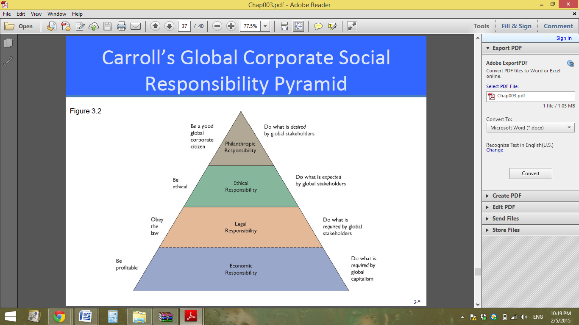
- Carroll’s Global Corporate Social Responsibility Pyramid:
- Twe Type of Social Responsibility:
✦ Philanthropy
making charitable donations to benefit humankind.

- Corporate Governance
✦ Corporate governance
the system of governing a company so that the interests of corporate owners and other stakeholders are protected.

- The Need for Independent Directors
✦ More attention is being paid to strengthening corporate governance so that directors are clearly separated in their authority from the CEO.

