Chapter Two
Management Theory:
Essential Background for the Successful Manager

Major Questions You Should Be Able to Answer
2.1 What’s the payoff in studying different management perspectives, both yesterday’s and today’s?
2.2 If the name of the game is to manage work more efficiently, what can the classical viewpoint teach me?
2.3 To understand how people are motivated to achieve, what can I learn from the behavioral viewpoint?
2.4 If the manager’s job is to solve problems, how might the two quantitative approaches help?
2.5 How can the exceptional manager be helped by the systems viewpoint?
2.6 In the end, is there one best way to manage in all situations?
2.7 Can the quality-management viewpoint offer guidelines for true managerial success?
2.8 How do I build a learning organization?

How We Got to Today’s Management Outlook
- Evidence based management
  - translating principles based on best evidence into organizational practice, bringing rationality to the decision making process
  - Pfeffer and Sutton
Two Overarching Perspectives about Management
- Historical perspective
  - classical, behavioral, and quantitative
- Contemporary perspective
  - systems, contingency, and quality-management
Five Practical Reasons for Studying This Chapter
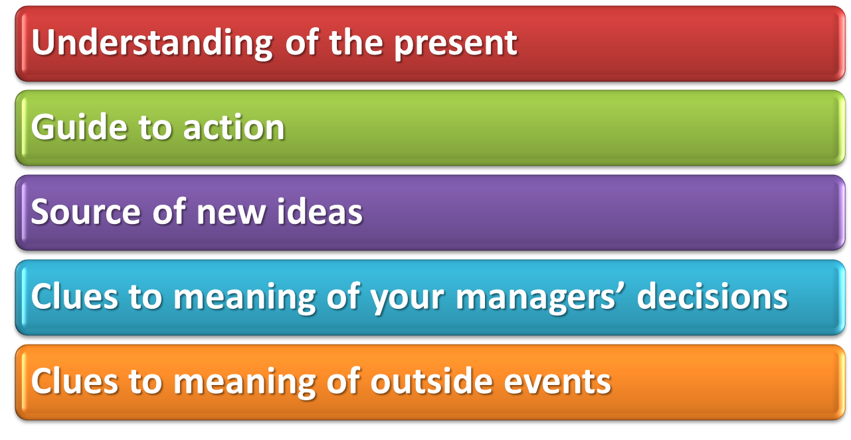

Classical Viewpoint: Scientific & Administrative Management
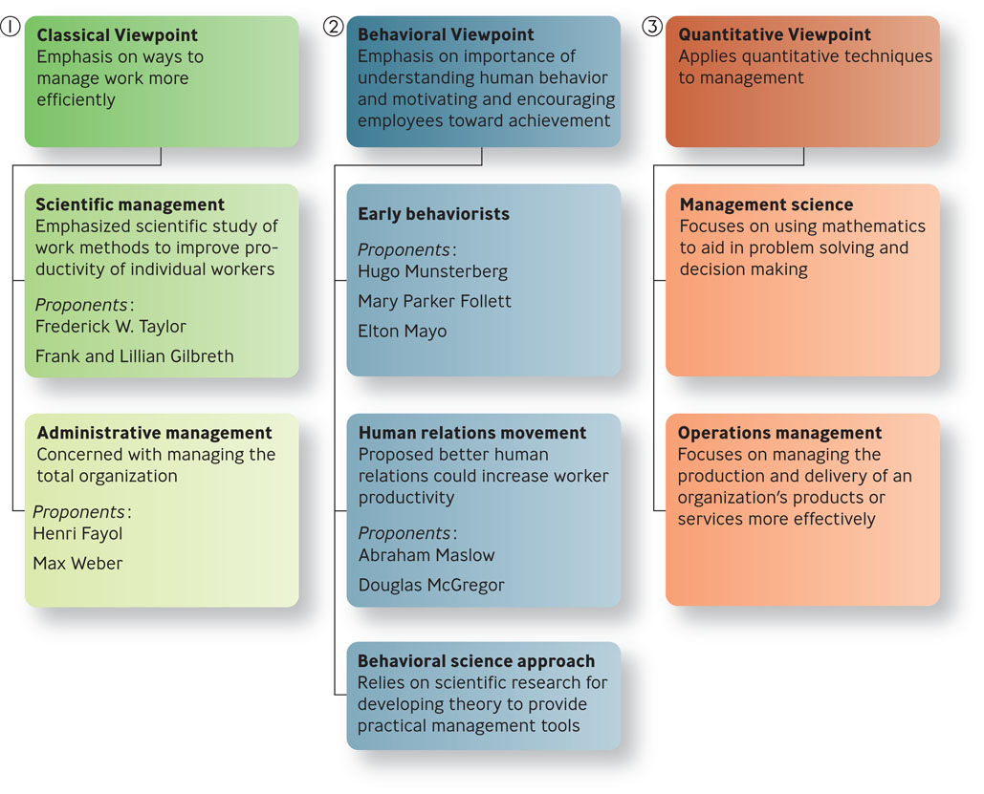
Question?
Which viewpoint emphasized the scientific study of work methods to improve the productivity of individual workers?
  - Scientific management
  - Administrative
management
  - Behavioral science
  - TQM

Scientific Management: Pioneered by Taylor & the Gilbreths
- Scientific management
  - emphasized the scientific study of work methods to improve the productivity of individual workers
  - Frederick W. Taylor, Frank and Lillian Gilbreth
Principles of Scientific Management
- Scientifically study each part of the task
- Carefully select workers with the right abilities
- Give workers the training and incentives to do the task
- Use scientific principles to plan the work methods
Administrative Management: Pioneered by Fayol & Weber
- Administrative management
  - concerned with managing the total organization
- Henri Fayol
  - French engineer and industrialist
  - first to identify the major functions of management
- Max Weber believed that a bureaucracy was a rational, efficient, ideal organization based on the principles of logic
Five Positive Bureaucratic Features
- A well-defined hierarchy of authority
- Formal rules and procedures
- A clear division of labor
- Impersonality
- Careers based on
merit
The Problem with the Classical Viewpoint
- Mechanistic
- Tends to view humans as cogs within a machine, not taking into account the importance of human needs
Why the Classical Viewpoint is Important?
- Work activity was amenable to a rational approach
- Through the application of scientific methods, time and motion studies, and job specialization it was possible to boost productivity
Question?
Which viewpoint emphasized the importance of understanding human behavior and of motivating employees toward achievement?
  - Scientific management
  - Administrative
management
  - Behavioral
  - TQM

Behavioral Viewpoint: Behaviorism, Human Relations, & Behavioral Science
- Behavioral viewpoint
  - emphasized the importance of understanding human behavior and of motivating employees toward achievement
The behavioral viewpoint developed over three phases:
- Early behaviorism
- The human relations movement
- Behavioral science.
Early Behaviorism: Pioneered by Munsterberg, Follett, & Mayo
- Hugo Munsterberg
  - father of industrial psychology
- Study jobs and determine which people are best suited to specific jobs
- Identify the psychological conditions under which employees do their best work
- Devise management strategies to influence employees to follow management’s interests
- Mary Parker Follett
  - social worker and social philosopher
- Organizations should be operated as “communities”
- Conflicts should be resolved by having managers and workers talk over differences and find solutions that would satisfy both parties
- The work process should be under control of workers with relevant knowledge
- Hawthorne effect
  - employees worked harder if they received added attention, thought that managers cared about their welfare and that supervisors paid special attention to them
  - Elton Mayo
The Human Relations Movement: Pioneered by Maslow & McGregor
- Human relations movement
  - proposed that better human relations could increase worker productivity
  - Abraham Maslow and Douglas McGregor

Maslow’s Hierarchy of Needs
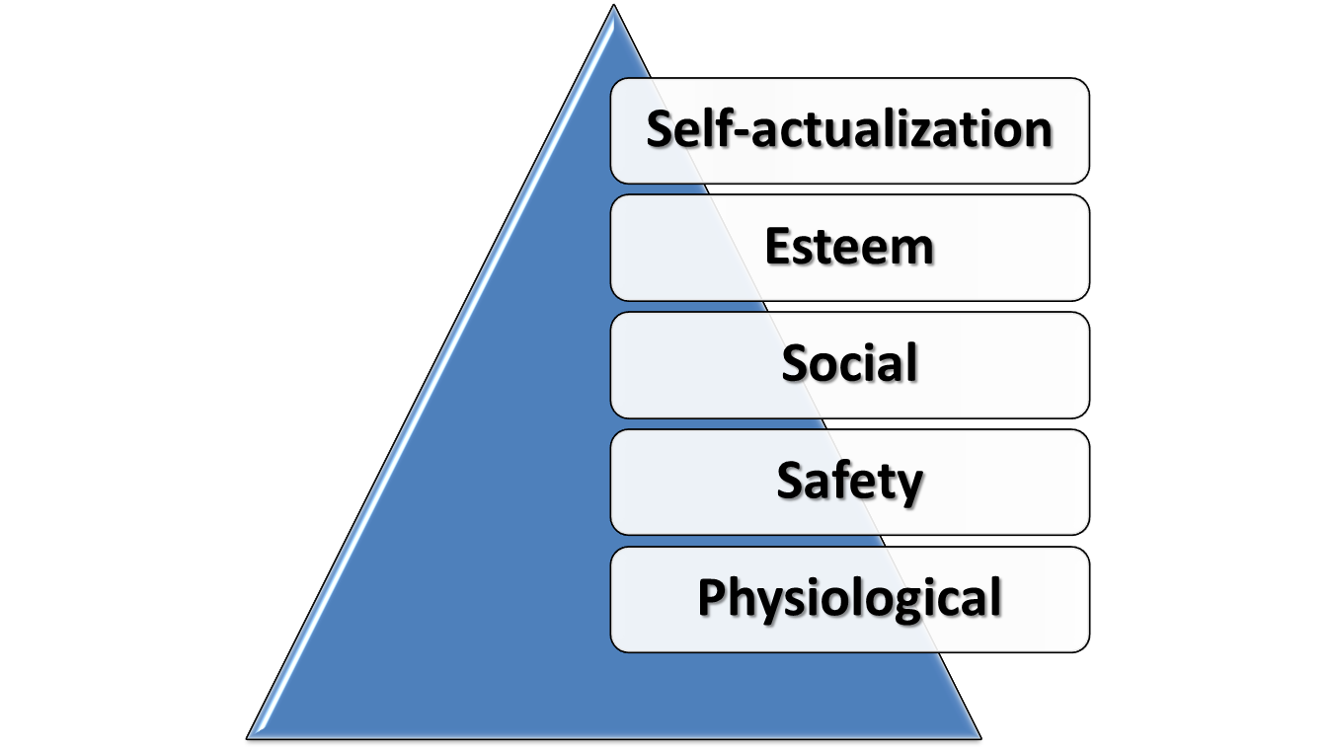
Douglas McGregor – Theory X versus Theory Y
- Theory X
  - represents a pessimistic, negative view of workers
  - workers are irresponsible, resistant to change, lack ambition, hate work, and want to be led
- Theory Y
  - represents an optimistic, positive view of workers
  - Workers are considered capable of accepting responsibility, self-direction, self control and being creative
Why Theory X/Theory Y Is Important
- Helps managers understand how their beliefs affect their behavior.
- Managers can be more effective by considering how their behavior is shaped by their expectations about human nature
The Behavioral Science Approach
- Behavioral science
  - relies on scientific research for developing theories about human behavior that can be used to provide practical tools for managers
Quantitative Viewpoints: Management Science & Operations Research
- Quantitative management
  - application to management of quantitative techniques, such as statistics and computer simulations
  - Management science,
operations management
Question?
Which viewpoint stresses the use of rational, science-based techniques and mathematical models to improve decision making and strategic planning?
  - Scientific management
  - Operations management
  - Production management
  - Management science
Management Science: Using Mathematics to Solve Management Problems
- Management science
  - stresses the use of rational, science-based techniques and mathematical models to improve decision making and strategic planning
Operations Management: Helping Organizations Deliver Products or Services More Effectively
- Operations management
  - focuses on managing the production and delivery of an organization’s products or services more effectively
  - work scheduling, production planning, facilities location and design
The Contemporary Perspective
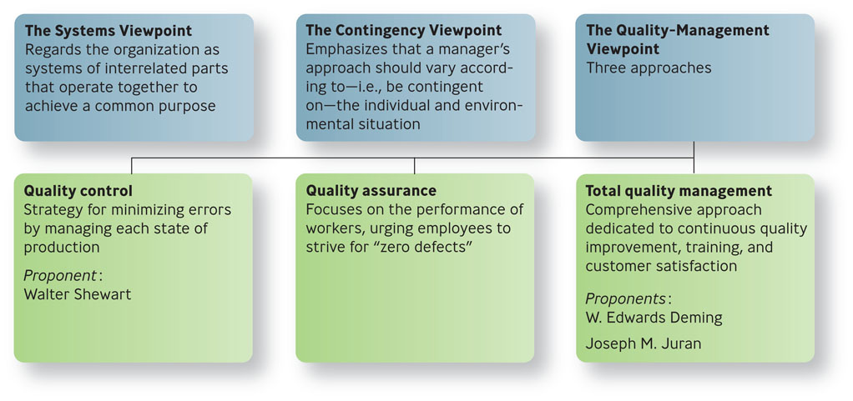
Systems Viewpoint
- Systems viewpoint
  - regards the organization as a system of interrelated parts
  - collection of subsystems
  - part of the larger environment

The Four Parts of a System
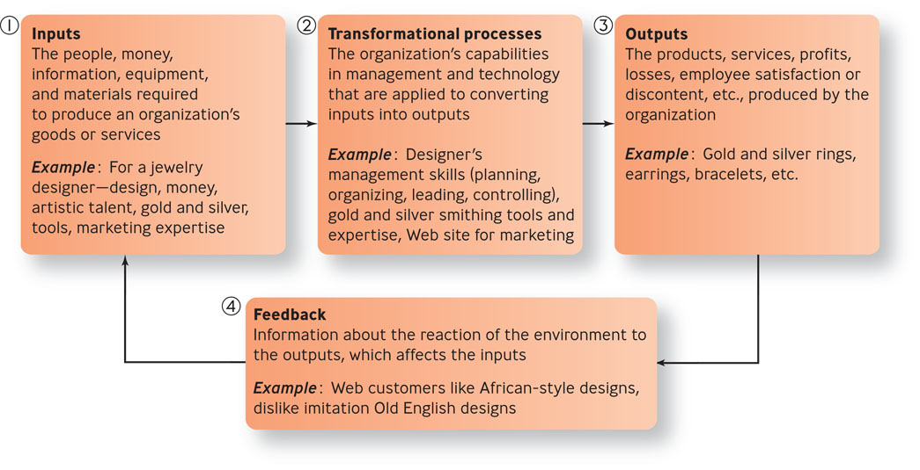
Systems Viewpoint
- Open system
  - continually interacts with its environment
- Closed system
  - has little interaction with its environment
Contingency Viewpoint
- Contingency viewpoint
  - emphasizes that a manager’s approach should vary according to the individual and the environmental situation
  - Most practical because it addresses problems on a case-by-case basis
Quality Control & Quality Assurance
- Quality
  - total ability of a product or service to meet customer needs
- Quality control
  - the strategy for minimizing errors by managing each stage of production
- Quality assurance
  - focuses on the performance of workers, urging employees to strive for “zero defects”

Quality-Management Viewpoint
- Total quality management (TQM)
  - comprehensive approach-led by top management and supported throughout the organization-dedicated to continuous quality improvement, training, and customer satisfaction
  - Deming, Juran
Total Quality Management
- Make continuous improvement a priority
- Get every employee involved
- Listen to and learn from customers and employees
- Use accurate standards to identify and eliminate problems
The Learning Organization: Handling Knowledge & Modifying Behavior
- Learning organization
  - organization that actively creates, acquires, and transfers knowledge within itself and is able to modify its behavior to reflect new knowledge
How to Build a Learning Organization: Three Roles Managers Play
How to build a learning organization
- Build a commitment to learning
- Work to generate ideas with impact
- Work to generalize ideas with impact

