Chapter One
The Exceptional Manager: What You Do, How You Do It
Major Questions You Should Be Able to Answer
1.1 What are the rewards of being an exceptional manager?
1.2 What are seven challenges I can look forward to as a manager?
1.3 What would I actually do—that is, what would be my four principal functions—as a manager?
1.4 What are the levels and areas of management I need to know to move up, down, and sideways?
1.5 To be an exceptional manager, what roles must I play successfully?
1.6 Do I have what it takes to be an entrepreneur?
1.7 To be a terrific manager, what skills should I cultivate?

Management: What It Is, What Its Benefits Are
Managers operate within an organization
- Organization
  - a group of people who work together to achieve some specific purpose
Management is defined as
- The pursuit of organizational goals efficiently and effectively by
- Integrating the work of people through
- Planning, organizing, leading, and controlling the organization’s resources
- To be efficient means to use resources -people, money, raw materials, and the like -wisely and cost-effectively
- To be effective means to achieve results, to make the right decisions and to successfully carry them out so that they achieve organizational goals
Question? Burger King decided to add breakfast to its hours of operation in order to increase its customers. This was an attempt to improve the organization's:
- Effectiveness
- Planning
- Leading strategy
- Efficiency

Example – Efficiency versus Effectiveness
- Many companies now use a recorded “telephone menu” of options to answer customer calls
- This is efficient for the companies, but not effective
- Most consumers prefer a live agent

Rewards of Studying Management
- Understanding how to deal with organizations from the outside
- Understanding how to relate to your supervisors
- Understanding how to interact with co-workers
- Understanding how to manage yourself in the workplace
Rewards of Practicing Management
- You and your employees can experience a sense of accomplishment
- You can stretch your abilities and magnify your range
- You can build a catalog of successful products or services
Seven Challenges to Being an Exceptional Manager
- Managing for competitive advantage – staying ahead of rivals
- Managing for diversity – the future won’t resemble the past
- Managing for globalization – the expanding management universe
- Managing for information technology
- Managing for ethical standards
- Managing for Sustainability— The Business of Green
- Managing for your own happiness & life goals
Example – Losing Competitive Advantage: How Did Newspapers Lose Their Way?
- First: Giving Away the Product
  - newspaper proprietors, decided to promote their product by giving it away for free to various Web sites
- Second: Relying Too Much on Advertising for Revenue
  - for decades publishers relied for revenues more on advertising than on readers willing to pay
Managing for Competitive Advantage
- Competitive advantage
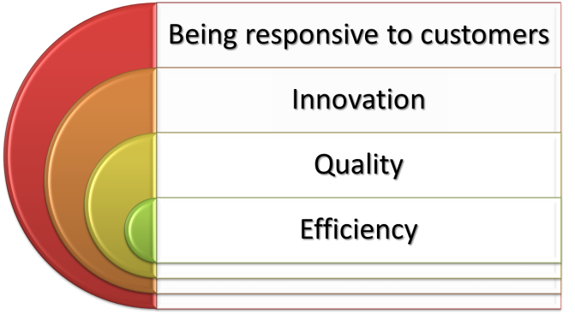
  - the ability of an organization to produce goods or services more effectively than competitors do, thereby outperforming them
Managing for Competitive Advantage

Question?
John wants his salespeople to use iPhones to improve their sales? Which challenge is he trying to manage?
- Diversity
- Information technology
- Competitive advantage
- Globalization

Managing for Information Technology
- By 2015, consumers are projected to spend $1.4 trillion online, a rise of 13.5 % annually
- Information technology has facilitated e-business, using the Internet to facilitate every aspect of running a business
Implications of e-business
- Far-ranging e-management and e-communication
- Accelerated decision making, conflict, and stress
- Changes in organizational structure, jobs, goal setting, and knowledge management
Managing for Sustainability
- Sustainability
  - economic development that meets the needs of the present without compromising the ability of future generations to meet their own needs.
What Managers Do: The Four Principal Functions
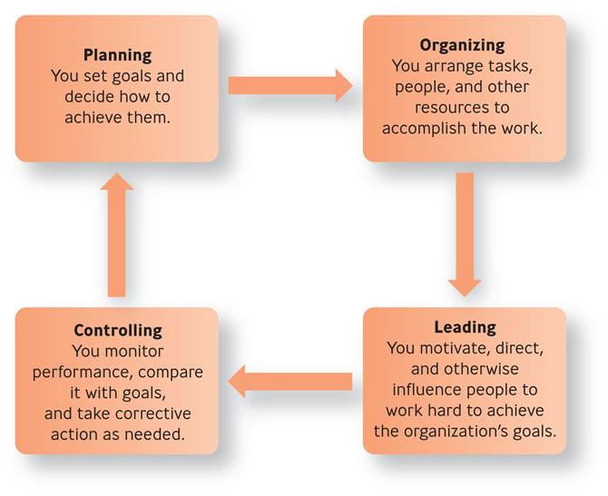
Question?
Laura runs a sales and expense report at the end of each work day? Which management function is she performing?
- Leading
- Organizing
- Controlling
- Planning
Pyramid Power: Levels & Areas of Management

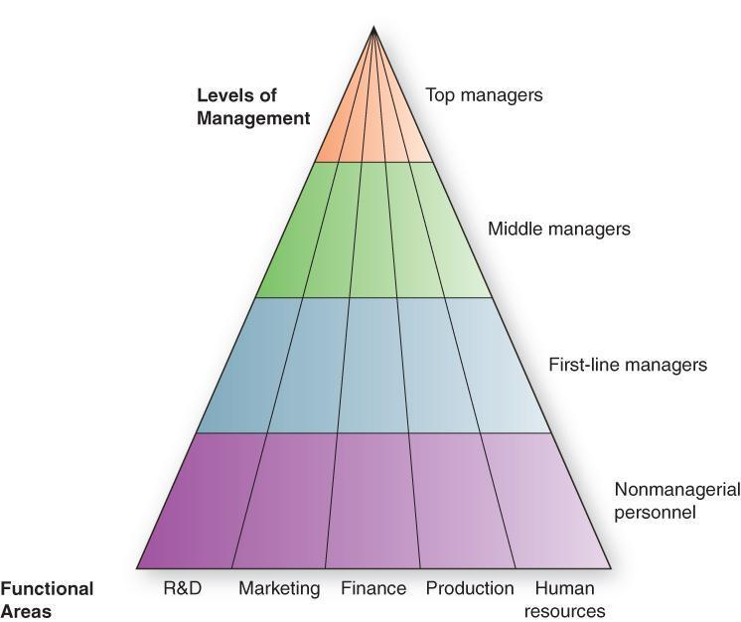
Pyramid Power: Levels & Areas of Management
- Top managers
  - make long-term decisions about the overall direction of the organization and establish the objectives, policies, and strategies for it
- Middle managers
  - implement the policies and plans of the top managers above them and supervise and coordinate the activities of the first-line managers below them
- First-line managers
  - make short-term operating decisions, directing the daily tasks of nonmanagerial personnel
- Functional manager
  - responsible for just one organizational activity
- General manager
  - responsible for several organizational activities
Question?
Donielle supervises the food assembly line workers. What type of manager is she?
- Top manager
- Middle manager
- First-line manager
- General manager

Roles Managers Must Play Successfully
The manager’s roles: Mintzberg’s useful findings
- A manager relies more on verbal than on written communication
- A manager works long hours at an intense pace
- A manager’s work is characterized by fragmentation, brevity, & variety
Three Types of Managerial Roles
- Interpersonal roles
  - managers interact with people inside and outside their work units
  - figurehead, leader, liaison
- Informational roles
  - managers receive and communicate information
  - monitor, disseminator, spokesperson
- Decisional roles
  - managers use information to make decisions to solve problems or take advantage of opportunities
  - entrepreneur, disturbance handler, resource allocator, negotiator
Question?
CEO, Gary Kelly sets the direction and strategy for Southwest Airlines. What type of managerial role is he performing?
- Interpersonal
- Informational
- Decisional
- Conclusive

The Entrepreneurial Spirit
- Entrepreneurship
  - process of taking risks to try to create a new empire
  - Entrepreneur,
intrapreneur
- Entrepreneur
  - someone who sees a new opportunity for a product or service and launches a business to try to realize it
- Intrapreneur
  - someone who works inside an existing organization who sees an opportunity for a product or service and mobilizes the organization’s resources to try to realize it

How Do Entrepreneurs & Managers Differ
- Being an entrepreneur is what it takes to start a business
- Being a manager is what it takes to grow or maintain a business
The Entrepreneurial Spirit
- Necessity entrepreneurs
  - people who suddenly must earn a living and are simply trying to replace lost income and are hoping a job comes along
- Opportunity entrepreneurs
  - those who start their business out of a burning desire rather than because they lost a job
Question?
George thought there was an opportunity and opened a new deli in Irmo. He is a(n) __________.
- Manager
- Intrapreneur
- Entrepreneur
- Omni-preneur

The Skills Exceptional Managers Need
- Technical skills
  - the job-specific knowledge needed to perform well in a specialized field
- Conceptual skills
  - the ability to think analytically, to visualize an organization as a whole and understand how the parts work together
- Human skills
  - the ability to work well in cooperation with other people to get things done
The Most Valued Traits in Managers
- The ability to motivate and engage others
- The ability to communicate
- Work experience outside the United States
- High energy levels to meet the demands of global travel and a 24/7 world

