Chapter 7:
Deadlocks
- System Model
- Deadlock Characterization
- Methods for Handling Deadlocks
- Deadlock Prevention
- Deadlock Avoidance
- Deadlock Detection
- Recovery from Deadlock
Chapter Objectives
- To develop a description of deadlocks, which prevent sets of concurrent processes from completing their tasks
- To present a number of different methods for preventing or avoiding deadlocks in a computer system
System Model
- System consists of resources
- Resource types R₁, R₂, . . ., R_{m}
CPU cycles, memory space, I/O devices
- Each resource type R_{i} has W_{i} instances.
- Each process utilizes a resource as follows:
  - request
  - use
  - release

Deadlock Characterization
- Mutual exclusion: only one process at a time can use a resource
- Hold and wait: a process holding at least one resource is waiting to acquire additional resources held by other processes
- No preemption: a resource can be released only voluntarily by the process holding it, after that process has completed its task
- Circular wait: there exists a set {P₀, P₁, …, P_{n}} of waiting processes such that P₀ is waiting for a resource that is held by P₁, P₁ is waiting for a resource that is held by
P₂, …, P_{n–1} is waiting for a resource that is held by P_{n}, and P_{n} is waiting for a resource that is held by P₀.

Deadlock with Mutex Locks
- Deadlocks can occur via system calls, locking, etc
- See example box in text page 318 for mutex deadlock

Resource-Allocation Graph
- V is partitioned into two types:
  - P = {P₁, P₂, …, P_{n}}, the set consisting of all the processes in the system
  - R = {R₁, R₂, …, R_{m}}, the set consisting of all resource types in the system
- request edge – directed edge P_{i} → R_{j}
- assignment edge – directed edge R_{j} → P_{i}
- Process
- Resource Type with 4 instances
- P_{i} requests instance of R_{j}
- P_{i} is holding an instance of R_{j}
Example of a Resource Allocation Graph
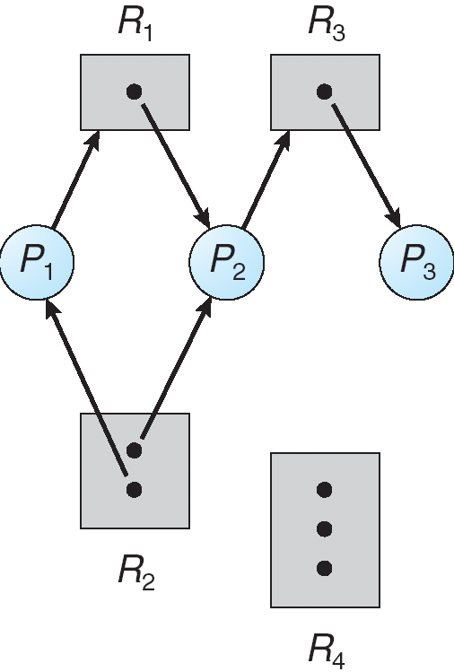
Resource Allocation Graph With A Deadlock
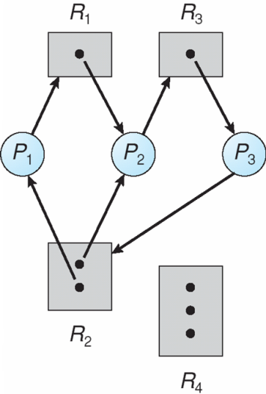
Graph With A Cycle But No Deadlock
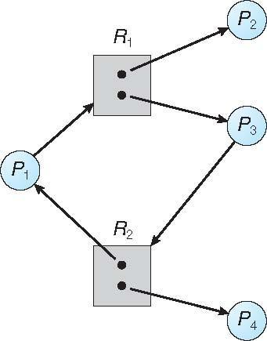
Basic Facts
- If graph contains no cycles ⇒ no deadlock
- If graph contains a cycle ⇒
  - if only one instance per resource type, then deadlock
  - if several instances per resource type, possibility of deadlock

Methods for Handling Deadlocks
- Ensure that the system will never enter a deadlock state
- Allow the system to enter a deadlock state and then recover
- Ignore the problem and pretend that deadlocks never occur in the system; used by most operating systems, including UNIX

Deadlock Prevention
- Mutual Exclusion – not required for sharable resources; must hold for nonsharable resources
- Hold and Wait – must guarantee that whenever a process requests a resource, it does not hold any other resources
  - Require process to request and be allocated all its resources before it begins execution, or allow process to request resources only when the process has none
  - Low resource utilization; starvation possible
- No Preemption –
  - If a process that is holding some resources requests another resource that cannot be immediately allocated to it, then all resources currently being held are released
  - Preempted resources are added to the list of resources for which the process is waiting
  - Process will be restarted only when it can regain its old resources, as well as the new ones that it is requesting
- Circular Wait – impose a total ordering of all resource types, and require that each process requests resources in an increasing order of enumeration

Deadlock Example
/* thread one runs in this function */
void *do work one(void *param)
{
pthread mutex lock(&first mutex);
pthread mutex lock(&second mutex);
/** * Do some work */
pthread mutex unlock(&second mutex);
pthread mutex unlock(&first mutex);
pthread exit(0);
}
/* thread two runs in this function */
void *do work two(void *param)
{
pthread mutex lock(&second mutex);
pthread mutex lock(&first mutex);
/** * Do some work */
pthread mutex unlock(&first mutex);
pthread mutex unlock(&second mutex);
pthread exit(0);
}
Deadlock Example with Lock Ordering
void transaction(Account from, Account to, double amount)
{
mutex lock1, lock2;
lock1 = get lock(from);
lock2 = get lock(to);
acquire(lock1);
acquire(lock2);
withdraw(from, amount);
deposit(to, amount);
release(lock2);
release(lock1); }
Deadlock Avoidance
- Simplest and most useful model requires that each process declare the maximum number of resources of each type that it may need
- The deadlock-avoidance algorithm dynamically examines the resource-allocation state to ensure that there can never be a circular-wait condition
- Resource-allocation state is defined by the number of available and allocated resources, and the maximum demands of the processes

Safe State
- When a process requests an available resource, system must decide if immediate allocation leaves the system in a safe state
- System is in safe state if there exists a sequence <P₁, P₂, …, P_{n}> of ALL the processes in the systems such that for each P_{i}, the resources that P_{i} can still request can be satisfied by currently available resources + resources held by all the P_{j}, with j < I
- That is:
  - If P_{i} resource needs are not immediately available, then P_{i} can wait until all P_{j} have finished
  - When P_{j} is finished, P_{i} can obtain needed resources, execute, return allocated resources, and terminate
  - When P_{i} terminates, P_{i +1} can obtain its needed resources, and so on

Basic Facts
- If a system is in safe state ⇒ no deadlocks
- If a system is in unsafe state ⇒ possibility of deadlock
- Avoidance ⇒ ensure that a system will never enter an unsafe state.

Safe, Unsafe, Deadlock State
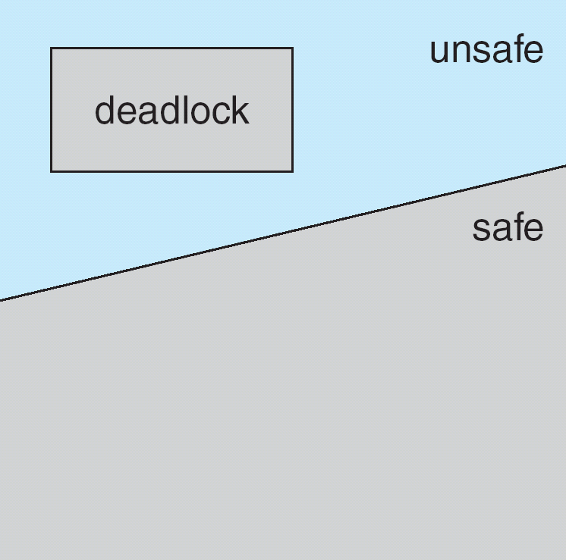

Avoidance algorithms
- Single instance of a resource type
  - Use a resource-allocation graph
- Multiple instances of a resource type
  - Use the banker’s algorithm
Resource-Allocation Graph Scheme
- Claim edge P_{i} → R_{j} indicated that process P_{j} may request resource R_{j}; represented by a dashed line
- Claim edge converts to request edge when a process requests a resource
- Request edge converted to an assignment edge when the resource is allocated to the process
- When a resource is released by a process, assignment edge reconverts to a claim edge
- Resources must be claimed a priori in the system

Resource-Allocation Graph
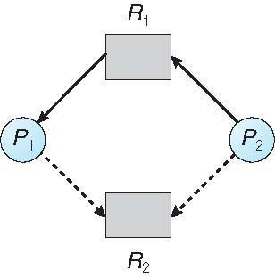
Unsafe State In Resource-Allocation Graph
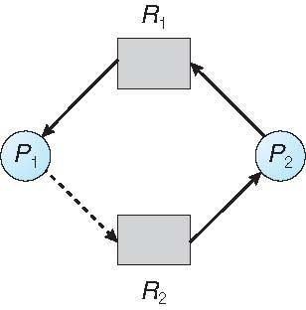
Resource-Allocation Graph Algorithm
- Suppose that process P_{i} requests a resource R_{j}
- The request can be granted only if converting the request edge to an assignment edge does not result in the formation of a cycle in the resource allocation graph

Banker’s Algorithm
- Multiple instances
- Each process must a priori claim maximum use
- When a process requests a resource it may have to wait
- When a process gets all its resources it must return them in a finite amount of time

Data Structures for the Banker’s Algorithm
- Available: Vector of length m. If available [j] = k, there are k instances of resource type R_{j} available
- Max: n x m matrix. If Max [i,j] = k, then process P_{i} may request at most k instances of resource type R_{j}
- Allocation: n x m matrix. If Allocation[i,j] = k then P_{i} is currently allocated k instances of R_{j}
- Need: n x m matrix. If Need[i,j] = k, then P_{i} may need k more instances of R_{j} to complete its task
Need [i,j] = Max[i,j] – Allocation [i,j]
Safety Algorithm
1. Let Work and Finish be vectors of length m and n, respectively. Initialize:
Work = Available
Finish [i] = false for i = 0, 1, …, n- 1
2. Find an i such that both:
(a) Finish [i] = false
(b) Need_{i} ≤ Work
If no such i exists, go to step 4
3. Work = Work + Allocation_{i}
Finish[i] = true
go to step 2
4. If Finish [i] == true for all i, then the system is in a safe state

Resource-Request Algorithm for Process P_{i}
Request = request vector for process P_{i}. If Request_{i} [j] = k then process P_{i} wants k instances of resource type R_{j}
1. If Request_{i} ≤ Need_{i} go to step 2. Otherwise, raise error condition, since process has exceeded its maximum claim
2. If Request_{i} ≤ Available, go to step 3. Otherwise P_{i} must wait, since resources are not available
3. Pretend to allocate requested resources to P_{i} by modifying the state as follows:
Available = Available – Request;
Allocation_{i} = Allocation_{i} + Request_{i};
Need_{i} = Need_{i} – Request_{i};
    - If safe ⇒ the resources are allocated to Pi
    - If unsafe ⇒ Pi must wait, and the old resource-allocation state is restored

Example of Banker’s Algorithm
- 5 processes P₀ through P₄;
3 resource types:
A (10 instances), B (5instances), and C (7 instances)
Snapshot at time T₀:
Allocation Max Available
A B C A B C A B C
P₀ 0 1 0 7 5 3 3 3 2
P₁ 2 0 0 3 2 2
P₂ 3 0 2 9 0 2
P₃ 2 1 1 2 2 2
P₄ 0 0 2 4 3 3

- The content of the matrix Need is defined to be Max – Allocation
Need
A B C
P₀ 7 4 3
P₁ 1 2 2
P₂ 6 0 0
P₃ 0 1 1
P₄ 4 3 1
- The system is in a safe state since the sequence < P₁, P₃, P₄, P₂, P₀> satisfies safety criteria

Example: P₁ Request (1,0,2)
- Check that Request ≤ Available (that is, (1,0,2) ≤ (3,3,2) ⇒ true
Allocation Need Available
A B C A B C A B C
P₀ 0 1 0 7 4 3 2 3 0
P₁ 3 0 2 0 2 0
P₂ 3 0 2 6 0 0
P₃ 2 1 1 0 1 1
P₄ 0 0 2 4 3 1
- Executing safety algorithm shows that sequence < P₁, P₃, P₄, P₀, P₂> satisfies safety requirement
- Can request for (3,3,0) by P₄ be granted?
- Can request for (0,2,0) by P₀ be granted?

Deadlock Detection
- Allow system to enter deadlock state
- Detection algorithm
- Recovery scheme

Single Instance of Each Resource Type
- Maintain wait-for graph
  - Nodes are processes
  - P_{i} → P_{j} if P_{i} is waiting for P_{j}
- Periodically invoke an algorithm that searches for a cycle in the graph. If there is a cycle, there exists a deadlock
- An algorithm to detect a cycle in a graph requires an order of n² operations, where n is the number of vertices in the graph

Resource-Allocation Graph and Wait-for Graph

Several Instances of a Resource Type
- Available: A vector of length m indicates the number of available resources of each type
- Allocation: An n x m matrix defines the number of resources of each type currently allocated to each process
- Request: An n x m matrix indicates the current request of each process. If Request [i][j] = k, then process P_{i} is requesting k more instances of resource type R_{j}.

Detection Algorithm
1. Let Work and Finish be vectors of length m and n, respectively Initialize:
(a) Work = Available
(b) For i = 1,2, …, n, if Allocation_{i} ≠ 0, then
Finish[i] = false; otherwise, Finish[i] = true

2. Find an index i such that both:
(a) Finish[i] == false
(b) Request_{i} ≤ Work
If no such i exists, go to step 4

3. Work = Work + Allocation_{i}
Finish[i] = true
go to step 2
4. If Finish[i] == false, for some i, 1 ≤ i ≤ n, then the system is in deadlock state. Moreover, if Finish[i] == false, then P_{i} is deadlocked
Algorithm requires an order of O(m x n²) operations to detect whether the system is in deadlocked state

Example of Detection Algorithm
- Five processes P₀ through P₄; three resource types
A (7 instances), B (2 instances), and C (6 instances)
- Snapshot at time T₀:
Allocation Request Available
A B C A B C A B C
P₀ 0 1 0 0 0 0 0 0 0
P₁ 2 0 0 2 0 2
P₂ 3 0 3 0 0 0
P₃ 2 1 1 1 0 0
P₄ 0 0 2 0 0 2
- Sequence <P₀, P₂, P₃, P₁, P₄> will result in Finish[i] = true for all i
- P₂ requests an additional instance of type C
Request
A B C
P₀ 0 0 0
P₁ 2 0 2
P₂ 0 0 1
P₃ 1 0 0
P₄ 0 0 2
- State of system?
  - Can reclaim resources held by process P₀, but insufficient resources to fulfill other processes; requests
  - Deadlock exists, consisting of processes P₁, P₂, P₃, and P₄

Detection-Algorithm Usage
- When, and how often, to invoke depends on:
  - How often a deadlock is likely to occur?
  - How many processes will need to be rolled back?
    - one for each disjoint cycle
- If detection algorithm is invoked arbitrarily, there may be many cycles in the resource graph and so we would not be able to tell which of the many deadlocked processes “caused” the deadlock.
Recovery from Deadlock: Process Termination
- Abort all deadlocked processes
- Abort one process at a time until the deadlock cycle is eliminated
- In which order should we choose to abort?
  - Priority of the process
  - How long process has computed, and how much longer to completion
  - Resources the process has used
  - Resources process needs to complete
  - How many processes will need to be terminated
  - Is process interactive or batch?

Recovery from Deadlock: Resource Preemption
- Selecting a victim – minimize cost
- Rollback – return to some safe state, restart process for that state
- Starvation – same process may always be picked as victim, include number of rollback in cost factor

