Definition of Operating System (Section 1.1)
1.1.3 Defining Operating Systems
Moore’s Law predicted that the number of transistors on an integrated circuit would double every eighteen months, and that prediction has held true.
Computers gained in functionality and shrunk in size, leading to a vast number of uses and a vast number and variety of operating systems.
- no completely adequate definition of an operating system
1- The common functions of controlling and allocating resources such as those controlling the I/O devices are brought together into one piece of software: the operating system.

2-A more common definition: the operating system is the one program running at all times on the computer—usually called the kernel:
Along with the kernel, there are two other types of programs:
System programs: associated with the operating system but are not necessarily part of the kernel
Application programs: include all programs not associated with the operation of the system.

3-Mobile operating systems often include not only a core kernel but also middleware—a set of software frameworks that provide additional services to application developers.

Bluetooth and 802.11 (Section 1.11)
Bluetooth and 802.11 devices use wireless technology to communicateover a distance of several feet, in essence creating a personal-area network (PAN)between a phone and a headset or a smartphone and a desktop computer.
Microkernel (Section 2.7)
2.7.3 Microkernels
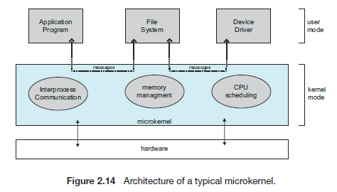
Researchers at Carnegie Mellon University developed an OS called Mach that modularized the kernel using the microkemel approach.
Microkernels method: structures the OS by removing all nonessential components from the kernel and implementing them as system and user-level programs. The result is a smaller kernel.
Micro kernels provide minimal process and memory management, and communication facility.
Main function of the microkemel is to provide communication through message passing between the client program and the various services running in user space.
Benefit of the microkernel:
- Makes extending the operating system easier (new services are added to user space and consequently do not require modification of the kernel.)
- The microkernel also provides more security and reliability, since most services are running as user- rather than kernel- processes.
- Ex: The Mac OS X kernel (also known as Darwin) is partly based on the Mach microkernel.
Unfortunately, the performance of microkernels can suffer due to increased system-function overhead. EX: Windows NT which corrected later (Windows 95. Windows NT 4.0).
By the time Windows XP was designed, Windows architecture had become more monolithic than microkernel.
Major categories of system calls (Section 2.4)
2.4 Types of System Calls
System calls can be grouped roughly into six major categories: process control, file manipulation, device manipulation, information maintenance, communications, and protection.

2.4.1 Process Control
- A running program needs to be able to halt its execution either normally (end()) or abnormally (abort()).
- Terminating abnormally:
A dump of memory is sometimes taken and an error message generated. The dump is written to disk and may be examined by a debugger—a system program designed to aid (help) the programmer in finding and correcting errors, or bugs—to determine the cause of the problem.

A process or job executing one program may want to load () and execute () another program.

THIS section is really important I couldn’t make a summary for it. Please look it in textbook.
2.4.2 File Management
We first need to be able to: create () and delete () open () read (), write (), or reposition () (rewind or skip to the end of the file, for example). Close () the file.
- For either files or directories, we need to be able to determine the values of various attributes and perhaps to reset them.
- File attributes include the file name, file type, protection codes, accounting information, and so on. At least two system calls, get file attributes () and set file attributes (), are required for this function.
- Some operating systems provide move () and copy ().
2.4.3 Device Management

The various resources (needed to execute a process) controlled by the operating system can be thought of as devices (physical devices (disk drives), and abstract or virtual devices (files)).
- A system with multiple first request () a device, to ensure exclusive use of it then release it.These functions is similar to the open () and close () system calls for files. We can read(),write (), and (possibly) reposition() the device, just as we can with files.
- The similarity led to merge the two into a combined file-device structure with system calls used on both.
2 .4.4 Information Maintenance
- Many system calls exist for transferring information between the user program and the operating system. EX: system call to return the current time () and date ().
- Another set of system calls is helpful in debugging a program.
EX: system calls to dump () memory.
- A program trace lists each system call as it is executed.
Microprocessors provide a single step, in which a trap is executed by the CPU after every instruction. The trap is usually caught by a debugger.
- Many operating systems provide a time profile (time that the program executes at a particular location) of a program.
- At every occurrence of the timer interrupt, the value of the program counter is recorded.
- Calls are also used to reset the process information (get-process-attributes () and set-process_attributes ()).

2.4.5 Communication
Two common models of interprocess communication: the message passing model and the shared-memory model.

- In the message-passing model, the communicating processes exchange messages with one another to transfer information directly or indirectly through a common mailbox.

Each computer in a network has a host name which must has network identifier (IP).
Each process has a process name, and this name is translated into an identifier.

- The get_hostid () and get_processid () system calls do this translation.
- Depending on the system’s model of communication, identifiers are then passed to the open() and close() calls or open_connection() and close_connection().
- The recipient process usually must give its permission with an accept_connection () call.

- Receiving connections processes are special-purpose daemons:
- They execute a wait_for_connection () call and are awakened when a connection is made.
- The source of the communication, known as the client, and the receiving daemon, known as a server, then exchange messages by using read_message() and write_message() system calls. The close connection () call terminates the communication.

- In the shared-memory model, processes use shared memory create () and shared memory attach () system calls to create and access to regions of memory owned by other processes.

2.4.6 Protection
Protection provides a mechanism for controlling access to the resources provided by a computer system.

System calls providing protection include set_permission () and get_Permission (), which manipulate the permission settings of resources such as files and disks.
The allow_user () and deny_user () system calls: access to certain resources.
•Process control  ◦end, abort  ◦load, execute  ◦create process, terminate process  ◦get process attributes, set process attributes  ◦wait for time  ◦wait event, signal event  ◦allocate and free memory | •Device management  ◦request device, release device  ◦read, write, reposition  ◦get device attributes, set device attributes  ◦logically attach or detach devices
•File management  ◦create file, delete file  ◦open, close  ◦read, write, reposition  ◦get file attributes, set file attributes | •Information maintenance  ◦get time or date, set time or date  ◦get system data, set system data  ◦get process, file, or device attributes  ◦set process, file, or device attributes
•Communications
◦create, delete communication connection
◦send, receive messages
◦transfer status information
◦attach or detach remote devices
Figure 2.8 Types of system calls.

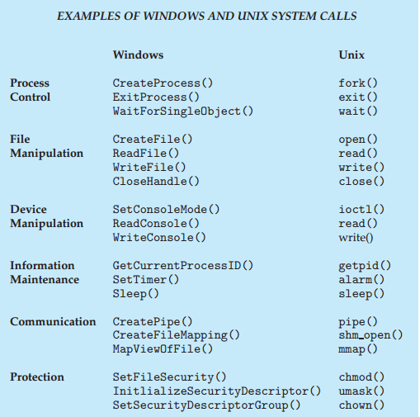

Process Control Block (Section 3.1)
3.1.3 Process Control Block
Each process is represented in the OS by a process control block (PCB) - also called a task control block.
A PCB contains many pieces of information associated with a specific process, including these:
• Process state: new, ready, running, waiting, halted, and so on.
• Program counter. Indicates the address of the next instruction to be executed for this process.
• CPU registers vary in number and type, They include accumulators, index registers, stack pointers, and general-purpose registers, plus any condition-code information. Along with the program counter, this state information must be saved when an interrupt occurs, to allow the process to be continued correctly afterward (Figure 3.4).
• CPU-scheduling information: includes a process priority, pointers to scheduling queues, and any other scheduling parameters.
• Memory-management information: include such items as the value of the base and limit registers and the page tables, or the segment tables, depending on the memory system used by the operating system .
• Accounting information: includes the amount of CPU and real time used, time limits, and so on.
• 110 status information: includes the list of I/O devices allocated to the process, a list of open files, and so on.
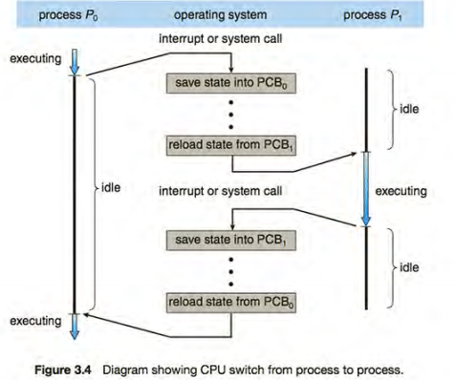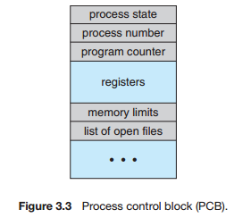

List of Process Queues (Section 3.2)
3.2.1 Scheduling Queues
- As processes enter the system, they are put into a job queue, which consists of all processes in the system.
- The processes in main memory (ready and waiting to execute) are kept on a linked list called the ready queue.
- A ready-queue header contains pointers to the first and final PCBs in the list.
- Each PCB includes a pointer field that points to the next PCB in the ready queue.
- The system also includes other queues.
- When a process is allocated the CPU, it executes for a while and eventually quits, is interrupted, or waits for the occurrence of a particular event, such as the completion of an I/O request.
- Suppose the process makes an I/O request to a shared device, such as a disk. Since there are many processes in the system, the disk may be busy with the I/O request of some other process.
- The list of processes waiting for a particular I/O device is called a device queue. Each device has its own device queue. Figure 3-5..
- A common representation of process scheduling is queuing diagram, such as that in Figure 3.6

A new process is initially put in the ready queue. It waits there until it is selected for execution, or dispatched. Once the process is allocated the CPU and is executing_ one of several events could occur:
• The process could issue an I/O request and then be placed in an I/O queue.
• The process could create a new child process and wait for the child's termination.
• The process could be removed forcibly from the CPU, as a result of an interrupt, and be put back in the ready queue.
In the first two cases, the process eventually switches from the waiting state to the ready state and is then put back in the ready queue. A process continues this cycle until it terminates, at which time it is removed from all queues and has its PCB and resources deallocated.
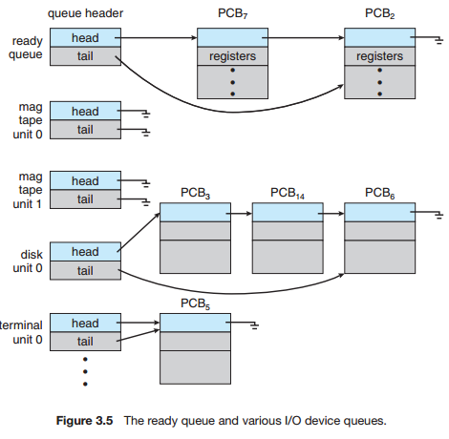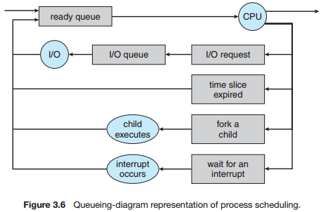
- Each rectangular box represents a queue.
- Two types of queues are present: the ready queue and a set of device queues.
- The circles represent the resources that serve the queues.
- The arrows indicate the flow of processes in the system.

Types of multithreading models (Section 4.3)
4.3 Multithreading Models
Support for threads may be provided either at the user level, for user threads (above the kernel), or by the kernel, for kernel threads.
Virtually all contemporary operating systems-including Windows, Linux, Mac OS X, and Solaris support kernel threads.
Three common ways of establishing a relationship between kernel and user thread:
4.3.1 Many-to-One Model | 4.3.2 One-to-One Model | 4.3.3 Many-to-Many Model
The many-to-one model maps many user-level threads to one kernel thread. | The one-to-one model maps each user thread to a kernel thread. | The many-to-many model multiplexes many user-level threads to a smaller or equal number of kernel threads.
Thread management is done by the thread library in user space, so it is efficient.  *Multiple threads are unable to run in parallel on multicore systems.  Green threads- a thread library available for Solaris used this model.  *very few systems continue to use the model because of its inability to take advantage of multiple processing cores. | Provides more concurrency than the many-to-one model by allowing another thread to run when a thread makes a blocking system call.  *allows multiple threads to run in parallel on multiprocessors.  *The only drawback is that creating a user thread requires creating the corresponding kernel thread. | the effect of this design on concurrency:  Developers can create as many user threads as necessary, and the corresponding kernel threads can run in parallel on a multiprocessor. Also, when a thread performs a blocking system call, the kernel can schedule another thread for  Execution.
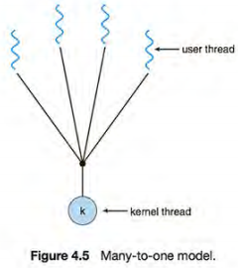 | 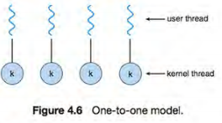 | 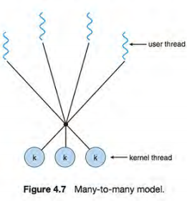
One variation on the many-to-many model still multiplexes many user level threads to a smaller or equal number of kernel threads but also allows a user-level thread to be bound to a kernel thread. This variation is sometimes referred to as the two-level model
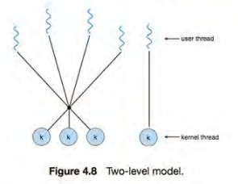

Threads and Thread Library (Section 4.4)
4.4 Thread libraries
A thread library provides the programmer with an API for creating and managing threads.
Two primary ways of implementing a thread library:
- The first approach is to provide a library entirely in user space with no kernel support: All code and data structures for the library exist in user space. This means that invoking a function in the library results in a local function call in user space and not a system call
- The second approach is to implement a kernel-level library supported directly by the operating system: code and data structures for the library exist in kernel space. Invoking a function in the API for the library typically results in a system call to the kernel.
Three main thread libraries are in use today: POSIX Pthreads (kernel or user), Windows (kernel), and Java.
- Pthreads, extension of the POSIX standard. Provided as either a user-level or a kernel-level library.
- The Java thread API
- Implemented using a thread library available on the host system because in most instances the JVM is running on top of a host operating system.
- Allows threads to be created and managed directly in Java programs.
- The Windows thread library is a kernel-level library available on Windows systems.
- This means that on Windows systems, Java threads are typically implemented using the Windows API; UNIX and Linux systems often use Pthreads.

- For POSIX and Windows threading, any data declared globally—that is, declared outside of any function—are shared among all threads belonging to the same process.

- Because Java has no notion of global data, access to shared data must be explicitly arranged between threads. Data declared local to a function are typically stored on the stack.

- Since each thread has its own stack, each thread has its own copy of local data.
Two general strategies for creating multiple threads:
- Asynchronous threading: once the parent creates a child thread, the parent resumes its execution, so that the parent and child execute concurrently.
- Each thread runs independently of every other thread, and the parent thread need not know when its child terminates.
- Little data sharing between threads.
- Synchronous threading occurs when the parent thread creates one or more children and then must wait for all of its children to terminate before it resumes-the so-called fork-join strategy.
- Significant data sharing among threads.
4.4.1 Pthreads
4.4.2 Windows Threads
4.4.3 Java Threads look textbook p170-175
I don’t know if we have to look at this much of details.
Definition of Throughput (Section 5.2)
Scheduling Criteria: Many criteria have been suggested for comparing CPU-scheduling algorithms. This is one of these criteria:
Throughput. If the CPU is busy executing processes, then work is being done. One measure of work is the number of processes that are completed per time unit, called throughput. For long processes, this rate may be one process per hour; for short transactions, it may be ten processes per second.
Time sharing 5-7
Solaris uses priority-based thread scheduling. Each thread belongs to one of six classes:
1. Tune sharing (TS)
2. Interactive (IA)
3. Real time (RT)
4. System (SYS)
5. Fair share (FSS)
6. Fixed priority (FP)
Within each class there are different priorities and different scheduling algorithms.
- The default scheduling class for a process is time sharing.
- The scheduling policy for the time-sharing class dynamically alters priorities and assigns time slices of different lengths using a multilevel feedback queue.
- By default, there is an inverse relationship between priorities and time slices. The higher the priority, the smaller the time slice; and the lower the priority, the larger the time slice.

Operations for protecting a critical section using mutex locks (Section 6.5)
6.5 Mutex Locks
Instead of hardware-based solutions, operating-systems designers build software tools to solve the critical-section problem mutex lock (short for mutual exclusion).
- Used to protect critical regions and thus prevent race conditions.
- A process must acquire (acquire ()) the lock before entering a critical section; it releases (release ()) the lock when it exits the critical section.
- A mutex lock has a Boolean variable available
- A process that attempts to acquire an unavailable lock is blocked until the lock is released.
- 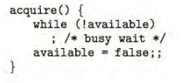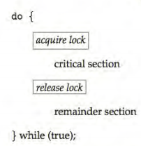
- The main disadvantage of the implementation given here is that it requires busy waiting.
- Spinlock: While a process is in its critical section, any other process that tries to enter its critical section must loop continuously.
- In fact, this type of mutex lock called a spinlock because the process "spins" while waiting for the lock to become available.
- Advantage: no context switch is required when a process must wait on a lock, and a context switch may take considerable time- employed on multiprocessor systems.

Priority Inversion (Section 6.6)
A scheduling challenge happened when a higher-priority process needs to read or modify kernel data that are currently accessed by (one/chain) of lower-priority processes.
- Since kernel data are protected with a lock, the higher-priority process will have to wait for a lower-priority one to finish with the resource.
- More complicated Situation if the lower-priority process is preempted in favor of another process with a higher priority.
- As an example, assume we have three processes-L, M, and H-whose priorities follow the order L < M < H.
- Assume that process H requires resource R, which is currently being accessed by process L. Ordinarily, process H would wait for L to finish using resource R. However, now suppose that process M becomes runnable, thereby preempting process L. Indirectly, a process with a lower priority- process M- has affected how long process H must wait for L to relinquish resource R.
- This problem is known as priority inversion. It occurs only in systems with more than two priorities, so one solution is to have only two priorities (insufficient solution).

- They solve the problem by implementing:
Priority-inheritance protocol: all processes that are accessing resources needed by a higher-priority process inherit the higher priority until they are finished with the resources in question.
- When they are finished, their priorities revert to their original values.
- In the example above, a priority-inheritance protocol would allow process L to temporarily inherit the priority of process H, thereby preventing process M from preempting its execution. When process L had finished using resource R, it would relinquish its inherited priority from H and assume its original priority. Because resource R would now be available, process H- not M- would run next.
Deadlock and necessary conditions for deadlock (Section 7.2)
7.2.1 Necessary Conditions
In a deadlock, processes never finish executing, and system resources are tied up, preventing other jobs from starting.
A deadlock situation can arise if the following four conditions hold simultaneously in a system:
- Mutual exclusion. At least one resource must be held in a nonsharable mode; that is, only one process at a time can use the resource. If another process requests that resource, the requesting process must be delayed until the resource has been released.
- Hold and wait. A process must be holding at least one resource and waiting to acquire additional resources that are currently being held by other processes.
- No preemption. Resources cannot be preempted; that is, a resource can be released only voluntarily by the process holding it, after that process has completed its task.
- Circular wait. A set {P0, P1, ... , P,} of waiting processes must exist such that Po is waiting for a resource held by P,, P1 is waiting for a resource held by P2, ... , P,_, is waiting for a resource held by P,, and Pn is waiting for a resource held by Po.
- All four conditions must hold for a deadlock to occur.
Logical Address (Section 8.1)
An address generated by the CPU is commonly referred to as a logical address (virtual address).
- The set of all logical addresses generated by a program is a logical address space.
- (In the range 0 to max).
- The user program generates only logical addresses and thinks that the process runs in locations 0 to max. However, these logical addresses must be mapped to physical addresses before they are used.
- The user program deals with logical addresses. The memory mapping hardware converts logical addresses into physical addresses.
- The run-time mapping from virtual to physical addresses is done by a hardware device called the memory-management unit (MMU): now called a relocation register.
- The value in the relocation register is added to every address generated by a user process at the time the address is sent to memory (see Figure 8.4). For example, if the base is at 14000, then an attempt by the user to address location 0 is dynamically relocated to location 14000; an access to location 346 is mapped to location 14346.
- The user program never sees the real physical addresses. The program can create a pointer to location 346, store it in memory, manipulate it, and compare it with other addresses.
- Only when it is used as a memory address (in an indirect load or store, perhaps) is it relocated relative to the base register.

Dynamically linked library (Section 8.1)
Dynamically linked libraries: are system libraries that are linked to user programs when the programs are run.
- Some operating systems support only static linking: in which system libraries are treated like any other object module and are combined by the loader into the binary program image.
- Dynamic linking, in contrast, is similar to dynamic loading. Here, though, linking, rather than loading, is postponed until execution time.
- With dynamic linking, a stub is included in the image for each library routine reference.
- The stub is a small piece of code that indicates how to locate the appropriate memory resident library routine or how to load the library if the routine is not already present.
- When the stub is executed, it checks to see whether the needed routine is already in memory.
- If it is not, the program loads the routine into memory. Either way, the stub replaces itself with the address of the routine and executes the routine.
- Thus, the next time that particular code segment is reached, the library routine is executed directly, incurring no cost for dynamic linking.
- Under this scheme, all processes that use a language library execute only one copy of the library code.
- This feature can be extended to library updates (such as bug fixes). A library may be replaced by a new version, and all programs that reference the library will automatically use the new version.
- More than one version of a library may be loaded into memory, and each program uses its version information to decide which copy of the library to use. This system is also known as shared libraries.
- Unlike dynamic loading, dynamic linking and shared libraries generally require help from the operating system.

The Vfork() system call in UNIX (Section 9.1)

- Several versions of UNIX provide a variation of the vfork() system call:
- Vfork() (for virtual memory fork)-that operates differently from fork () with copy-on-write.
- With vfork (), the parent process is suspended, and the child process uses the address space of the parent.
- Because vfork () does not use copy-on-write, if the child process changes any pages of the parent's address space, the altered pages will be visible to the parent once it resumes.
- The vfork () Must be used with caution to ensure that the child process does not modify the address space of the parent.
- Vfork () is intended to be used when the child process calls exec() immediately after creation.
- Because no copying of pages takes place, vfork() is an extremely efficient method of process creation and is sometimes used to implement UNIX command-line shell interfaces.
Examples of executable files (Section 10.1)
The name is split into two parts- a name and an extension, usually separated by a period.
- In this way, the user and the operating system can tell from the name alone what the type of a file is.
- Most operating systems allow users to specify a file name as a sequence of characters followed by a period and terminated by an extension made up of additional characters.
- Examples include resume. docx, server. c, and ReaderThread.cpp.
Only a file with a.com, a. exe, or a. sh extension can be executed, for instance.
- The. com and . exe files are two forms of binary executable files, whereas the . sh file is a shell script containing, in ASCll format, commands to the operating system.
- Application programs also use extensions to indicate file types in which they are interested.
- For example, Java compilers expect source files to have a. java extension, and the Microsoft Word word processor expects its files to end with a . doc or . docx extension. These extensions are not always required.
- Consider, too, the Mac OS X operating system. In this system, each file has a type, such as .app (for application). Each file also has a creator attribute containing the name of the program that created it.
- This attribute is set by the operating system during the create () call,
- For instance, a file produced by a word processor has the word processor's name as its creator.
- The UNIX system uses a crude magic number stored at the beginning of some files to indicate roughly the type of the file-executable program, shell script, PDF file, and so on.
File attributes (Section 10.1)
A file's attributes vary from one operating system to another but typically consist of these:
- Name. The symbolic file name is the only information kept in human readable form.
- Identifier. This unique tag, usually a number, identifies the file within the file system; it is the non-human-readable name for the file.
- Type. This information is needed for systems that support different types of files.
- Location. This information is a pointer to a device and to the location of the file on that device.
- Size. The current size of the file (in bytes, words, or blocks) and possibly the maximum allowed size are included in this attribute.
- Protection. Access-control information determines who can do reading, writing, executing, and so on.
- Time, date, and user identification. This information may be kept for creation, last modification, and last use. These data can be useful for protection, security, and usage monitoring.
File access methods (Section 10.2)
The information in the file can be accessed in several ways. Some systems provide only one access method for files. while others support many access methods, and choosing the right one for a particular application is a major design problem.
10.2.1 Sequential Access
The simplest access method and most common.
- Information in the file is processed in order, one record after the other.
- Reads and writes make up the bulk of the operations on a file.
- A read operation –read_next ()-reads the next portion of the file and automatically advances a file pointer, which tracks the I/o location.
- The write operation- write_next () - appends to the end of the file and advances to the end of the newly written material (the new end of file).
- Such a file can be reset to the beginning, and on some systems, a program may be able to skip forward or backward n records for some integer n perhaps only for n = 1.
- Sequential access, which is depicted in Figure 10.4, is based on a tape model of a file and works as well on sequential-access devices as it does on random-access ones.
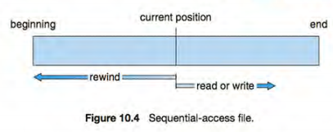
10.2.2 Direct Access (relative access)
- A file is made up of fixed-length logical records that allow programs to read and write records rapidly in no particular order.
- The direct-access method is based on a disk model of a file, since disks allow random access to any file block.
- The file is viewed as a numbered sequence of blocks or records. Thus, we may read block 14.
- Direct-access files are of great use for immediate access to large amounts of information. Databases are often of this type.
- For the direct-access method, the file operations must be modified to include the block number as a parameter. Thus, we have read (n), where n is the block number, rather than read.next ().
- The block number provided by the user to the operating system is normally a relative block number: an index relative to the beginning of the file.
- There are no restrictions on the order of reading or writing for a direct-access file.
- The use of relative block numbers
- Allows the operating system to decide where the file should be placed {called the allocation problem.
- Helps to prevent the user from accessing portions of the file system that may not be part of her file.
- How, then, does the system satisfy a request for record Nina file?
- Assuming we have a logical record length L, the request for record N is turned into an I/0 request for L bytes starting at location L * (N) with.in the file (assuming the first record is N = 0). Since logical records are of a fixed size, it is also easy to read, write, or delete a record.
10.2.3 Other Access Methods
Other access methods can be built on top of a direct-access method. These methods generally involve the construction of an index for the file.
- The index, like an index in the back of a book, contains pointers to the various blocks.
- To find a record in the file, we first search the index and then use the pointer to access the file directly and to find the desired record.
- For example, a retail-price file might list the universal product codes (UPCs) for items, with the associated prices. Each record consists of a 10-digit UPC and a 6-digit price, for a 16-byte record. If our disk has 1,024 bytes per block, we can store 64 records per block. A file of 120,000 records would occupy about 2,000 blocks (2 million bytes).
- By keeping the file sorted by UPC, we can define an index consisting of the first UPC in each block. This index would have 2,000 entries of 10 digits each, or 20,000 bytes, and thus could be kept in memory.
- To find the price of a particular item, we can make a binary search of the index.
- With large files, the index file itself may become too large to be kept in memory.
- One solution is to create an index for the index file. The primary index file contains pointers to secondary index files, which point to the actual data items.
- For example, IBM's indexed sequential-access method (ISAM) uses a small master index that points to disk blocks of a secondary index.

Algorithms for managing a buffer cache File access methods (Section 11.6)

- Some systems maintain a separate section of main memory for a buffer cache, where blocks are kept under the assumption that they will be used again shortly.
- Other systems cache file data using a page cache.
- The page cache uses virtual memory techniques to cache file data as pages rather than as file-system-oriented blocks.
- Caching file data using virtual addresses is far more efficient than caching through physical disk blocks, as accesses interface with virtual memory rather than the file system.
- Several systems-including Solaris, Linux, and Windows -use page caching to cache both process pages and file data. This is known as unified virtual memory.
- Some versions of UNIX and Linux provide a unified buffer cache.
- To illustrate the benefits of the unified buffer cache, consider the two alternatives for opening and accessing a file:
- One approach is to use memory mapping (Section 9 .7).
- the second is to use the standard system calls read() and write ().
Without a unified buffer cache, we have a situation similar to Figure 11.11.
- 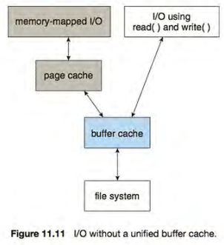
- Here, the read() and write() system calls go through the buffer cache.
- The memory-mapping call, however, requires using two caches- the page cache and the buffer cache. A memory mapping proceeds by reading in disk blocks from the file system and storing them in the buffer cache. Because the virtual memory system does not interface with the buffer cache, the contents of the file in the buffer cache must be copied into the page cache.
- This situation, known as double caching, requires caching file-system data twice.
- Not only does it waste memory but it also wastes significant CPU and I/0 cycles due to the extra data movement within system memory.
- Inconsistencies between the two caches can result in corrupt files.
In contrast, when a unified buffer cache is provided,
Both memory mapping and the read () and write () system calls use the same page cache.
- This has the benefit of avoiding double caching, and it allows the virtual memory system to manage file-system data. The unified buffer cache is shown in Figure 11.12.
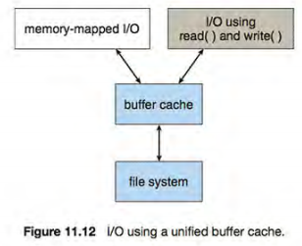

- Another issue that can affect the performance of 1/0 is whether writes to the file system occur synchronously or asynchronously.
Synchronous writes | asynchronous write
Occur in the order in which the disk subsystem receives them, and the writes are not buffered.  Thus, the calling routine must wait for the data to reach the disk drive before it can proceed.  - Operating systems frequently include a flag in the open system call to allow a process to request that writes be performed synchronously. | The data are stored in the cache, and control returns to the caller. Most writes are asynchronous.

- Some systems optimize their page cache by using different replacement algorithms, depending on the access type of the file.
- A file being read or written sequentially should not have its pages replaced in LRU order, because the most recently used page will be used last, or perhaps never again.
- Instead, sequential access can be optimized by techniques known as free-behind and read-ahead.
Free-behind removes a page from the buffer as soon as the next page is requested. The previous pages are not likely to be used again and waste buffer space. | With read-ahead, a requested page and several subsequent pages are read and cached. These pages are likely to be requested after the current page is processed. Retrieving these data from the disk in one transfer and caching them saves a considerable amount of time.

