Midterm Examination Cover Sheet
First Semester: 1435-1436 / 2014-2015
Course Instructor: |  | Exam Date: | 13-11-2014
Course Title: | Discrete Mathematics | Course Code: | Math-150
Exam Duration: | One Hour | Number of Pages: (including cover page) | 4

Exam Guidelines
- Mobile phones are not permitted.
- Calculators are permitted.

Marking Scheme
Questions | Score

Student Name: |  | Student ID:
Section I
State whether the following statements are True or False (1 Mark Each)

(i) The bi conditional statement $p↔q$ is false when both $p$ and $q$ are false. F
(ii) The value of is 0. True
(iii) If n is odd integer, then n² is odd. True
(iv) The seventh term $a_{6}$ of the sequence defined by the recurrence relation and initial conditions,
$a_{n}=a_{n-1}- a_{n-2}+a_{n-3}$ , $a_{0}=1, a_{1}=1, a_{2}=2$ is 1. F
(v) If f1(x) and f2(x) are both O(g(x)). Then (f1+f2)(x) is O(g(x)). True
Question | (i) | (ii) | (iii) | (iv) | (v)
Answer

Section II
From the following choose the correct answer (1 Mark Each)
1. the negation of the statement $\sim p→q$ is:
(a) $p⋀q$ (b)$p⋀∼q$ (c)$\sim p⋀∼q$ (d)$\sim p⋀q$
2.Derive the Boolean expression for the logic circuit shown below:
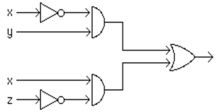
(a) $\overline{x}y+xz$ (b) $\overline{x}y+x\overline{z}$ (c) $x\overline{y}+xz$ (d) None of above
3. Universal quantifier is denoted by
(a)$∀$ (b)µ (c) (d)None
4. Let A be a $3×4$ matrix, B be a $4×5$ matrix, and C be a $4×4$ matrix. Determine which of the
following products is not defined ?
(a)AB (b) AC (c) CA (d) CB.
5. which of these functions is not O(x²).
(a) f(x)=17x +11 (b)f(x)=x²+1000 (c) f(x)= xlogx (d)f(x)=x⁴/2
6. convert ( 204 ) ₁₀ to base 2 .
(a)10001000 (b)11001100 (c)00001111 ( d)00000000
7. The prime factorization of 56 is
(a)2³.7 (b) 2².7 (c)7³.2 (d)None
Question | 1 | 2 | 3 | 4 | 5 | 6 | 7
Answer

Section III
Attempt all questions (3 Marks Each)

1. Build a digital circuit that produces the output (p ∨￢r) ∧(￢p ∨(q ∨￢r)) when
given input bits p, q, and r.
Solutions:

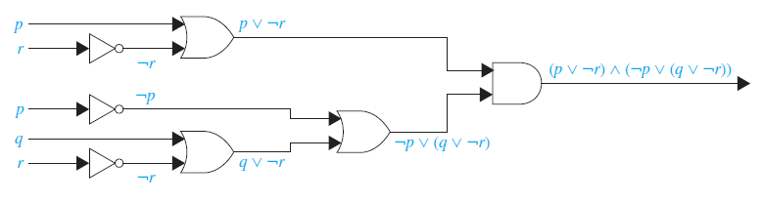
2. Let $A=\left[\begin{matrix}1 & 1 \\ 0 & 1\end{matrix}\right]$ and $B=\left[\begin{matrix}0 & 1 \\ 1 & 0\end{matrix}\right]$. Find
(a)$A˅B$ (b) A ⨀ B.
Sol:
$A˅B$ =$\left[\begin{matrix}1˅0 & 1˅1 \\ 0˅1 & 1˅0\end{matrix}\right]$=$\left[\begin{matrix}1 & 1 \\ 1 & 1\end{matrix}\right]$, A ⨀ B =$\left[\begin{matrix}1.0+1.1 & 1.1+1.0 \\ 0.0+1.1 & 0.1+1.0\end{matrix}\right]$=$\left[\begin{matrix}1 & 1 \\ 1 & 0\end{matrix}\right]$
To avoid confusion $˄ has been replaced with . and ˅ with+$
3. List all the steps used to search for 7 in the sequence 1,3, 4, 5, 6, 8, 9, 11 for both a linear search and a
binary search.
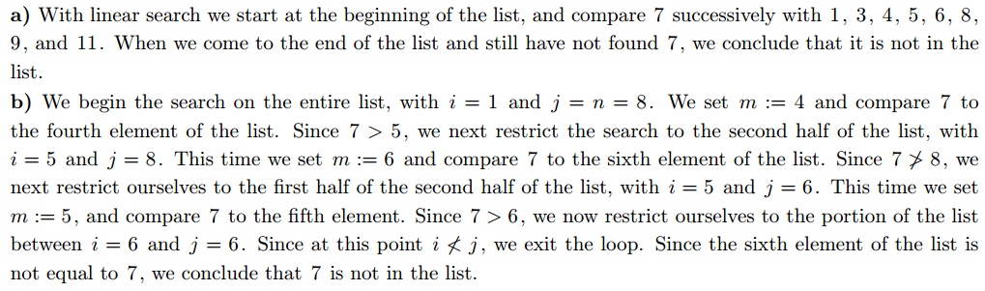
4. (a) Use the Euclidean algorithm to ﬁnd gcd(34, 21).
(b)what is the decimal expansion of the integer that ( 101011111)₂ as its binary expansion
Solution (a) We have 34 = 1 · 21 + 13, 21 = 1 · 13 + 8, 13 = 1 · 8 + 5, 8 = 1 · 5 + 3,
- = 1 · 3 + 2, 3 = 1 · 2 + 1, 2 = 2 · 1 Hence gcd(34, 21) = 1.
(b) 1.2⁸ + 0.2⁷ + 1.2⁶ + 0.2⁵+ 1.2⁴+ 1.2³+ 1.2²+ 1.2¹+ 1.2⁰ $=351$

